

CAPSTONE PROJECT REPORT
Report 3 – Software Requirement Specification

AI-POWERED EXAMINATION AND PROGRAMMING PRACTICE PLATFORM
(APE)

Group: SEP490-G26
Lecturer: Nguyễn Mạnh Hiển

– Hanoi, June 2026 –

Table of Contents
I. Record of Changes 6
II. Software Requirement Specification 7
1. Overall Requirements 7
1.1 Context Diagram 7
1.2 Main Workflows 8
1.2.1 Data Ingestion & AI Gatekeeper 8
1.2.2 PE (Practical Exam) Generation – Hybrid Validation 9
1.2.3 FE (Multiple-Choice) Generation – Actor-Critic 10
1.2.4 Exam Workspace, Code Execution & AI Code Mentor 11
1.2.5 Knowledge Analytics & AI Study Advice 11
1.3 User Requirements 12
1.3.1 Actors 12
1.3.2 Use Cases (UC) 14
1.3.2 Use Case Diagrams 17
1.4 System Functionalities 19
1.4.1 Screens Flow 19
1.4.2 Screen Authorization 19
1.4.3 Non-UI Functions 20
1.5 Entity Relationship Diagram 22
2. Use Case Specifications 24
2.1 FE-01: AI-Powered Data Ingestion & Vectorization 24
2.1.1 UC-01: Upload Personal Materials 24
2.1.2 UC-02: Preview Extracted Content 25
2.1.3 UC-22 Upload System Syllabus 26
2.1.4 UC-23 Edit Extracted Content 27
2.1.5 UC-24 Review Document 28
2.2 FE-02: Dynamic Practice Exam Generation 29
2.2.1 UC-03: Generate FE Exam 29
2.2.2 UC-04: Generate PE Exam 30
2.2.3 UC-05: Practice Multiple Choice 31
2.2.4 UC-06: Practice Flashcard 32
2.3 FE-03: Exam Workspace & Auto-Grading 33
2.3.1 UC-07: Practice Coding 33
2.3.2 UC-08: Request AI Code Review 34
2.3.3 UC-09: View Submission Result 35
2.4 FE-04: Knowledge Analytics & AI Study Advice 36
2.4.1 UC-10: View Competency Chart 36
2.4.2 UC-11: Request AI Study Advice 37
2.4.3 UC-12: View Summary Statistics 38
2.5 FE-05: Gamification & Engagement System 38
2.5.1 UC-13: View Daily Streak 38
2.5.2 UC-14: View Badge Collection 39
2.5.3 UC-15: View Leaderboard 40
2.6 FE-06: AI Configurator 40
2.6.1 UC-34: Create System Prompt 40
2.6.2 UC-35: View System Prompt List 41
2.6.3 UC-36: Edit System Prompt 42
2.6.4 UC-37: Delete System Prompt 43
2.6.5 UC-38: Configure AI Model Routing 43
2.6.6 UC-39: Configure API Parameters 44
2.7 FE-07: System Dashboard & User Management 45
2.7.1 UC-40: View Traffic Analytics 45
2.7.2 UC-41: View User Analytics 46
2.7.3 UC-42: View API Cost Tracker 47
2.7.4 UC-43: View User List 48
2.7.5 UC-44: Ban User 48
2.7.6 UC-45: Unban User 49
2.7.7 UC-46: Assign Custom AI Model 50
2.8 FE-08: Course & Question Bank Management 51
2.8.1 UC-25: Create Course 51
2.8.2 UC-26: View Course List 52
2.8.3 UC-27: Update Course 52
2.8.4 UC-28: Delete Course 53
2.8.5 UC-29: Activate Course 54
2.8.6 UC-30: Deactivate Course 55
2.8.7 UC-31: View Question Bank 56
2.8.8 UC-32: Edit Question 56
2.8.9 UC-33: Disable Question 57
2.9 FE-09: Authentication & Profile Management 58
2.9.1 UC-16: Login via Google SSO 58
2.9.2 UC-17: View Profile 59
2.9.3 UC-18: Edit Profile 60
2.9.4 UC-19: View Practice History 60
2.10 Payment Management 61
2.10.1 UC-20: Purchase Credits 61
2.10.2 UC-21: View Purchase History 62
2.10.3 UC-47: Troubleshoot Payment 63
3. Functional Requirements 64
3.1 FE-09: Authentication & Profile Management 64
3.1.1 Login Page (Google SSO) 64
3.1.2 Profile Settings 65
3.1.3 Subscription Management 67
3.1.4 Practice History 68
3.2 FE-01: AI-Powered Data Ingestion & Vectorization 70
3.2.1 Data Ingestion Upload (Admin - System Level) 70
3.2.2 BYOS Upload (Student - Personal Materials) 71
3.2.3 Data Approval & Preview 72
3.3 Data Approval & Preview 74
3.3.1 Course Management 74
3.3.2 Question Bank Management 75
3.4 FE-02: Dynamic Practice Exam Configuration & Generation 77
3.4.1 Exam Configuration (FE - Multiple Choice) 77
3.4.2 Exam Configuration (PE - Coding) 78
3.4.3 Practice MCQ Space 79
3.4.4 Flashcard Viewer 81
3.5 FE-03: Isolated Exam Workspace & Judge0 Auto-Grading 82
3.5.1 Practice Coding Space (Web IDE) 82
3.5.2 Result Viewer 83
3.5.3 AI Code Review Dialog 85
3.6 FE-04: Knowledge Analytics & AI Study Advice 86
3.6.1 Knowledge Analytics Dashboard 86
3.6.2 AI Study Advice Panel 88
3.7 FE-05: Gamification & Engagement System 89
3.7.1 Streak & Badges 89
3.7.2 Leaderboard 90
3.8 FE-06: Advanced AI Configurator 92
3.8.1 System Prompts Management 92
3.8.2 AI Model & Routing Configuration 93
3.8.3 API Parameters Configuration 94
3.9 FE-07: System Dashboard & User Management 95
3.9.1 Traffic Analytics Dashboard 95
3.9.2 User Analytics Dashboard 96
3.9.3 API Cost Tracker 97
3.9.4 User Management 99
3.10 Payment Management 100
3.10.1 Purchase Credits 100
3.10.2 Purchase History 101
3.10.3 Payment Troubleshooting (Admin) 103
4. Non-Functional Requirements 105
4.1 External Interfaces 105
4.2 Quality Attributes 106
4.2.1 Usability 106
4.2.2 Performance 107
4.2.3 Security 107
4.2.4 Scalability 109
4.2.5 Reliability 109
5. Requirement Appendix 110
5.1 Business Rules 110
5.2 System Messages 121
5.3 Other Requirements 126

I. Record of Changes
Date | A*  M, D | In charge | Change Description
10/06/2026 | A | Nguyễn Việt Đức | 1. Overall Requirements (1.1)
12/06/2026 | A | Nguyễn Viết Sang,  Phạm Quốc Minh | 1. Overall Requirements (1.5)
*A - Added M - Modified D - Deleted

II. Software Requirement Specification

1. Overall Requirements

1.1 Context Diagram
The APE (AI-Powered Examination and Programming Practice Platform) is a web application designed for FPT University IT students. The context diagram below illustrates the system boundary, external entities (terminators), and all data/control flows between them.

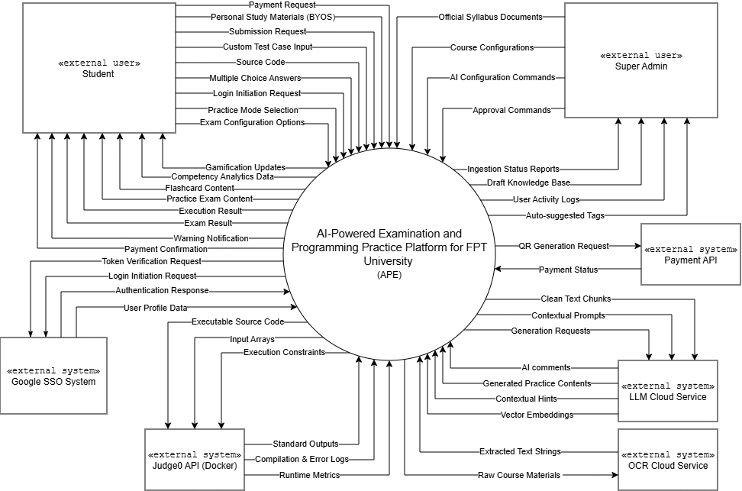

External Entities:
Student: The primary end-user. Students interact with the system to upload personal study materials (BYOS), configure and take practice exams (FE/PE), view results, request AI Mentor hints, track learning analytics, and manage their profile/wallet.
Super Admin: The administrative user who manages courses, question banks, AI configurations, system prompts, user accounts, and monitors system dashboards (traffic, API cost).
Google SSO System: Handles user authentication via OAuth 2.0. APE sends Login Initiation Requests and Token Verification Requests; receives Authentication Responses.
Judge0 API (Docker): The external code execution engine. APE sends Executable Source Code, Input Arrays, and Execution Constraints; receives Standard Outputs, Compilation & Error Logs, and Runtime Metrics.
LLM Cloud Service (OpenAI / Google Gemini): Provides AI capabilities. APE sends Clean Text Chunks, Contextual Prompts, and Generation Requests; receives Generated Practice Contents, AI Comments, Contextual Hints, and Vector Embeddings.
OCR Cloud Service: Processes raw uploaded documents. APE sends Raw Course Materials; receives Extracted Text Strings.
Payment API: Handles financial transactions for purchase credits . APE sends QR Generation Requests; receives Payment Status confirmations.

1.2 Main Workflows
The APE system operates through five (5) core business workflows. Each workflow is described with a PlantUML swim-lane activity diagram.

1.2.1 Data Ingestion & AI Gatekeeper

This workflow covers uploading, validating, and vectorizing course materials. Applies to both Admin uploads (system-level syllabus) and Student uploads (BYOS – personal materials).
Flow: User uploads file → OCR extracts text → AI Gatekeeper samples 1,000–2,000 tokens → Classify (is_supported) → If supported: Auto-Chunking → Auto-Tagging → Vector Embedding → Store. If rejected: Warning Notification.
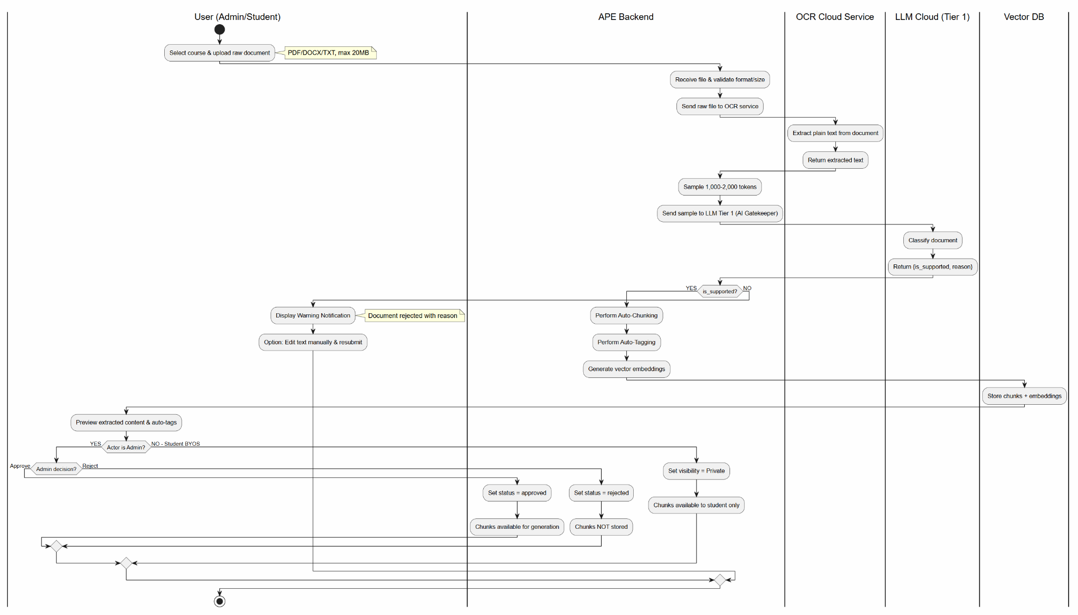

1.2.2 PE (Practical Exam) Generation – Hybrid Validation
The most complex AI pipeline. Uses Generator Agent → Critic Agent (retry ≤2) → Judge0 Validation Loop (retry ≤2). AI is strictly forbidden from generating Expected Outputs — only Judge0 produces actual outputs.
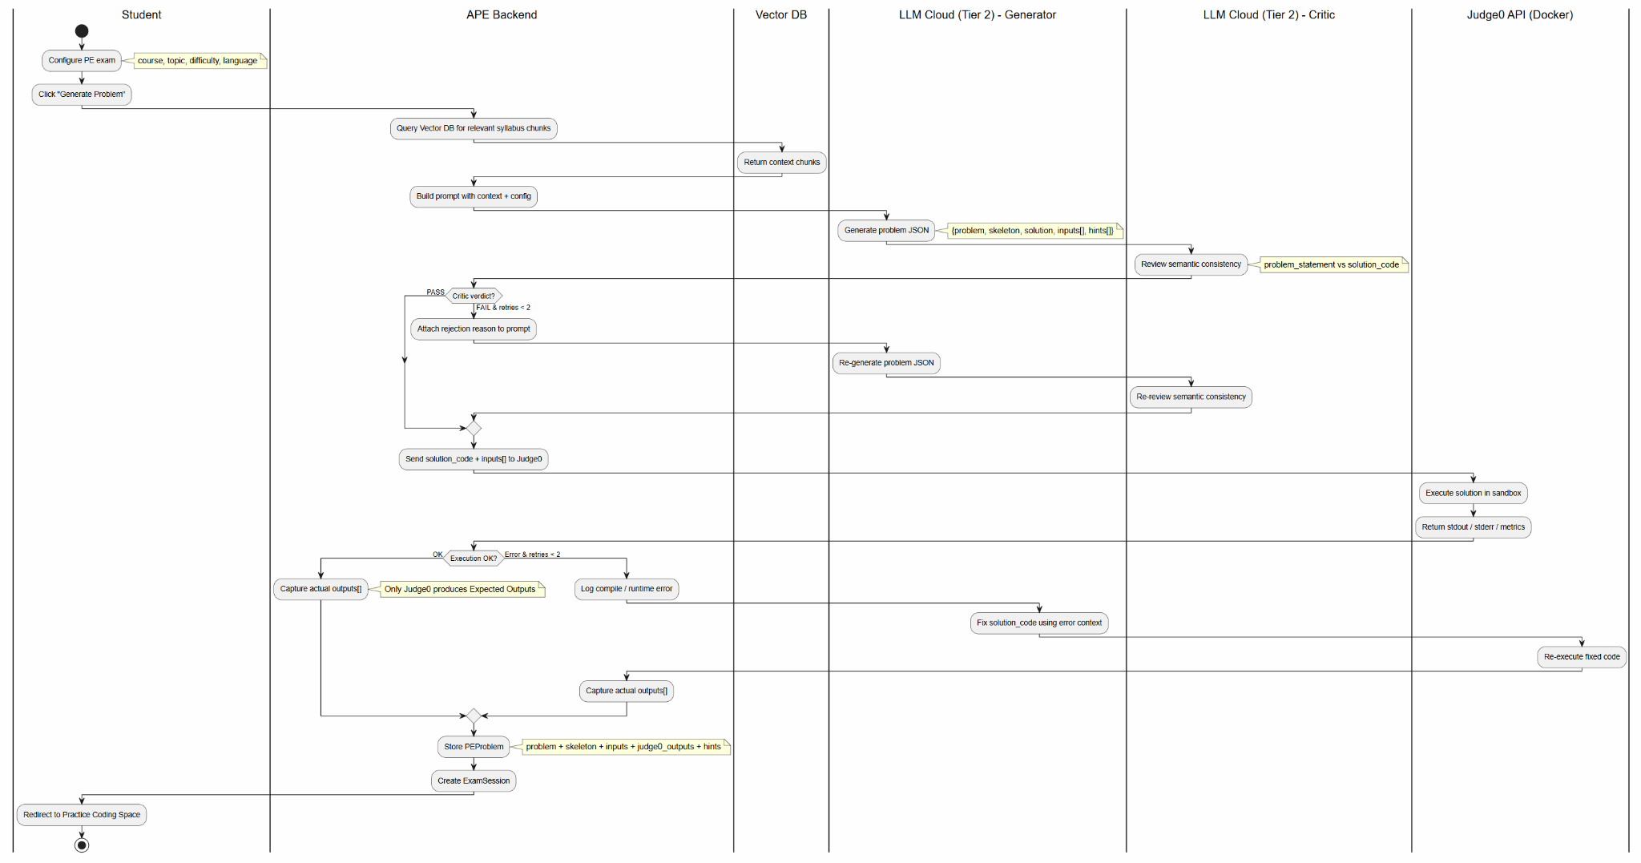

1.2.3 FE (Multiple-Choice) Generation – Actor-Critic
3-layer architecture: (1) RAG Strictness forces AI to use only Vector DB knowledge, (2) Actor-Critic where Agent 1 generates MCQ and Agent 2 reviews distractor quality, (3) Structured JSON Output with schema validation.
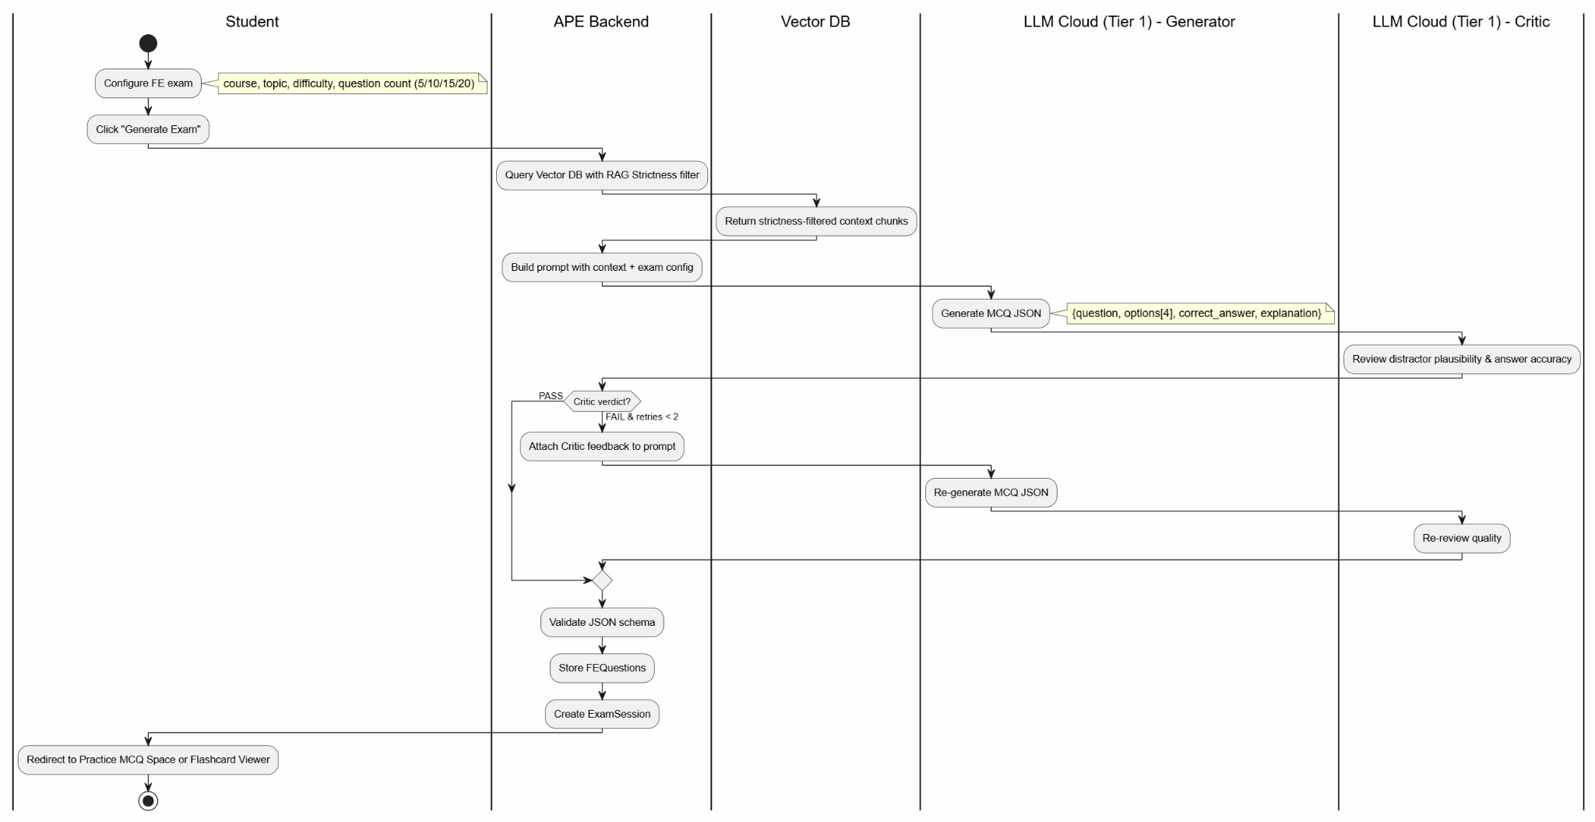

1.2.4 Exam Workspace, Code Execution & AI Code Mentor
Students code in the Practice Coding Space (web IDE), submit to Judge0 for grading, and optionally request AI Code Mentor (max 2/session). AI Mentor provides conceptual hints without revealing solution code. Resubmission uses Overwrite (Optimistic Locking).
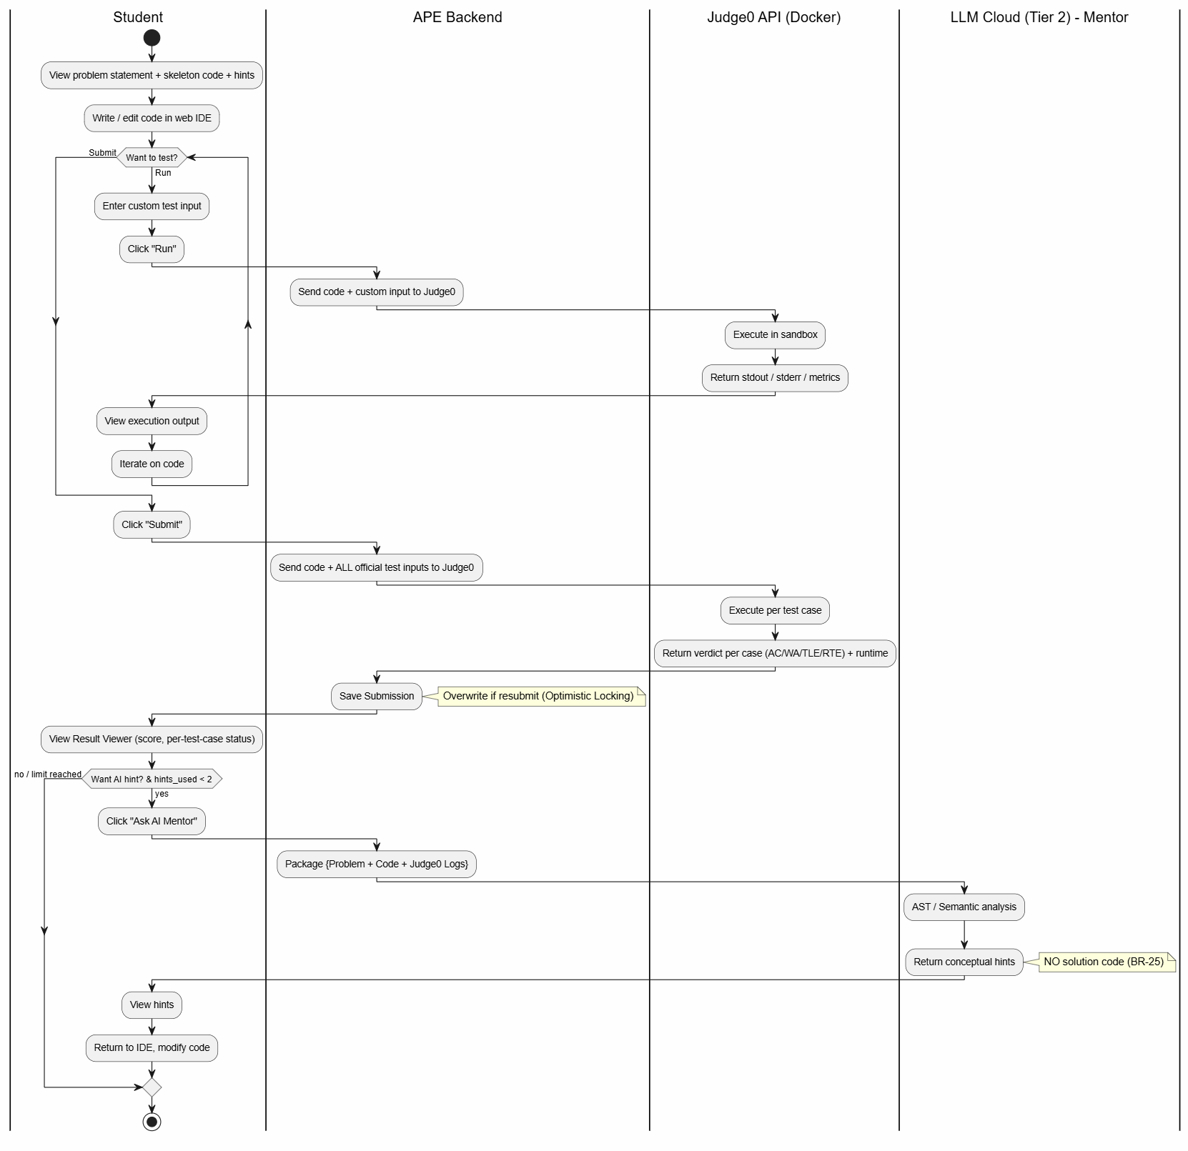

1.2.5 Knowledge Analytics & AI Study Advice
After sufficient practice sessions, the system aggregates performance data, generates Competency Assessment Charts per topic, and compiles personalized reports. The AI analyzes patterns to provide tailored study advice.
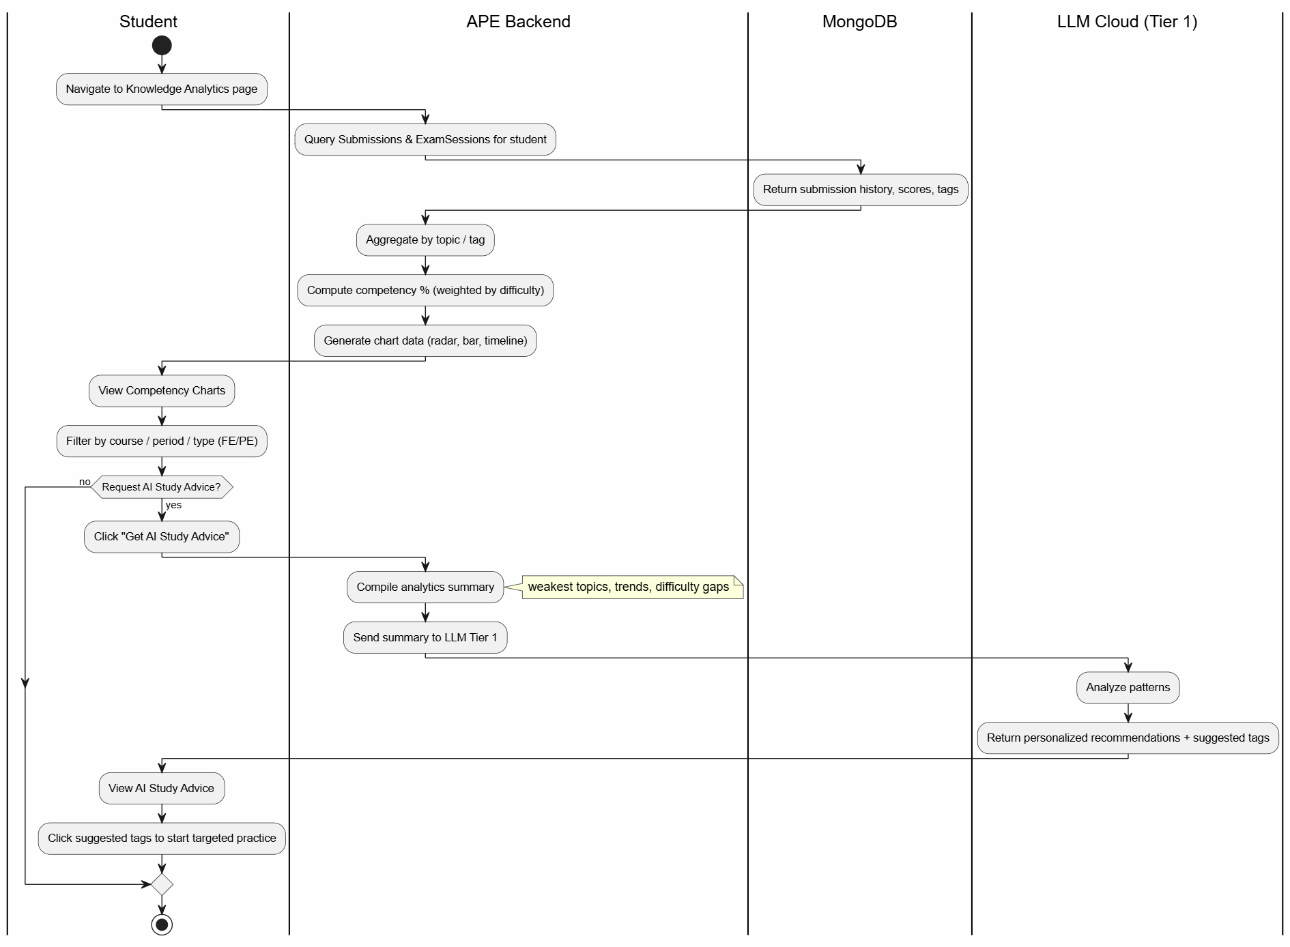

1.3 User Requirements

1.3.1 Actors
An actor is an external entity that interacts with the APE system. The table below describes all actors, including human users and external systems.

# | Actor | Description
1 | Student | The primary human user. An FPT University IT student who uses the platform to upload personal study materials (BYOS), take AI-generated practice exams (FE/PE), write and submit code for auto-grading, request AI Code Mentor hints, view learning analytics and study advice, earn badges and track streaks, and manage their profile/subscription/wallet.
2 | Super Admin | The administrative human user. Manages system-level content: uploads official syllabus, approves/rejects ingested documents, performs CRUD operations on courses, censors AI-generated questions, configures AI models/prompts/parameters, monitors system dashboards (traffic, user analytics, API cost tracker), and manages user accounts (ban/unban).
3 | Google SSO System | External authentication system. Provides OAuth 2.0 / OIDC login flow. APE delegates all authentication to Google and verifies the returned ID Token.
4 | Judge0 API (Docker) | External code execution engine. Runs student-submitted code in isolated Docker containers. Returns stdout, stderr, and runtime metrics per test case. Enforces CPU/memory/time limits.
5 | LLM Cloud Service | External AI provider (Google Gemini / OpenAI). Tier 1 handles fast tasks (Gatekeeper, Tagging, FE Generation). Tier 2 handles deep reasoning (PE Generation, Code Mentor). Receives prompts + context; returns generated content.
6 | OCR Cloud Service | External text extraction service (Google Cloud Vision / Azure OCR). Converts raw uploaded documents (PDF, DOCX, scanned images) into plain text for AI processing.
7 | Payment API | External payment gateway (VNPay / MoMo). Processes Premium Tier purchases and wallet top-ups. Returns payment status via webhook callback.

1.3.2 Use Cases (UC)
The table below lists all use cases in the system, grouped by feature. Complex UCs involving main business workflows have detailed specifications in Section 2. Simple UCs (CRUD, data-viewing) are described in Section 3 (Functional Requirements).

ID | Use Case | Feature | Use Case Description
UC-01 | Upload Personal Materials | FE-01: Data Ingestion | Student uploads personal study materials (BYOS) for AI processing. System performs OCR, AI Gatekeeper classification, chunking, tagging, and vectorization.
UC-02 | Preview Extracted Content | FE-01: Data Ingestion | Student previews OCR-extracted text and auto-generated tags before confirming upload. «include» from UC-01.
UC-03 | Generate FE Exam | FE-02: Exam Generation | Student selects course, topic, difficulty, question count, and display mode (Practice/Flashcard). System generates MCQs via RAG + Actor-Critic pipeline. Credits are deducted.
UC-04 | Generate PE Exam | FE-02: Exam Generation | Student selects course, topic, difficulty, and programming language. System generates coding problem via Generator → Critic → Judge0 Validation pipeline. Credits are deducted.
UC-05 | Practice Multiple Choice | FE-02: Exam Generation | Student answers generated MCQs: select answer, check correctness, view explanation. Score is recorded in PracticeSession.
UC-06 | Practice Flashcard | FE-02: Exam Generation | Student reviews generated FE questions in flip-card format: view question, flip to reveal answer. Memorization status is tracked.
UC-07 | Practice Coding | FE-03: Exam Workspace | Student writes code in web-based IDE, runs custom tests, and submits for auto-grading against official test cases via Judge0.
UC-08 | Request AI Code Review | FE-03: Exam Workspace | After submission, student requests AI-powered code review: error analysis, quality scoring (x/10), improvement suggestions. Max 2 requests/session. «extend» UC-07.
UC-09 | View Submission Result | FE-03: Exam Workspace | Student views per-test-case verdict (AC/WA/TLE/RTE), runtime metrics, and overall score. «include» from UC-07.
UC-10 | View Competency Chart | FE-04: Analytics | Student views radar/bar chart showing competency percentage per topic, filtered by course, time period, or exam type.
UC-11 | Request AI Study Advice | FE-04: Analytics | Student requests personalized AI-generated study recommendations based on analytics data. «extend» UC-10. Credits are deducted.
UC-12 | View Summary Statistics | FE-04: Analytics | Student views aggregated metrics: total problems solved, average score, time spent, improvement trends over past 4 weeks.
UC-13 | View Daily Streak | FE-05: Gamification | Student views current streak count (consecutive days with at least 1 completed practice session).
UC-14 | View Badge Collection | FE-05: Gamification | Student views earned and unearned badges with unlock criteria and progress indicators.
UC-15 | View Leaderboard | FE-05: Gamification | Student views rankings filtered by course or global scope, based on total score and problems solved.
UC-16 | Login via Google SSO | FE-09: Auth & Profile | Student authenticates via Google OAuth 2.0. System creates or retrieves user account. Shared with Super Admin.
UC-17 | View Profile | FE-09: Auth & Profile | Student views personal information: name, email, avatar, credit balance, BYOK status. Shared with Super Admin.
UC-18 | Edit Profile | FE-09: Auth & Profile | Student updates personal information, avatar, and BYOK API key. Shared with Super Admin.
UC-19 | View Practice History | FE-09: Auth & Profile | Student views historical exam sessions with date, course, score, and duration for both FE and PE exams.
UC-20 | Purchase Credits | Payment | Student purchases credits via Payment API (QR code). Credits are added to balance upon successful payment confirmation.
UC-21 | View Purchase History | Payment | Student views transaction history: date, amount, credits received, payment status.
UC-22 | Upload System Syllabus | FE-01: Data Ingestion | Admin uploads official course syllabus. System performs OCR, AI Gatekeeper, chunking, tagging, vectorization. Document requires admin approval.
UC-23 | Edit Extracted Content | FE-01: Data Ingestion | Admin edits OCR-extracted text and auto-generated tags before approving for exam generation. «include» from UC-22.
UC-24 | Review Document | FE-01: Data Ingestion | Admin reviews processed document and decides to Approve (chunks become available) or Reject (chunks discarded).
UC-25 | Create Course | FE-08: Course & Question Mgmt | Admin creates a new course record with name, code, description, and category.
UC-26 | View Course List | FE-08: Course & Question Mgmt | Admin views all courses with status (active/inactive), document count, and question count.
UC-27 | Update Course | FE-08: Course & Question Mgmt | Admin updates course information: name, description, category, metadata.
UC-28 | Delete Course | FE-08: Course & Question Mgmt | Admin deletes a course. Cascade policy: associated documents and questions are soft-deleted.
UC-29 | Activate Course | FE-08: Course & Question Mgmt | Admin activates a course, making it available for students to select during exam configuration.
UC-30 | Deactivate Course | FE-08: Course & Question Mgmt | Admin deactivates a course, hiding it from student exam configuration without deleting data.
UC-31 | View Question Bank | FE-08: Course & Question Mgmt | Admin browses all generated questions (FE + PE) with filters: course, type, difficulty, status.
UC-32 | Edit Question | FE-08: Course & Question Mgmt | Admin edits question content, options, correct answer, or explanation for quality control.
UC-33 | Disable Question | FE-08: Course & Question Mgmt | Admin disables a problematic question (censorship). Disabled questions are excluded from future exam generation.
UC-34 | Create System Prompt | FE-06: AI Configurator | Admin creates a new system prompt template for a specific AI agent (Gatekeeper, Generator, Critic, etc.).
UC-35 | View System Prompt List | FE-06: AI Configurator | Admin views all system prompts with agent type, version, and active status.
UC-36 | Edit System Prompt | FE-06: AI Configurator | Admin modifies prompt content, adjusts instructions, or updates version.
UC-37 | Delete System Prompt | FE-06: AI Configurator | Admin deletes an unused system prompt. Active prompts cannot be deleted.
UC-38 | Configure AI Model Routing | FE-06: AI Configurator | Admin assigns LLM models to task tiers: Tier 1 (fast/cheap) for Gatekeeper, Tagging, FE Generator; Tier 2 (deep reasoning) for PE Generator, AI Code Review.
UC-39 | Configure API Parameters | FE-06: AI Configurator | Admin adjusts API parameters per task type: temperature, max_tokens, top_p, frequency_penalty.
UC-40 | View Traffic Analytics | FE-07: Dashboard & User Mgmt | Admin views system traffic metrics: total requests, response times, error rates, peak usage hours.
UC-41 | View User Analytics | FE-07: Dashboard & User Mgmt | Admin views user metrics: registration trends, daily active users, retention rates, feature adoption.
UC-42 | View API Cost Tracker | FE-07: Dashboard & User Mgmt | Admin monitors LLM token usage and costs (VND): per model, per task type, daily/weekly/monthly aggregation.
UC-43 | View User List | FE-07: Dashboard & User Mgmt | Admin browses user accounts with search/filter by name, email, status, registration date.
UC-44 | Ban User | FE-07: Dashboard & User Mgmt | Admin bans a user account. Banned users cannot login or access any features.
UC-45 | Unban User | FE-07: Dashboard & User Mgmt | Admin restores a banned user account to active status.
UC-46 | Assign Custom AI Model | FE-07: Dashboard & User Mgmt | Admin assigns a specific AI model to an individual user, overriding the default model routing configuration.
UC-47 | Troubleshoot Payment | Payment | Admin investigates and resolves payment issues: failed transactions, incorrect credit amounts, refund processing.

1.3.2 Use Case Diagrams

1.3.2.1 UCs for Student
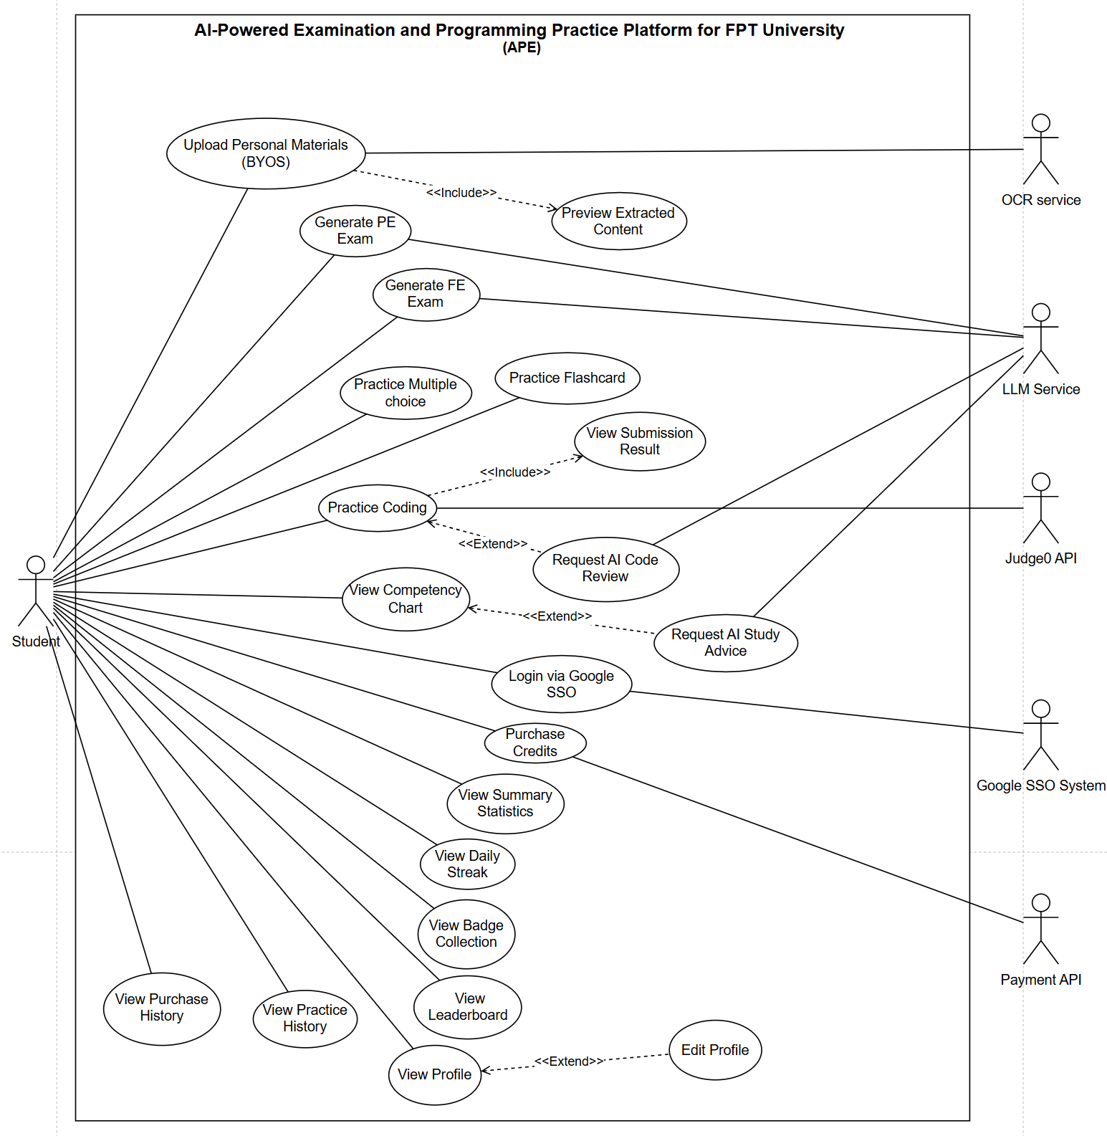

1.3.2.2 UCs for Super Admin
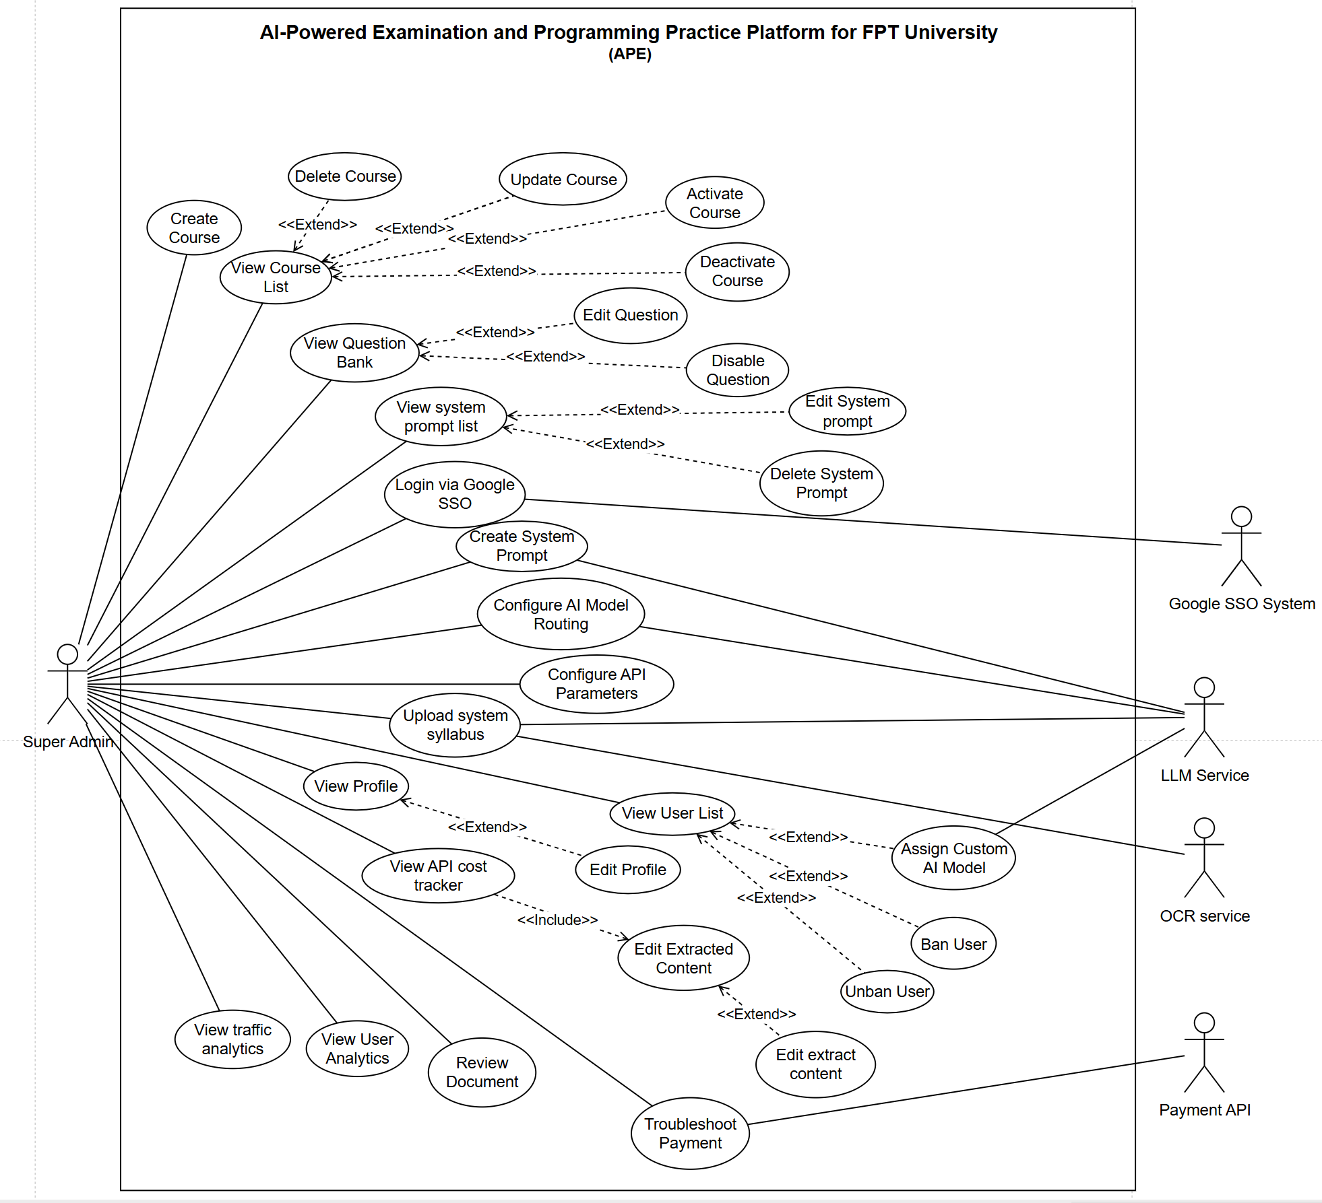

1.4 System Functionalities

1.4.1 Screens Flow

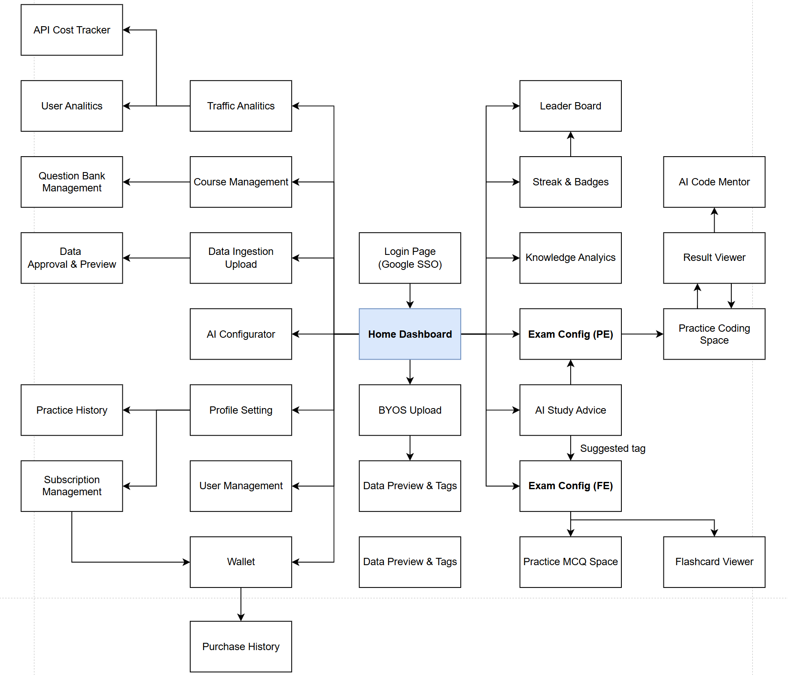

1.4.2 Screen Authorization

Screen | Student | System Admin
Login / Register | X | X
Home Dashboard | X | X
Profile Settings | X | X
BYOS Upload (Personal Materials) | X
Exam Configuration (FE) | X
Exam Configuration (PE) | X
Practice Multiple Choice Space | X
Practice Coding Space (IDE) | X
Result Viewer | X
AI Code Mentor Dialog | X
Knowledge Analytics Dashboard | X
AI Study Advice | X
Gamification (Streak/Badge) | X
Leaderboard | X | X
Flashcard Viewer | X
Top-up Wallet | X
Purchase History | X | X
Data Ingestion Upload (System) |  | X
Data Approval & Preview |  | X
Course Management (CRUD) |  | X
Question Bank Management |  | X
AI Configurator (Prompts/Models/Params) |  | X
Traffic Analytics Dashboard |  | X
User Analytics |  | X
API Cost Tracker |  | X
User Management (Ban/Unban) |  | X
Payment Troubleshooting |  | X

1.4.3 Non-UI Functions
[Provide the descriptions for the non-screen system functions, i.e batch/cron job, service, API, etc.]
# | Feature | System Function | Description
1 | FE-01 | OCR Text Extraction Service | Receives raw uploaded documents, sends to OCR Cloud Service, returns extracted plain text. Triggered asynchronously after file upload.
2 | FE-01 | AI Gatekeeper Classification | Samples 1,000–2,000 tokens from extracted text, sent to LLM Tier 1 for classification. Returns {is_supported, reason}.
3 | FE-01 | Auto-Chunking & Tagging Pipeline | Splits supported documents into semantic chunks, auto-tags each chunk, generates vector embeddings, stores in Vector DB.
4 | FE-02 | FE Generator (Actor-Critic) | RAG query → LLM Tier 1 generates MCQ JSON → Critic reviews → retry max 2 → JSON schema validation → store to QuestionsBank (type=FE) → serve to PracticeSession (mode: Practice or Flashcard).
5 | FE-02 | PE Generator (Hybrid Validation) | Generator creates {Problem, Skeleton, Solution, Inputs, Hints} → Critic review (retry ≤2) → Judge0 executes to produce Outputs (retry ≤2).
6 | FE-03 | Judge0 Code Execution Service | Sends submitted code + test inputs to Judge0 Docker sandbox. Receives stdout/stderr per test case. Enforces timeout and language restrictions.
7 | FE-03 | AI Code Mentor Service | On-demand (max 2/session). Packages {Problem + Code + Logs}, sent to LLM Tier 2 for analysis. Returns conceptual hints (no solution code).
8 | FE-03 | Submission Overwrite Handler | Implements Optimistic Locking on MongoDB. Resubmit overwrites existing records. Front debounce prevents race conditions.
9 | FE-04 | Performance Aggregation Job | Cron Job nightly + hybrid trigger on page visit. Queries Submissions (PE results) AND PracticeSessions.fe_answers (FE results). Computes competency % per topic/tag. Updates UserAnalytics collection.
10 | FE-04 | AI Study Advice Generator | Sends aggregated performance data to LLM Tier 1. Returns personalized study recommendations.
11 | FE-06 | Model Routing Engine | Routes AI requests to appropriate model tier: Tier 1 (Gatekeeper, Tagging, FE Gen) vs Tier 2 (PE Gen, Code Mentor).
12 | FE-07 | API Cost Tracking Service | Logs token usage per AI call. Aggregates daily/weekly costs. Enforces hard limit on tokens/day via budget alerts.
13 | Payment | Payment Webhook Handler | Receives Payment Status callbacks from Payment API. Auto-confirms purchase and updates user subscription tier.

1.5 Entity Relationship Diagram
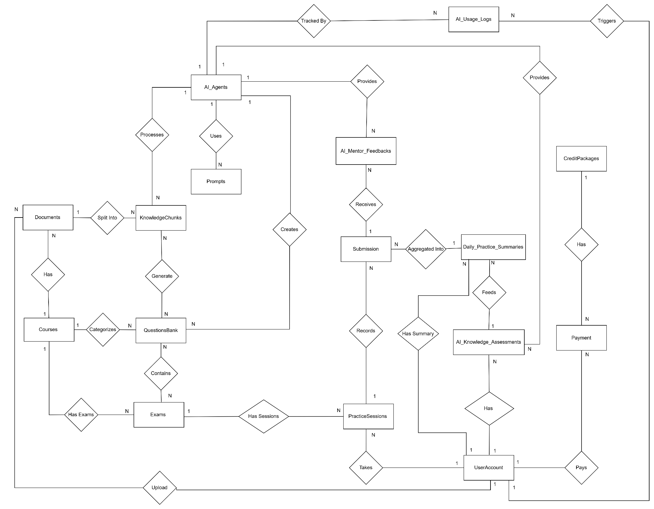
Entities Description
# | Entity | Description
1 | UserAccount | Manages identity information (Google SSO) for students and Admins, and handles system role-based access control (RBAC). It also stores Gamification progress (EXP points, learning Streaks) and manages Credit balances (Free/Paid) for utilizing AI services.
2 | Courses | A catalog of core subjects supported by the system. Acts as the root reference to categorize documents, questions, and performance statistics.
3 | Documents | Stores file paths and statuses of uploaded course syllabi and lecture slides that have been validated and approved (via AI Gatekeeper screening).
4 | KnowledgeChunks | The main data repository for the system (Vector Database). Stores small knowledge chunks automatically extracted from Documents, including the original raw text and multi-dimensional Vector matrices to serve RAG (Retrieval-Augmented Generation) queries.
5 | QuestionsBank | Stores the polymorphic structure of all Multiple-Choice Questions (FE) and Practical Programming Exercises (PE). It contains problem descriptions, skeleton code, solutions, and hidden Test Cases automatically generated by AI from KnowledgeChunks.
6 | Exams | A configuration wrapper for a specific exam or practice playlist. Defines the execution mode (Timed Mock Test or Free Practice), difficulty level, visibility (Public/Private), and contains a list of questions belonging to a specific course.
7 | PracticeSessions | Records the lifecycle of a student's coding practice or mock test session. Manages auto-save draft states to prevent data loss, records start/end times, and finalizes the total score for the entire session.
8 | Submissions | Detailed history of each source code submission made by a student during a practice session. Contains independent evaluation statuses from the Judge0 environment (Pass, Fail, Compile Error), the number of passed Test Cases, and execution runtime.
9 | AI_Mentor_Feedbacks | Stores pedagogical analyses, advice, and logical debugging hints provided by the AI Code Mentor for each failed submission (Strictly prohibits storing exact code solutions).
10 | Daily_Practice_Summaries | A daily summary table of each student's practice achievements and performance, providing clean aggregated data for AI Analytics.
11 | AI_Knowledge_Assessments | Stores periodic performance evaluation reports. Contains proficiency metrics categorized by Topic and personalized learning path advice analyzed by AI.
12 | Payment | Manages the history of financial transactions and user Credit top-ups. Records detailed balance fluctuations (before/after transactions) and exchange rates to ensure transparent auditing.
13 | AI_Agents | A registry/dictionary defining "AI Personnels" (e.g., Gatekeeper, Mentor, Generator). Manages the configurations of LLM Models (such as GPT-4o, Gemini 3.5 Flash, etc.), Token limits, and Credit pricing per API call.
14 | Prompts | A centralized repository for prompt templates used to communicate and instruct the AI. Supports Versioning to help administrators easily rollback and optimize accuracy.
15 | AI_Usage_Logs | An Audit Trail that records all API transactions between the system and AI providers. Deeply tracks Token consumption (Input/Output), costs, caller IDs, and temporarily stores Payload contents (JSON) for evidence and debugging.

2. Use Case Specifications

2.1 FE-01: AI-Powered Data Ingestion & Vectorization

2.1.1 UC-01: Upload Personal Materials

UC ID | UC-01
UC Name | Upload Personal Materials
Primary Actors | Student
Secondary Actors | OCR Cloud Service, LLM Cloud Service (Tier 1)
Description | As a Student, I want to upload my personal study materials (BYOS) so that the AI can generate practice exams tailored to my own documents.
Preconditions | 1. Student is authenticated.  2. Student has sufficient credits for BYOS processing (or valid BYOK API key).  3. OCR and LLM services are operational.
Postconditions | 1. Personal document is stored with visibility = "Private".  2. Text chunks are stored in Vector DB under student’s personal namespace.  3. Student’s credit balance is deducted for the BYOS processing cost.  4. Student can generate exams from personal materials.
Normal Sequence/Flow | 1. Student navigates to BYOS Upload page.  2. Student uploads personal document file (PDF/DOCX/TXT, max 20MB).  3. System checks student’s credit balance against BYOS cost.  4. System sends file to OCR Cloud Service for text extraction.  5. System invokes AI Gatekeeper for classification.  6. LLM returns {is_supported: true}.  7. System performs Auto-Chunking and Auto-Tagging.  8. System stores chunks in Vector DB with visibility = "Private" and user_id = current student.  9. System displays preview of extracted content. « include » UC-02: Preview Extracted Content.  10. Student confirms upload.  11. System deducts credits from student’s balance.
Alternative Sequences/Flows | 6a. AI Gatekeeper returns {is_supported: false}:  6a.1. System displays warning: "Your document does not appear to be an IT study material."  6a.2. Student can choose to force-process (at own risk, credits still deducted) or cancel.  3a. Insufficient credits:  3a.1. System displays: "Insufficient credits. Please purchase more credits to use BYOS."  3a.2. Redirect to Purchase Credits (UC-20).
Exceptions | 4a. OCR failure: System suggests "Please ensure the document is not a scanned image with poor quality."  File format not supported: System blocks with "Supported formats: PDF, DOCX, TXT."
Business Rules | BR-05: BYOS processing costs credits. Cost depends on document size.  BR-06: Personal documents are private; only the uploading student can access/generate from them.  BR-07: Maximum 10 personal documents per student.  BR-08: Students with valid BYOK API key bypass credit deduction for LLM calls.

2.1.2 UC-02: Preview Extracted Content

UC ID | UC-02
UC Name | Preview Extracted Content
Primary Actors | Student
Secondary Actors | None (internal display)
Description | As a Student, I want to preview the OCR-extracted text and auto-generated tags before confirming my upload, so that I can verify content accuracy.
Preconditions | 1. UC-01 (Upload Personal Materials) has been initiated.  2. OCR processing and AI Gatekeeper classification are complete.
Postconditions | 1. Student has reviewed extracted content and tags.  2. Student proceeds to confirm or cancel the upload.
Normal Sequence/Flow | 1. System displays extracted plain text from OCR processing (read-only).  2. System displays auto-generated tags (#Array, #Pointer, #OOP, etc.).  3. System displays chunk count and estimated token count.  4. Student reviews content accuracy and tag relevance.  5. Student clicks "Confirm" to proceed with vectorization and credit deduction.
Alternative Sequences/Flows | 5a. Student clicks "Cancel":  5a.1. System discards all extracted content and chunks.  5a.2. Credits are NOT deducted.  5a.3. Student returns to BYOS Upload page.
Exceptions | N/A
Business Rules | BR-40: Preview is mandatory before upload confirmation («include» relationship enforced).  BR-41: Student CANNOT edit extracted content (read-only preview). Only Admin can edit (UC-23).

2.1.3 UC-22 Upload System Syllabus

UC ID | UC-22
UC Name | Upload System Syllabus
Primary Actors | Super Admin
Secondary Actors | OCR Cloud Service, LLM Cloud Service (Tier 1)
Description | As a Super Admin, I want to upload official course syllabus documents so that the system can process, validate, chunk, tag, and vectorize the content for AI-powered exam generation.
Preconditions | 1. Admin is authenticated and has Super Admin role.  2. Target course exists and is in active status.  3. OCR Cloud Service and LLM Cloud Service are operational.
Postconditions | 1. Document record is created with status = "processed".  2. Text chunks are stored in Vector DB with auto-generated tags.  3. Document is linked to the target course.  4. Admin can preview extracted content and tags.
Normal Sequence/Flow | 1. Admin navigates to Data Ingestion page.  2. Admin selects target course from dropdown.  3. Admin uploads document file (PDF/DOCX/TXT, max 20MB).  4. System sends file to OCR Cloud Service for text extraction.  5. System receives extracted plain text.  6. System invokes AI Gatekeeper: samples 1,000–2,000 tokens, sends to LLM Tier 1 for classification.  7. LLM returns {is_supported: true, category: "IT_Syllabus"}.  8. System performs Auto-Chunking (semantic splitting).  9. System performs Auto-Tagging on each chunk (#Array, #Pointer, #OOP, etc.).  10. System generates vector embeddings and stores chunks in Vector DB.  11. System displays preview: extracted content, tags, chunk count. «include» UC-23: Edit Extracted Content.  12. Admin reviews and clicks "Approve" to finalize.  13. System updates document status to "approved" and makes chunks available for exam generation.
Alternative Sequences/Flows | 7a. AI Gatekeeper returns {is_supported: false}:  7a.1. System displays warning with rejection reason.  7a.2. Admin can edit extracted text manually and re-submit for classification.  7a.3. Return to step 6.  12a. Admin clicks "Reject":  12a.1. System marks document status as "rejected".  12a.2. Chunks are NOT stored in Vector DB.
Exceptions | 4a. OCR Service timeout (>30s): System displays error "OCR service unavailable, please retry."  6a. LLM Service timeout (>30s): System displays error "AI classification unavailable, please retry."  3a. File exceeds 20MB: System blocks upload with validation message.
Business Rules | BR-01: Maximum file size = 20MB.  BR-02: Supported formats: PDF, DOCX, TXT.  BR-03: AI Gatekeeper samples 1,000–2,000 tokens (cover + TOC + random pages).  BR-04: Document must be approved by Admin before chunks are available for generation.

2.1.4 UC-23 Edit Extracted Content

UC ID | UC-23
UC Name | Edit Extracted Content
Primary Actors | Super Admin
Secondary Actors | None
Description | As a Super Admin, I want to edit OCR-extracted text and auto-generated tags before approving a document, so that I can correct extraction errors and improve tag accuracy.
Preconditions | 1. Admin is authenticated with Super Admin role.  2. UC-22 (Upload System Syllabus) has been initiated.  3. OCR extraction and auto-tagging are complete.
Postconditions | 1. Edited content and tags are saved.  2. Admin can proceed to approve or reject the document.
Normal Sequence/Flow | 1. System displays extracted content in an editable text area. «include» from UC-22.  2. System displays auto-generated tags as editable chips/badges.  3. Admin reviews content for OCR errors (misrecognized characters, formatting issues).  4. Admin corrects text where needed.  5. Admin adds, removes, or modifies tags as needed.  6. Admin clicks "Save Changes".  7. System updates the extracted content and tags in the Document record.  8. Admin proceeds to approve (UC-24) or continues editing.
Alternative Sequences/Flows | 6a. Admin clicks "Reset to Original": system reverts to original OCR output.  4a. Large document: system provides search & replace functionality within extracted text.
Exceptions | N/A
Business Rules | BR-73: Only Super Admin can edit extracted content (Student has read-only preview via UC-02).  BR-74: Edit history is logged (who edited, when, what changed) for audit trail.

2.1.5 UC-24 Review Document

UC ID | UC-24
UC Name | Review Document
Primary Actors | Super Admin
Secondary Actors | None
Description | As a Super Admin, I want to review a processed document and decide to approve or reject it, so that only quality-verified content enters the exam generation pipeline.
Preconditions | 1. Admin is authenticated with Super Admin role.  2. Document has been uploaded and processed (status = "processed").  3. Extracted content and tags are available for review.
Postconditions | 1. Document status updated to "approved" or "rejected".  2. If approved: chunks are available for exam generation.  3. If rejected: chunks are discarded from Vector DB.
Normal Sequence/Flow | 1. Admin navigates to Document Review page.  2. System displays list of documents with status = "processed" (pending review).  3. Admin selects a document to review.  4. System displays: document metadata, extracted content preview, tags, chunk count, AI Gatekeeper classification result.  5. Admin reviews content quality and relevance.  6a. Admin clicks "Approve":  6a.1. System updates document status to "approved".  6a.2. Chunks become available for exam generation queries.  6a.3. System displays confirmation: "Document approved successfully."
Alternative Sequences/Flows | 6b. Admin clicks "Reject":  6b.1. Admin provides rejection reason (required text field).  6b.2. System updates document status to "rejected".  6b.3. System removes associated chunks from Vector DB.  6b.4. System displays confirmation: "Document rejected."  3a. Admin clicks "Edit" before deciding: redirects to UC-23 (Edit Extracted Content).
Exceptions | N/A
Business Rules | BR-75: Rejection reason is mandatory when rejecting a document.  BR-76: Approved documents cannot be un-approved (must re-upload if content needs change).  BR-77: Only documents with status="processed" appear in the review queue.

2.2 FE-02: Dynamic Practice Exam Generation

2.2.1 UC-03: Generate FE Exam

UC ID | UC-03
UC Name | Generate FE Exam
Primary Actors | Student
Secondary Actors | LLM Cloud Service (Tier 1), Vector DB
Description | As a Student, I want to configure exam parameters and generate AI-powered multiple-choice questions so that I can practice for my FE exams.
Preconditions | 1. Student is authenticated.  2. At least one approved course with vectorized content exists.  3. Student has sufficient credits (or valid BYOK API key).  4. LLM Tier 1 service is operational.
Postconditions | 1. Generated questions are stored in QuestionsBank (type=FE).  2. A PracticeSession record is created (mode based on user selection).  3. Student is presented with Practice MCQ or Flashcard interface.  4. Credits are deducted from student’s balance.
Normal Sequence/Flow | 1. Student navigates to Exam Configuration (FE) page.  2. Student selects course from available courses.  3. Student configures: topic/tags filter, difficulty (Easy/Medium/Hard), question count (5/10/15/20), display mode (Practice/Flashcard).  4. System displays estimated credit cost for generation.  5. Student clicks "Generate Exam".  6. Backend queries Vector DB with RAG Strictness for relevant chunks.  7. Backend sends context + config to LLM Tier 1 (Generator Agent).  8. Generator produces MCQ JSON: {question, options[4], correct_answer, explanation} per question.  9. Backend sends generated questions to Critic Agent for review.  10. Critic validates: distractor plausibility, answer accuracy, no ambiguity.  11. Critic returns PASS for all questions.  12. Backend validates JSON schema.  13. Backend stores questions in QuestionsBank (type=FE).  14. Backend creates PracticeSession (student_id, start_time, status=InProgress).  15. Backend deducts credits from student’s balance.  16. Student is redirected to Practice interface based on selected mode.
Alternative Sequences/Flows | 10a. Critic returns FAIL for some questions:  10a.1. Backend re-sends failed questions to Generator with Critic feedback.  10a.2. Generator produces new versions.  10a.3. Retry max 2 times total.  10a.4. If still failing after 2 retries: exclude failed questions, notify student of reduced count.  5a. Insufficient credits:  5a.1. System displays credit cost and current balance.  5a.2. Redirect to Purchase Credits (UC-20).
Exceptions | 6a. No relevant chunks found in Vector DB: System displays "Not enough content for this topic. Please choose another."  7a. LLM timeout (>30s): System displays "AI service busy, please retry in a moment."
Business Rules | BR-09: Each FE generation costs credits based on question count.  BR-10: FE Generation uses LLM Tier 1 (Gemini 2.5 Flash / GPT-4o-mini).  BR-11: Actor-Critic retry maximum = 2 attempts.  BR-12: All generated questions default to status = "active".  BR-13: Students with BYOK API key bypass credit deduction.

2.2.2 UC-04: Generate PE Exam

UC ID | UC-04
UC Name | Generate PE Exam
Primary Actors | Student
Secondary Actors | LLM Cloud Service (Tier 2), Judge0 API, Vector DB
Description | As a Student, I want to generate AI-powered practical coding exercises so that I can practice algorithm/data-structure problems with auto-graded test cases.
Preconditions | 1. Student is authenticated.  2. At least one approved course with vectorized content exists.  3. Student has sufficient credits (or valid BYOK API key).  4. LLM Tier 2 and Judge0 API are operational.
Postconditions | 1. A QuestionsBank document (type=PE) is created with problem_statement, skeleton_code, solution_code, test_cases, hints.  2. Expected_outputs are generated ONLY by Judge0 (never by AI).  3. Student is redirected to Practice Coding Space.  4. Credits are deducted.
Normal Sequence/Flow | 1. Student navigates to Exam Configuration (PE) page.  2. Student selects course and topic/tags.  3. Student selects difficulty (Easy/Medium/Hard) and programming language (C/C++/Java/Python).  4. System displays estimated credit cost.  5. Student clicks "Generate Problem".  6. Backend queries Vector DB for relevant context.  7. Backend sends context + config to Generator Agent (LLM Tier 2).  8. Generator produces JSON: {problem_statement, skeleton_code, solution_code, test_cases}.  9. Backend sends to Critic Agent for semantic consistency review.  10. Critic returns PASS.  11. Backend sends solution_code + inputs[] to Judge0 API for execution.  12. Judge0 returns actual outputs[] (stdout per test case).  13. Backend stores QuestionsBank document with Judge0-generated expected_outputs.  14. Backend creates Exams and PracticeSessions records.  15. Backend deducts credits.  16. Student is redirected to Practice Coding Space.
Alternative Sequences/Flows | 10a. Critic returns FAIL: retry max 2 times, then return error.  12a. Judge0 returns Compile/Runtime Error: retry with code fix, max 2 times. Credits NOT deducted on failure.  5a. Insufficient credits: redirect to UC-20.
Exceptions | 7a. LLM Tier 2 timeout (>30s): 30s hard timeout per AI call.  11a. Judge0 API unavailable: "Code execution service unavailable, please retry."
Business Rules | BR-14: AI is STRICTLY FORBIDDEN from generating Expected Outputs. Only Judge0.  BR-15: PE uses LLM Tier 2 (Gemini 2.5 Pro / GPT-4o).  BR-16: Critic retry = 2. Judge0 validation retry = 2.  BR-17: Supported languages: C, C++, Java, Python.  BR-18: 30-second hard timeout per AI call.  BR-19: PE costs more credits than FE (~3–5 credits/exercise).  BR-20: If generation fails after all retries, credits NOT deducted (rollback).

2.2.3 UC-05: Practice Multiple Choice

UC ID | UC-05
UC Name | Practice Multiple Choice
Primary Actors | Student
Secondary Actors | None (internal processing)
Description | As a Student, I want to answer generated MCQs in practice mode so that I can test my knowledge and review explanations.
Preconditions | 1. FE Exam has been generated (UC-03 completed).  2. PracticeSession exists with status = "InProgress" and mode = "Practice".
Postconditions | 1. Student’s answers are recorded in PracticeSession.fe_answers[].  2. Score summary is displayed.  3. PracticeSession status updated to "Completed".
Normal Sequence/Flow | 1. System displays first question with 4 answer options (A/B/C/D).  2. Student selects an answer.  3. System immediately reveals correctness (green/red highlight).  4. System displays explanation for the correct answer.  5. Student clicks "Next" to proceed to next question.  6. Steps 2–5 repeat until all questions are answered.  7. System saves fe_answers[{question_id, selected_answer, is_correct}] in PracticeSession.  8. System updates PracticeSession.status = "Completed".  9. System displays summary: correct X/Y, score %, per-topic breakdown.
Alternative Sequences/Flows | 2a. Student clicks "Skip": question marked as unanswered (is_correct = false), can revisit later.  5a. Student clicks "Previous": navigate back to review previous answers (read-only after answering).
Exceptions | N/A
Business Rules | BR-42: Score = (correct / total) × 100%.  BR-43: All answers are auto-saved per question (resilient to disconnection).  BR-44: Once answered, an answer cannot be changed (immediate feedback model).

2.2.4 UC-06: Practice Flashcard

UC ID | UC-06
UC Name | Practice Flashcard
Primary Actors | Student
Secondary Actors | None (internal processing)
Description | As a Student, I want to review generated FE questions in flip-card format so that I can memorize key concepts through self-assessment.
Preconditions | 1. FE Exam has been generated with display mode = "Flashcard" (UC-03 completed).  2. PracticeSession exists with status = "InProgress" and mode = "Flashcard".
Postconditions | 1. Self-assessment results recorded in PracticeSession.fe_answers[].  2. Summary shows memorized X/Y cards.  3. PracticeSession status updated to "Completed".
Normal Sequence/Flow | 1. System displays question text on front of card.  2. Student thinks about the answer.  3. Student clicks "Flip" to reveal correct answer on back of card.  4. Student self-reports: clicks "Knew It" or "Didn’t Know".  5. System records {question_id, selected_answer: "knew_it"|"didnt_know", is_correct: based on selection}.  6. Student swipes/clicks to navigate to next card.  7. Steps 1–6 repeat for all questions.  8. System updates PracticeSession.status = "Completed".  9. System displays summary: memorized X/Y cards, percentage.
Alternative Sequences/Flows | 6a. Student swipes back: can revisit previous cards and change self-assessment.
Exceptions | N/A
Business Rules | BR-45: Flashcard mode is self-assessment; no automated grading against correct answer.  BR-46: "Knew It" counts as is_correct = true; "Didn’t Know" counts as is_correct = false.

2.3 FE-03: Exam Workspace & Auto-Grading

2.3.1 UC-07: Practice Coding

UC ID | UC-07
UC Name | Practice Coding
Primary Actors | Student
Secondary Actors | Judge0 API
Description | As a Student, I want to write code directly in a web-based IDE, test with custom inputs, and submit for auto-grading against all test cases.
Preconditions | 1. Student has an active PracticeSession with a PE problem loaded.  2. Judge0 API is operational.  3. Student is in the Practice Coding Space.
Postconditions | 1. Submission record is created in Submissions collection.  2. Judge0 results (AC/WA/TLE/RTE per test case) are stored.  3. Student sees Result Viewer. «include» UC-09: View Submission Result.
Normal Sequence/Flow | 1. Student views problem statement and skeleton code in Web IDE.  2. Student writes/edits code directly in the web-based IDE.  3. Student clicks "Run" with custom test input.  4. System sends code + custom input to Judge0 via Backend.  5. Judge0 executes in Docker sandbox, returns stdout/stderr.  6. System displays execution output to student.  7. Student iterates on code (steps 2–6, unlimited).  8. Student clicks "Submit" when satisfied.  9. Backend sends code + ALL official test inputs to Judge0.  10. Judge0 returns verdict per test case + runtime metrics.  11. Backend creates Submission record.  12. System displays Result Viewer. «include» UC-09.
Alternative Sequences/Flows | 8a. Resubmission: creates new Submission record. Final grading uses last submission per question.  12a. Session ends: Backend updates PracticeSessions.status = "Submitted", aggregates scores.
Exceptions | 4a. Judge0 timeout: return TLE status.  4b. Judge0 runtime error: return RTE with sanitized message.  9a. Judge0 API unavailable: queue submission, notify student.
Business Rules | BR-21: "Run" = custom input (free, unlimited). "Submit" = official tests.  BR-22: Resubmit creates new record; last submission = final grade.  BR-23: Debounce Submit button to prevent double-submission.  BR-24: Supported: C, C++, Java, Python (Console Application only).

2.3.2 UC-08: Request AI Code Review

UC ID | UC-08
UC Name | Request AI Code Review
Primary Actors | Student
Secondary Actors | LLM Cloud Service (Tier 2)
Description | As a Student, I want to request an AI-powered code review after submitting my code, so that I can receive feedback on code quality, logic correctness, and improvement suggestions.
Preconditions | 1. Student has at least one Submission for the current PE problem.  2. Student has used fewer than 2 AI Code Review requests in this session.  3. Student has sufficient credits (or valid BYOK API key).
Postconditions | 1. AI Code Review count for this session is incremented.  2. Code review feedback is displayed: error analysis, quality assessment, improvement suggestions.  3. No solution code is revealed.  4. Credits are deducted.
Normal Sequence/Flow | 1. Student is on Result Viewer screen after a submission. «extend» UC-07.  2. Student clicks "Request AI Code Review" button.  3. System checks credit balance and session review count.  4. Backend packages: {problem_statement, submitted_code, judge0_results, runtime_metrics}.  5. Backend sends package to LLM Tier 2 for code analysis.  6. LLM returns structured review: {error_analysis, code_quality: {score: x/10, issues[]}, improvement_suggestions[], related_concepts[]}.  7. System displays review to student in structured dialog.  8. System deducts credits.  9. Student reads feedback, returns to IDE to modify and resubmit.
Alternative Sequences/Flows | 2a. Already used 2 reviews: button is disabled with tooltip.  6a. AI response contains solution code: Backend filters/redacts complete solutions.  3a. Insufficient credits: display message, redirect to UC-20.
Exceptions | 5a. LLM Tier 2 timeout (>30s): "AI Code Review is busy, please retry." Credits NOT deducted.
Business Rules | BR-25: Max 2 AI Code Review requests per session.  BR-26: AI Code Review MUST NOT reveal solution code. Backend MUST filter/redact.  BR-27: Uses LLM Tier 2 (deep reasoning model).  BR-28: Each request costs ~1–2 credits.  BR-29: If LLM fails/times out, credits NOT deducted.

2.3.3 UC-09: View Submission Result

UC ID | UC-09
UC Name | View Submission Result
Primary Actors | Student
Secondary Actors | None (internal display)
Description | As a Student, I want to view detailed verdict and runtime metrics after submitting my code, so that I can understand which test cases passed or failed.
Preconditions | 1. Student has submitted code via UC-07 (Practice Coding).  2. Judge0 has returned results for all test cases.
Postconditions | 1. Student sees per-test-case verdict and overall score.  2. "Request AI Code Review" button is available if review count < 2.
Normal Sequence/Flow | 1. System displays overall verdict: Accepted / Partial / Wrong Answer.  2. System shows per-test-case table: test #, status (AC/WA/TLE/RTE), runtime (ms), memory (KB).  3. For visible test cases: system shows input, expected output, actual output.  4. For hidden test cases: system shows only status (no input/output revealed).  5. System displays total score: passed_tests / total_tests.  6. System shows "Request AI Code Review" button (if review count < 2 for this session).
Alternative Sequences/Flows | 2a. Judge0 results delayed: system shows "Judging..." spinner with auto-refresh every 3 seconds.
Exceptions | N/A
Business Rules | BR-30: Hidden test cases NEVER reveal input/output to student.  BR-31: Score = (passed_tests / total_tests) × 100.  BR-32: Result Viewer is triggered automatically after submission («include» from UC-07).

2.4 FE-04: Knowledge Analytics & AI Study Advice

2.4.1 UC-10: View Competency Chart

UC ID | UC-10
UC Name | View Competency Chart
Primary Actors | Student
Secondary Actors | None (internal aggregation)
Description | As a Student, I want to view my competency assessment charts so that I can understand my strengths and weaknesses per topic.
Preconditions | 1. Student has completed at least 3 exam sessions.  2. Student is authenticated.
Postconditions | 1. Dashboard displays up-to-date competency charts.  2. Aggregated metrics are computed per topic/tag.
Normal Sequence/Flow | 1. Student navigates to Knowledge Analytics page.  2. Backend reads UserAnalytics for the student (pre-computed by Cron Job).  3. If new data exists today → trigger hybrid recalculation.  4. Frontend renders Competency Charts from UserAnalytics.topic_stats[].  5. Student can filter by course, time period, or exam type (FE/PE).
Alternative Sequences/Flows | 2a. Fewer than 3 sessions: display placeholder with "Complete at least 3 practice sessions to unlock analytics."
Exceptions | N/A
Business Rules | BR-33: Minimum 3 completed sessions required.  BR-34: Competency % = (correct / total attempts) × 100, weighted by difficulty.  BR-35: Analytics refreshed on page visit (hybrid) + nightly Cron Job.

2.4.2 UC-11: Request AI Study Advice

UC ID | UC-11
UC Name | Request AI Study Advice
Primary Actors | Student
Secondary Actors | LLM Cloud Service (Tier 1)
Description | As a Student, I want to receive AI-generated personalized study advice based on my analytics so that I can focus on areas needing improvement.
Preconditions | 1. Student has sufficient analytics data (min 3 sessions).  2. Student has sufficient credits (or valid BYOK API key).  3. LLM Tier 1 is operational.
Postconditions | 1. AI-generated study advice is displayed.  2. Advice is specific to weak topics and recent performance trends.  3. Credits are deducted.
Normal Sequence/Flow | 1. Student is on Knowledge Analytics page (UC-10). «extend» UC-10.  2. Student clicks "Get AI Study Advice".  3. System checks credit balance.  4. Backend reads UserAnalytics.topic_stats[] + historical trend (past 4 weeks).  5. Backend sends to LLM Tier 1 with study advice prompt.  6. LLM returns personalized recommendations.  7. Backend caches response to UserAnalytics.ai_study_advice.  8. System deducts credits.  9. Student views advice with links to recommended topics.
Alternative Sequences/Flows | 3a. Insufficient credits: show cached version (if available), otherwise redirect to UC-20.
Exceptions | 5a. LLM timeout: show cached version or "AI advisor busy." Credits NOT deducted.
Business Rules | BR-36: Uses LLM Tier 1 (cost-efficient).  BR-37: Last advice is cached for fallback.  BR-38: Each request costs ~0.5 credit.  BR-39: If LLM fails, credits NOT deducted.

2.4.3 UC-12: View Summary Statistics

UC ID | UC-12
UC Name | View Summary Statistics
Primary Actors | Student
Secondary Actors | None (internal aggregation)
Description | As a Student, I want to view aggregated performance metrics so that I can track my overall progress and improvement trends.
Preconditions | 1. Student is authenticated.  2. Student has at least 1 completed practice session.
Postconditions | 1. Summary metrics dashboard is displayed with current data.
Normal Sequence/Flow | 1. Student navigates to Analytics page.  2. System reads UserAnalytics for the student.  3. System displays summary cards: Total Problems Solved, Average Score (%), Total Time Spent (hours), Current Streak.  4. System displays trend charts: score improvement over past 4 weeks, problems solved per week.  5. Student can filter by course or exam type (FE/PE).
Alternative Sequences/Flows | 2a. No sessions found: display "Complete your first practice session to see statistics."
Exceptions | N/A
Business Rules | BR-47: Trend data shows past 4 weeks by default.  BR-48: Statistics are computed from PracticeSessions and Submissions collections.

2.5 FE-05: Gamification & Engagement System

2.5.1 UC-13: View Daily Streak

UC ID | UC-13
UC Name | View Daily Streak
Primary Actors | Student
Secondary Actors | None
Description | As a Student, I want to view my daily practice streak so that I can stay motivated to practice consistently.
Preconditions | 1. Student is authenticated.
Postconditions | 1. Current streak count and streak calendar are displayed.
Normal Sequence/Flow | 1. Student views Gamification section on dashboard.  2. System queries UserAnalytics.streak_data for the student.  3. System displays current streak count (consecutive days with ≥1 completed session).  4. System displays longest streak (historical best).  5. System shows streak calendar highlighting active practice days.
Alternative Sequences/Flows | 2a. Never practiced: display streak = 0 with motivational message "Start your first session to begin your streak!"
Exceptions | N/A
Business Rules | BR-49: A "practice day" = at least 1 completed session (FE or PE).  BR-50: Streak resets at midnight (UTC+7) if no session is completed that day.

2.5.2 UC-14: View Badge Collection

UC ID | UC-14
UC Name | View Badge Collection
Primary Actors | Student
Secondary Actors | None
Description | As a Student, I want to view my earned and unearned badges so that I can track my achievements and unlock goals.
Preconditions | 1. Student is authenticated.
Postconditions | 1. Badge collection is displayed with progress indicators.
Normal Sequence/Flow | 1. Student navigates to Badge Collection page.  2. System queries UserAnalytics.badges[] for the student.  3. System displays earned badges (colored, with earned date).  4. System displays unearned badges (grayed out, with unlock criteria).  5. For partially-completed badges: system shows progress bar (e.g., "3/10 Array problems solved").
Alternative Sequences/Flows | N/A
Exceptions | N/A
Business Rules | BR-51: Badge criteria are predefined (e.g., "Solve 10 Array problems", "7-day streak", "First PE submission").  BR-52: Badges are awarded automatically when criteria are met (checked after each session completion).

2.5.3 UC-15: View Leaderboard

UC ID | UC-15
UC Name | View Leaderboard
Primary Actors | Student
Secondary Actors | None
Description | As a Student, I want to view rankings by course or globally so that I can compare my performance with peers.
Preconditions | 1. Student is authenticated.
Postconditions | 1. Leaderboard is displayed with student’s rank highlighted.
Normal Sequence/Flow | 1. Student navigates to Leaderboard page.  2. System queries aggregated scores from all students.  3. System displays ranking table: Rank, Avatar, Name, Total Score, Problems Solved.  4. Student’s own row is highlighted in the list.  5. Student can switch between "Course" filter and "Global" view.  6. System shows top 100 by default; student’s rank is always visible.
Alternative Sequences/Flows | 5a. No data for selected course: display "No leaderboard data for this course yet."
Exceptions | N/A
Business Rules | BR-53: Leaderboard score = weighted sum of FE scores + PE scores.  BR-54: Leaderboard is cached and refreshed every 15 minutes.

2.6 FE-06: AI Configurator

2.6.1 UC-34: Create System Prompt

UC ID | UC-34
UC Name | Create System Prompt
Primary Actors | Super Admin
Secondary Actors | None
Description | As a Super Admin, I want to create a new system prompt template so that I can customize AI agent behavior for different tasks.
Preconditions | 1. Admin is authenticated with Super Admin role.
Postconditions | 1. New SystemPrompt record is created with status = "draft".
Normal Sequence/Flow | 1. Admin navigates to AI Configurator > System Prompts page.  2. Admin clicks "Create Prompt" button.  3. System displays form: Prompt Name (required), Agent Type (dropdown: Gatekeeper/Generator/Critic/CodeReview/StudyAdvisor), Prompt Content (rich text area), Version (auto-generated).  4. Admin fills in the form with prompt instructions.  5. Admin clicks "Save as Draft" or "Save & Activate".  6. System creates SystemPrompts record.  7. System displays confirmation.
Alternative Sequences/Flows | 5a. "Save & Activate": system deactivates current active prompt for the same Agent Type, then activates the new one.  4a. Admin clicks "Test Prompt": system sends a sample input to the LLM with this prompt and displays the response (preview mode).
Exceptions | N/A
Business Rules | BR-98: Only one prompt can be active per Agent Type at a time.  BR-99: Version is auto-incremented per Agent Type.

2.6.2 UC-35: View System Prompt List

UC ID | UC-35
UC Name | View System Prompt List
Primary Actors | Super Admin
Secondary Actors | None
Description | As a Super Admin, I want to view all system prompts so that I can manage and track prompt versions per AI agent.
Preconditions | 1. Admin is authenticated with Super Admin role.
Postconditions | 1. Prompt list is displayed.
Normal Sequence/Flow | 1. Admin navigates to AI Configurator > System Prompts page.  2. System queries SystemPrompts collection.  3. System displays table: Prompt Name, Agent Type, Version, Status (active/draft/archived), Last Modified Date.  4. Active prompts are highlighted with a green indicator.  5. Admin can filter by Agent Type or Status.  6. Admin can click on a prompt to view full content or edit (UC-36).
Alternative Sequences/Flows | 2a. No prompts found: display default system prompts with "System Default" tag.
Exceptions | N/A
Business Rules | BR-100: Active prompt per agent type is always visible at the top of the list.

2.6.3 UC-36: Edit System Prompt

UC ID | UC-36
UC Name | Edit System Prompt
Primary Actors | Super Admin
Secondary Actors | None
Description | As a Super Admin, I want to modify a system prompt so that I can fine-tune AI agent behavior based on output quality.
Preconditions | 1. Admin is authenticated with Super Admin role.  2. Prompt exists in SystemPrompts.
Postconditions | 1. Prompt record is updated. Version is incremented if content changed.
Normal Sequence/Flow | 1. Admin selects a prompt from Prompt List (UC-35).  2. Admin clicks "Edit" button.  3. System displays pre-filled form: Prompt Name, Agent Type (read-only), Prompt Content, current Version.  4. Admin modifies prompt content.  5. Admin clicks "Save Changes".  6. System increments version number.  7. System updates SystemPrompts record.  8. System displays confirmation: "Prompt updated (v{new_version})."
Alternative Sequences/Flows | 5a. Admin clicks "Save & Activate": saves changes and sets this prompt as the active one for its Agent Type.  4a. Admin clicks "Test Prompt": sends sample input to LLM for preview.
Exceptions | N/A
Business Rules | BR-101: Agent Type is immutable after creation.  BR-102: Version auto-increments on content change.  BR-103: Editing an active prompt takes effect immediately.

2.6.4 UC-37: Delete System Prompt

UC ID | UC-37
UC Name | Delete System Prompt
Primary Actors | Super Admin
Secondary Actors | None
Description | As a Super Admin, I want to delete an unused system prompt so that I can keep the prompt library clean.
Preconditions | 1. Admin is authenticated with Super Admin role.  2. Prompt exists with status ≠ "active".
Postconditions | 1. Prompt record is deleted.
Normal Sequence/Flow | 1. Admin selects a non-active prompt from Prompt List (UC-35).  2. Admin clicks "Delete" button.  3. System displays confirmation: "Delete prompt [name]? This action cannot be undone."  4. Admin confirms.  5. System deletes SystemPrompts record.  6. System displays confirmation: "Prompt deleted."
Alternative Sequences/Flows | 2a. Prompt is active: "Delete" button is disabled with tooltip "Cannot delete an active prompt. Deactivate or replace it first."  4a. Admin cancels: no changes.
Exceptions | N/A
Business Rules | BR-104: Active prompts CANNOT be deleted. Must be deactivated or replaced first.  BR-105: Deletion is permanent (hard delete, not soft delete).

2.6.5 UC-38: Configure AI Model Routing

UC ID | UC-38
UC Name | Configure AI Model Routing
Primary Actors | Super Admin
Secondary Actors | None
Description | As a Super Admin, I want to assign LLM models to task tiers so that I can optimize cost vs quality for different AI features.
Preconditions | 1. Admin is authenticated with Super Admin role.
Postconditions | 1. Model routing configuration is updated.  2. All subsequent AI calls use the new model assignments.
Normal Sequence/Flow | 1. Admin navigates to AI Configurator > Model Routing page.  2. System displays current routing configuration table:  - Tier 1 (fast/cheap): current model assignment, used for Gatekeeper, Auto-Tagging, FE Generator, Study Advice.  - Tier 2 (deep reasoning): current model assignment, used for PE Generator, AI Code Review.  3. Admin selects new model from dropdown for a tier (e.g., Gemini 2.5 Flash, GPT-4o-mini, Gemini 2.5 Pro, GPT-4o).  4. Admin clicks "Save Configuration".  5. System updates AIConfig record.  6. System displays confirmation: "Model routing updated. Changes take effect immediately."
Alternative Sequences/Flows | 4a. Admin clicks "Reset to Default": system reverts to default model assignments.
Exceptions | N/A
Business Rules | BR-106: Model changes take effect immediately for all new AI calls.  BR-107: In-progress AI calls are not affected by routing changes.  BR-108: Available models are predefined in system configuration.

2.6.6 UC-39: Configure API Parameters

UC ID | UC-39
UC Name | Configure API Parameters
Primary Actors | Super Admin
Secondary Actors | None
Description | As a Super Admin, I want to adjust API parameters per task type so that I can fine-tune AI output quality and behavior.
Preconditions | 1. Admin is authenticated with Super Admin role.
Postconditions | 1. API parameters are updated for the selected task type.
Normal Sequence/Flow | 1. Admin navigates to AI Configurator > API Parameters page.  2. System displays parameter configuration grouped by task type: Gatekeeper, FE Generator, FE Critic, PE Generator, PE Critic, Code Review, Study Advice.  3. Admin selects a task type to configure.  4. System displays adjustable parameters: temperature (0.0–2.0), max_tokens (100–8000), top_p (0.0–1.0), frequency_penalty (-2.0–2.0).  5. Admin adjusts sliders/inputs.  6. Admin clicks "Save".  7. System validates parameter ranges.  8. System updates AIConfig.parameters for the selected task type.  9. System displays confirmation.
Alternative Sequences/Flows | 7a. Parameter out of range: display validation error with allowed range.  6a. Admin clicks "Reset to Default": reverts to default values.
Exceptions | N/A
Business Rules | BR-109: Parameter changes take effect immediately.  BR-110: Each task type has independent parameter configuration.  BR-111: Default values: temperature=0.7, max_tokens=4096, top_p=0.95, frequency_penalty=0.

2.7 FE-07: System Dashboard & User Management

2.7.1 UC-40: View Traffic Analytics

UC ID | UC-40
UC Name | View Traffic Analytics
Primary Actors | Super Admin
Secondary Actors | None
Description | As a Super Admin, I want to view system traffic metrics so that I can monitor platform usage and identify performance issues.
Preconditions | 1. Admin is authenticated with Super Admin role.
Postconditions | 1. Traffic analytics dashboard is displayed with current data.
Normal Sequence/Flow | 1. Admin navigates to System Dashboard > Traffic Analytics.  2. System queries aggregated traffic data from logs/metrics store.  3. System displays dashboard with:  - Total requests (today/this week/this month)  - Average response time (ms)  - Error rate (%)  - Peak usage hours (heatmap)  - API endpoint breakdown (top 10 most called endpoints)  4. Admin can select time range: Today, Last 7 Days, Last 30 Days, Custom.  5. Admin can export data as CSV.
Alternative Sequences/Flows | 2a. No traffic data available: display "No traffic data recorded yet."
Exceptions | N/A
Business Rules | BR-112: Traffic data is aggregated from application logs.  BR-113: Dashboard auto-refreshes every 60 seconds.  BR-114: Historical data retained for 90 days.

2.7.2 UC-41: View User Analytics

UC ID | UC-41
UC Name | View User Analytics
Primary Actors | Super Admin
Secondary Actors | None
Description | As a Super Admin, I want to view user-related metrics so that I can understand user growth, engagement, and retention patterns.
Preconditions | 1. Admin is authenticated with Super Admin role.
Postconditions | 1. User analytics dashboard is displayed.
Normal Sequence/Flow | 1. Admin navigates to System Dashboard > User Analytics.  2. System queries aggregated user data from UserAccounts and PracticeSessions.  3. System displays dashboard:  - Total registered users (cumulative)  - New registrations (today / this week / this month)  - Daily Active Users (DAU) and Monthly Active Users (MAU)  - Retention rate (% returning users after 7/30 days)  - Feature adoption: % users who used FE, PE, BYOS, AI Code Review  4. Admin can select time range: Last 7 Days, Last 30 Days, Last 90 Days, Custom.  5. Charts display trends over selected period.
Alternative Sequences/Flows | 2a. Insufficient data (< 7 days since launch): display partial data with note.
Exceptions | N/A
Business Rules | BR-115: DAU = unique users with ≥1 session that day.  BR-116: MAU = unique users with ≥1 session in the past 30 days.

2.7.3 UC-42: View API Cost Tracker

UC ID | UC-42
UC Name | View API Cost Tracker
Primary Actors | Super Admin
Secondary Actors | None
Description | As a Super Admin, I want to monitor LLM API token usage and costs so that I can control expenses and optimize model routing.
Preconditions | 1. Admin is authenticated with Super Admin role.
Postconditions | 1. API cost dashboard is displayed with breakdown by model and task.
Normal Sequence/Flow | 1. Admin navigates to System Dashboard > API Cost Tracker.  2. System queries APIUsageLogs collection.  3. System displays dashboard:  - Total tokens consumed (input + output) today / this week / this month  - Estimated cost in VND (based on per-token pricing)  - Breakdown by model (Gemini 2.5 Flash, GPT-4o-mini, Gemini 2.5 Pro, GPT-4o)  - Breakdown by task type (Gatekeeper, FE Generator, PE Generator, Critic, Code Review, Study Advice)  - Daily cost trend chart  4. Admin can select time range.  5. Admin can export report as CSV.
Alternative Sequences/Flows | 2a. No API usage data: display "No API calls recorded yet."
Exceptions | N/A
Business Rules | BR-117: Token costs are calculated based on provider pricing at time of call.  BR-118: Costs are displayed in VND (converted from USD at configured exchange rate).  BR-119: API usage logs are retained for 180 days.

2.7.4 UC-43: View User List

UC ID | UC-43
UC Name | View User List
Primary Actors | Super Admin
Secondary Actors | None
Description | As a Super Admin, I want to browse all user accounts so that I can find specific users and manage their status.
Preconditions | 1. Admin is authenticated with Super Admin role.
Postconditions | 1. User list is displayed with search and filter options.
Normal Sequence/Flow | 1. Admin navigates to User Management page.  2. System queries UserAccounts collection.  3. System displays table: Avatar, Name, Email, Role, Status (active/banned), Credit Balance, Registration Date, Last Login.  4. Admin can search by name or email.  5. Admin can filter by status (active/banned) or role (Student/Super Admin).  6. Admin can click on a user row to view detailed profile and perform actions (Ban, Unban, Assign AI Model).
Alternative Sequences/Flows | 2a. No users found matching filter: display "No users match your criteria."
Exceptions | N/A
Business Rules | BR-120: Pagination: 20 users per page, sorted by registration date descending.  BR-121: Admin cannot view or modify their own account status from this page.

2.7.5 UC-44: Ban User

UC ID | UC-44
UC Name | Ban User
Primary Actors | Super Admin
Secondary Actors | None
Description | As a Super Admin, I want to ban a user account so that users who violate policies are prevented from accessing the system.
Preconditions | 1. Admin is authenticated with Super Admin role.  2. Target user exists with status = "active".  3. Target user is NOT a Super Admin.
Postconditions | 1. User status updated to "banned".  2. User’s active sessions are invalidated.  3. User cannot login until unbanned.
Normal Sequence/Flow | 1. Admin selects a user from User List (UC-43).  2. Admin clicks "Ban User" button.  3. System displays confirmation dialog: "Ban [User Name]? This will immediately revoke their access."  4. Admin provides ban reason (required text field).  5. Admin clicks "Confirm Ban".  6. System updates UserAccounts.status = "banned", stores ban_reason, banned_by, banned_at.  7. System invalidates all active JWT tokens for this user.  8. System displays confirmation: "User banned successfully."
Alternative Sequences/Flows | 3a. Target is Super Admin: "Ban User" button is hidden/disabled.  5a. Admin cancels: no changes.
Exceptions | N/A
Business Rules | BR-122: Ban reason is mandatory (for audit trail).  BR-123: Super Admin accounts CANNOT be banned (protected role).  BR-124: All active sessions are invalidated immediately upon ban.

2.7.6 UC-45: Unban User

UC ID | UC-45
UC Name | Unban User
Primary Actors | Super Admin
Secondary Actors | None
Description | As a Super Admin, I want to unban a user account so that they can regain access to the system.
Preconditions | 1. Admin is authenticated with Super Admin role.  2. Target user exists with status = "banned".
Postconditions | 1. User status updated to "active".  2. User can login again.
Normal Sequence/Flow | 1. Admin selects a banned user from User List (UC-43, filtered by status=banned).  2. Admin clicks "Unban User" button.  3. System displays confirmation: "Restore access for [User Name]?"  4. Admin confirms.  5. System updates UserAccounts.status = "active", stores unbanned_by, unbanned_at.  6. System displays confirmation: "User unbanned. They can now login again."
Alternative Sequences/Flows | 4a. Admin cancels: no changes.
Exceptions | N/A
Business Rules | BR-125: Unban does NOT restore expired JWT tokens; user must login again.  BR-126: Ban/unban history is retained in audit log.

2.7.7 UC-46: Assign Custom AI Model

UC ID | UC-46
UC Name | Assign Custom AI Model
Primary Actors | Super Admin
Secondary Actors | None
Description | As a Super Admin, I want to assign a specific AI model to an individual user so that I can provide customized AI service for testing or VIP users.
Preconditions | 1. Admin is authenticated with Super Admin role.  2. Target user exists.
Postconditions | 1. User’s AI model override is saved.  2. All subsequent AI calls for this user use the assigned model instead of default routing.
Normal Sequence/Flow | 1. Admin selects a user from User List (UC-43).  2. Admin clicks "Assign Custom AI Model" button.  3. System displays form:  - Current assignment: "Default (system routing)" or specific model name  - Model dropdown: Default, Gemini 2.5 Flash, GPT-4o-mini, Gemini 2.5 Pro, GPT-4o  - Apply to: All tasks / Tier 1 only / Tier 2 only  4. Admin selects desired model and scope.  5. Admin clicks "Save".  6. System updates UserAccounts.custom_ai_model field.  7. System displays confirmation: "Custom AI model assigned to [User Name]."
Alternative Sequences/Flows | 5a. Admin selects "Default": removes custom assignment, user falls back to system routing.
Exceptions | N/A
Business Rules | BR-127: Custom model assignment overrides system-level routing (UC-38) for that specific user.  BR-128: Setting to "Default" removes the override.  BR-129: Custom assignment does NOT affect credit costs (costs still based on actual model used).

2.8 FE-08: Course & Question Bank Management

2.8.1 UC-25: Create Course

UC ID | UC-25
UC Name | Create Course
Primary Actors | Super Admin
Secondary Actors | None
Description | As a Super Admin, I want to create a new course record so that syllabus documents and exam content can be organized under it.
Preconditions | 1. Admin is authenticated with Super Admin role.
Postconditions | 1. New course record is created with status = "inactive" by default.  2. Course is available for syllabus upload and activation.
Normal Sequence/Flow | 1. Admin navigates to Course Management page.  2. Admin clicks "Create Course" button.  3. System displays form: Course Name (required), Course Code (required, unique), Description, Category (dropdown).  4. Admin fills in the form.  5. Admin clicks "Save".  6. System validates: Course Code uniqueness, required fields.  7. System creates Courses record with status = "inactive".  8. System displays confirmation: "Course created successfully."
Alternative Sequences/Flows | 6a. Course Code already exists: display error "Course code already in use. Please choose another."  6b. Required field missing: highlight field with validation message.
Exceptions | N/A
Business Rules | BR-78: New courses default to status = "inactive" (requires explicit activation via UC-29).  BR-79: Course Code must be unique across the system.

2.8.2 UC-26: View Course List

UC ID | UC-26
UC Name | View Course List
Primary Actors | Super Admin
Secondary Actors | None
Description | As a Super Admin, I want to view all courses with their status so that I can manage the course catalog.
Preconditions | 1. Admin is authenticated with Super Admin role.
Postconditions | 1. Course list is displayed with current data.
Normal Sequence/Flow | 1. Admin navigates to Course Management page.  2. System queries all Courses, sorted by creation date descending.  3. System displays table: Course Code, Course Name, Status (active/inactive), Document Count, Question Count, Created Date.  4. Admin can search by name or code.  5. Admin can filter by status (active/inactive/all).  6. Admin can click on a course row to view details or perform actions (edit, activate, deactivate, delete).
Alternative Sequences/Flows | 2a. No courses found: display "No courses created yet. Click 'Create Course' to get started."
Exceptions | N/A
Business Rules | BR-80: Pagination: 20 courses per page.  BR-81: Soft-deleted courses are excluded from the list by default.

2.8.3 UC-27: Update Course

UC ID | UC-27
UC Name | Update Course
Primary Actors | Super Admin
Secondary Actors | None
Description | As a Super Admin, I want to update course information so that I can keep course details accurate and current.
Preconditions | 1. Admin is authenticated with Super Admin role.  2. Course exists in the system.
Postconditions | 1. Course record is updated with new information.
Normal Sequence/Flow | 1. Admin selects a course from Course List (UC-26).  2. Admin clicks "Edit" button.  3. System displays pre-filled form: Course Name, Course Code (read-only), Description, Category.  4. Admin modifies desired fields.  5. Admin clicks "Save Changes".  6. System validates inputs.  7. System updates Courses record.  8. System displays confirmation: "Course updated successfully."
Alternative Sequences/Flows | 6a. Validation error: highlight invalid field, do not save.
Exceptions | N/A
Business Rules | BR-82: Course Code is immutable after creation (read-only in edit form).  BR-83: Update is allowed regardless of course status (active or inactive).

2.8.4 UC-28: Delete Course

UC ID | UC-28
UC Name | Delete Course
Primary Actors | Super Admin
Secondary Actors | None
Description | As a Super Admin, I want to delete a course so that obsolete or erroneous courses are removed from the system.
Preconditions | 1. Admin is authenticated with Super Admin role.  2. Course exists in the system.
Postconditions | 1. Course is soft-deleted (is_deleted = true).  2. Associated documents and questions are soft-deleted.  3. Course no longer appears in student exam configuration.
Normal Sequence/Flow | 1. Admin selects a course from Course List (UC-26).  2. Admin clicks "Delete" button.  3. System displays confirmation dialog: "Are you sure you want to delete [Course Name]? This will also remove X documents and Y questions."  4. Admin clicks "Confirm Delete".  5. System soft-deletes Course, associated Documents, and QuestionsBank records.  6. System displays confirmation: "Course deleted successfully."
Alternative Sequences/Flows | 4a. Admin clicks "Cancel": dialog closes, no changes.
Exceptions | N/A
Business Rules | BR-84: Soft-delete only (is_deleted = true). Data is retained for audit.  BR-85: Cascade: documents and questions linked to the course are also soft-deleted.  BR-86: Active courses must be deactivated before deletion (or system auto-deactivates).

2.8.5 UC-29: Activate Course

UC ID | UC-29
UC Name | Activate Course
Primary Actors | Super Admin
Secondary Actors | None
Description | As a Super Admin, I want to activate a course so that students can select it for exam generation.
Preconditions | 1. Admin is authenticated with Super Admin role.  2. Course exists with status = "inactive".  3. Course has at least one approved document with vectorized content.
Postconditions | 1. Course status updated to "active".  2. Course appears in student exam configuration dropdowns.
Normal Sequence/Flow | 1. Admin selects an inactive course from Course List (UC-26).  2. Admin clicks "Activate" button.  3. System checks that course has at least one approved document.  4. System updates Courses.status = "active".  5. System displays confirmation: "Course activated. Students can now generate exams from this course."
Alternative Sequences/Flows | 3a. No approved documents: display warning "Cannot activate course without approved documents. Please upload and approve at least one syllabus."
Exceptions | N/A
Business Rules | BR-87: Course requires ≥1 approved document to be activated.  BR-88: Activation is immediate (no approval workflow needed).

2.8.6 UC-30: Deactivate Course

UC ID | UC-30
UC Name | Deactivate Course
Primary Actors | Super Admin
Secondary Actors | None
Description | As a Super Admin, I want to deactivate a course so that it is temporarily hidden from students without deleting any data.
Preconditions | 1. Admin is authenticated with Super Admin role.  2. Course exists with status = "active".
Postconditions | 1. Course status updated to "inactive".  2. Course is hidden from student exam configuration.  3. Existing questions and documents remain intact.
Normal Sequence/Flow | 1. Admin selects an active course from Course List (UC-26).  2. Admin clicks "Deactivate" button.  3. System displays confirmation: "Deactivating this course will hide it from students. Existing data is preserved."  4. Admin confirms.  5. System updates Courses.status = "inactive".  6. System displays confirmation: "Course deactivated."
Alternative Sequences/Flows | 4a. Admin cancels: no changes.
Exceptions | N/A
Business Rules | BR-89: Deactivation does NOT delete documents or questions.  BR-90: Students with in-progress sessions on this course can finish, but cannot start new exams.

2.8.7 UC-31: View Question Bank
UC ID | UC-31
UC Name | View Question Bank
Primary Actors | Super Admin
Secondary Actors | None
Description | As a Super Admin, I want to browse all AI-generated questions so that I can monitor content quality and perform censorship.
Preconditions | 1. Admin is authenticated with Super Admin role.
Postconditions | 1. Question bank is displayed with filtering and search.
Normal Sequence/Flow | 1. Admin navigates to Question Bank page.  2. System queries QuestionsBank collection.  3. System displays table: Question ID, Type (FE/PE), Course, Difficulty, Status (active/disabled), Created Date, Preview (truncated text).  4. Admin can filter by: course, type (FE/PE), difficulty, status.  5. Admin can search by keyword in question text.  6. Admin can click on a question to view full details.
Alternative Sequences/Flows | 2a. No questions found: display "No questions generated yet."
Exceptions | N/A
Business Rules | BR-91: Pagination: 20 questions per page.  BR-92: Both active and disabled questions are visible (filterable by status).

2.8.8 UC-32: Edit Question

UC ID | UC-32
UC Name | Edit Question
Primary Actors | Super Admin
Secondary Actors | None
Description | As a Super Admin, I want to edit a question's content so that I can correct AI-generated errors or improve question quality.
Preconditions | 1. Admin is authenticated with Super Admin role.  2. Question exists in QuestionsBank.
Postconditions | 1. Question record is updated with new content.  2. Edit is logged for audit trail.
Normal Sequence/Flow | 1. Admin selects a question from Question Bank (UC-31).  2. Admin clicks "Edit" button.  3. System displays editable form based on question type:  - FE: question text, 4 options, correct answer, explanation.  - PE: problem_statement, skeleton_code, test_cases, hints.  4. Admin modifies desired fields.  5. Admin clicks "Save Changes".  6. System validates inputs (all required fields present).  7. System updates QuestionsBank record.  8. System logs edit: {admin_id, timestamp, fields_changed}.  9. System displays confirmation: "Question updated successfully."
Alternative Sequences/Flows | 6a. Validation error: highlight invalid field.  5a. Admin clicks "Preview": renders question as student would see it.
Exceptions | N/A
Business Rules | BR-93: All edits are logged with admin ID and timestamp.  BR-94: Editing a PE question does NOT re-run Judge0 validation. Admin must ensure test cases remain valid.

2.8.9 UC-33: Disable Question

UC ID | UC-33
UC Name | Disable Question
Primary Actors | Super Admin
Secondary Actors | None
Description | As a Super Admin, I want to disable a problematic question so that it is excluded from future exam generation while retaining historical data.
Preconditions | 1. Admin is authenticated with Super Admin role.  2. Question exists with status = "active".
Postconditions | 1. Question status updated to "disabled".  2. Question is excluded from future exam generation.  3. Historical sessions that used this question are unaffected.
Normal Sequence/Flow | 1. Admin selects a question from Question Bank (UC-31).  2. Admin clicks "Disable" button.  3. System displays confirmation: "Disable this question? It will be excluded from future exams."  4. Admin provides reason for disabling (required text field).  5. Admin confirms.  6. System updates QuestionsBank.status = "disabled", stores reason and admin_id.  7. System displays confirmation: "Question disabled."
Alternative Sequences/Flows | 5a. Admin cancels: no changes.  2a. Question already disabled: button shows "Re-enable" instead. Clicking re-enables (status = "active").
Exceptions | N/A
Business Rules | BR-95: Disable reason is mandatory (for audit/quality tracking).  BR-96: Disabled questions remain in database but are filtered out of generation queries.  BR-97: Admin can re-enable a previously disabled question.

2.9 FE-09: Authentication & Profile Management

2.9.1 UC-16: Login via Google SSO

UC ID | UC-16
UC Name | Login via Google SSO
Primary Actors | Student, Super Admin
Secondary Actors | Google SSO System
Description | As a User, I want to authenticate via Google OAuth 2.0 so that I can access the APE system without creating a separate account.
Preconditions | 1. User has a valid Google account.  2. Google SSO System is operational.
Postconditions | 1. User is authenticated with JWT access token + refresh token.  2. User account exists in system (created on first login with role=Student, credit=0).
Normal Sequence/Flow | 1. User navigates to APE login page.  2. User clicks "Login with Google" button.  3. System redirects to Google OAuth 2.0 consent screen.  4. User grants permission.  5. Google returns authorization code to APE callback URL.  6. Backend exchanges code for Google access token.  7. Backend retrieves user profile (email, name, avatar) from Google API.  8. Backend checks if email exists in UserAccounts collection.  9a. If exists: retrieve user record.  9b. If not exists: create new UserAccount with role=Student, credit=0.  10. Backend generates JWT access_token (15min TTL) + refresh_token (7 days TTL).  11. Frontend stores tokens and redirects to Home Page.
Alternative Sequences/Flows | 4a. User denies permission: redirect back to login page with "Permission denied" message.  9b. Admin role: only assignable by existing Super Admin (not auto-created).
Exceptions | 5a. Google SSO unavailable: "Google authentication service is unavailable. Please try again later."
Business Rules | BR-55: Only Google SSO is supported (no username/password registration).  BR-56: JWT access token TTL = 15 minutes; refresh token TTL = 7 days.  BR-57: New users default to role="Student", credit=0.  BR-58: Super Admin role can only be assigned by another Super Admin.

2.9.2 UC-17: View Profile

UC ID | UC-17
UC Name | View Profile
Primary Actors | Student, Super Admin
Secondary Actors | None
Description | As a User, I want to view my personal profile information so that I can verify my account details and credit balance.
Preconditions | 1. User is authenticated.
Postconditions | 1. Profile information is displayed.
Normal Sequence/Flow | 1. User clicks on avatar/profile icon in the navigation bar.  2. System queries UserAccounts for the current user.  3. System displays profile page: Name, Email (read-only), Avatar, Role, Credit Balance, BYOK Status (configured / not configured), Account Created Date.
Alternative Sequences/Flows | N/A
Exceptions | N/A
Business Rules | BR-59: Credit balance is real-time (queried on page load).  BR-60: BYOK status shows "Configured" if api_key field is not null, "Not Configured" otherwise.

2.9.3 UC-18: Edit Profile

UC ID | UC-18
UC Name | Edit Profile
Primary Actors | Student, Super Admin
Secondary Actors | None
Description | As a User, I want to update my personal information and BYOK API key so that I can keep my profile up-to-date and configure AI access.
Preconditions | 1. User is authenticated.  2. User is on Profile page (UC-17).
Postconditions | 1. Updated information is saved to UserAccounts.  2. Success confirmation displayed.
Normal Sequence/Flow | 1. User clicks "Edit Profile" button on profile page.  2. System displays editable form: Name (text input), Avatar (file upload), BYOK API Key (masked input).  3. User modifies desired fields.  4. User clicks "Save Changes".  5. System validates inputs: name (required, max 100 chars), avatar (max 2MB, jpg/png), API key (valid format check).  6. System updates UserAccounts record.  7. System displays success message: "Profile updated successfully."
Alternative Sequences/Flows | 5a. Validation error: highlight invalid field with error message, do not save.  3a. New avatar upload: system resizes to 200x200px and stores.
Exceptions | N/A
Business Rules | BR-61: Email CANNOT be changed (linked to Google SSO identity).  BR-62: BYOK API key is encrypted at rest (AES-256).  BR-63: Avatar max size = 2MB, formats: JPG, PNG.

2.9.4 UC-19: View Practice History

UC ID | UC-19
UC Name | View Practice History
Primary Actors | Student
Secondary Actors | None
Description | As a Student, I want to view my historical exam sessions so that I can review past performance and track progress over time.
Preconditions | 1. Student is authenticated.
Postconditions | 1. Practice history is displayed with filtering and sorting options.
Normal Sequence/Flow | 1. Student navigates to Practice History page.  2. System queries PracticeSessions for the student, sorted by date descending.  3. System displays table: Date, Course, Exam Type (FE/PE), Score, Duration, Status (Completed/Abandoned).  4. Student can filter by course, exam type, or date range.  5. Student can click on a session row to view detailed results (redirects to UC-09 for PE or score breakdown for FE).
Alternative Sequences/Flows | 2a. No sessions found: display "No practice history yet. Start your first exam!"
Exceptions | N/A
Business Rules | BR-64: History shows all sessions regardless of status (completed, abandoned, submitted).  BR-65: Pagination: 20 sessions per page, sorted by most recent first.

2.10 Payment Management

2.10.1 UC-20: Purchase Credits

UC ID | UC-20
UC Name | Purchase Credits
Primary Actors | Student
Secondary Actors | Payment API
Description | As a Student, I want to purchase credits via a payment gateway so that I can use AI-powered features (exam generation, code review, BYOS, study advice).
Preconditions | 1. Student is authenticated.  2. Payment API is operational.
Postconditions | 1. Credits are added to student’s balance.  2. Transaction record is created with status = "completed".
Normal Sequence/Flow | 1. Student navigates to Purchase Credits page.  2. System displays available credit packages (e.g., 10 credits = 20,000 VND, 50 credits = 90,000 VND, 100 credits = 160,000 VND).  3. Student selects a package.  4. System creates a pending Transaction record and sends payment request to Payment API.  5. Payment API returns QR code for bank transfer.  6. System displays QR code to student.  7. Student scans QR code and completes payment via banking app.  8. Payment API sends webhook callback to APE backend upon successful payment.  9. Backend verifies webhook signature (HMAC-SHA256) and updates Transaction status to "completed".  10. Backend adds credits to student’s UserAccounts.credit balance.  11. System displays confirmation: "X credits added to your balance."
Alternative Sequences/Flows | 8a. Payment timeout (15 minutes): Transaction status set to "expired". Credits NOT added. Student can retry.  8b. Webhook verification fails: Transaction flagged for manual review (UC-47: Troubleshoot Payment).
Exceptions | 5a. Payment API unavailable: "Payment service is temporarily unavailable. Please try again later."
Business Rules | BR-66: Credit packages are predefined by Admin.  BR-67: Payment method = bank transfer via QR code (no credit card in v1.0).  BR-68: Webhook signature verified with HMAC-SHA256 before crediting.  BR-69: Transaction timeout = 15 minutes.  BR-70: All transactions are logged for audit trail.

2.10.2 UC-21: View Purchase History

UC ID | UC-21
UC Name | View Purchase History
Primary Actors | Student
Secondary Actors | None
Description | As a Student, I want to view my transaction history so that I can track all credit purchases and verify payment status.
Preconditions | 1. Student is authenticated.
Postconditions | 1. Transaction history is displayed with filtering options.
Normal Sequence/Flow | 1. Student navigates to Purchase History page.  2. System queries Transactions collection for the student, sorted by date descending.  3. System displays table: Date, Package, Credits Received, Amount (VND), Payment Method, Status (completed/expired/pending).  4. Student can filter by date range or status.  5. Student can click on a transaction to view payment details (transaction ID, payment reference).
Alternative Sequences/Flows | 2a. No transactions found: display "No purchase history yet."
Exceptions | N/A
Business Rules | BR-71: All transaction statuses are immutable after final state (completed/expired).  BR-72: Pagination: 20 transactions per page.

2.10.3 UC-47: Troubleshoot Payment

UC ID | UC-47
UC Name | Troubleshoot Payment
Primary Actors | Super Admin
Secondary Actors | Payment API
Description | As a Super Admin, I want to investigate and resolve payment issues so that students receive correct credit amounts and failed transactions are handled properly.
Preconditions | 1. Admin is authenticated with Super Admin role.  2. A payment issue has been reported or flagged by the system.
Postconditions | 1. Payment issue is resolved: credits adjusted, transaction status corrected, or refund initiated.
Normal Sequence/Flow | 1. Admin navigates to Payment Management page.  2. System displays flagged transactions: failed webhooks, expired transactions, disputed amounts.  3. Admin selects a transaction to investigate.  4. System displays full transaction details: Transaction ID, Student Name, Package, Amount, Payment Reference, Webhook Payload, Status, Timestamps.  5. Admin verifies payment against Payment API records (cross-reference).  6a. Payment confirmed but credits not added:  6a.1. Admin clicks "Manual Credit".  6a.2. Admin enters credit amount and reason.  6a.3. System adds credits to student’s balance.  6a.4. System updates Transaction status to "completed" with admin_note.
Alternative Sequences/Flows | 6b. Payment not confirmed (false webhook):  6b.1. Admin clicks "Reject Transaction".  6b.2. System updates Transaction status to "rejected".  6b.3. No credits are added.  6c. Student requests refund:  6c.1. Admin clicks "Initiate Refund".  6c.2. Admin enters refund amount and reason.  6c.3. System deducts credits from student balance (if sufficient).  6c.4. System creates refund record for manual bank transfer.
Exceptions | 5a. Payment API unavailable for verification: Admin proceeds with manual verification using bank statement.
Business Rules | BR-130: All manual credit adjustments require admin reason (audit trail).  BR-131: Manual credit and refund actions are logged: admin_id, timestamp, amount, reason.  BR-132: Refund can only be initiated if student has sufficient credit balance.  BR-133: Only Super Admin can perform manual credit adjustments.

3. Functional Requirements

3.1 FE-09: Authentication & Profile Management

3.1.1 Login Page (Google SSO)
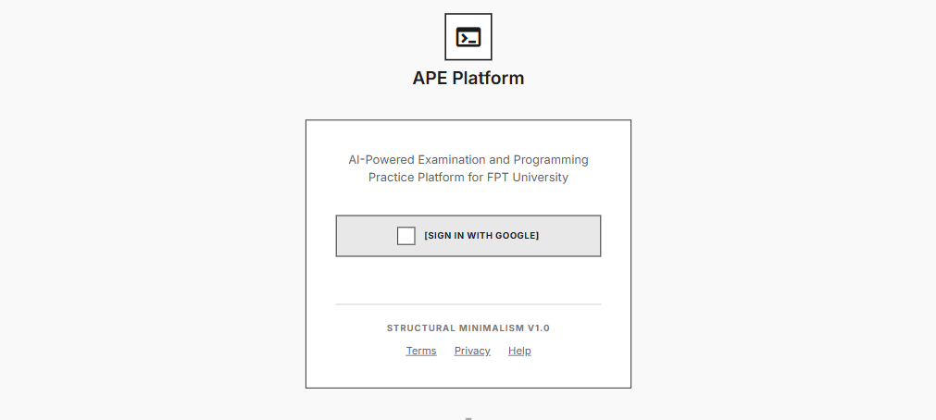

Related Use Cases: UC-16 (Login via Google SSO)
This screen is the entry point of the APE platform. It allows any user to:
- Authenticate via Google SSO: Click the "Sign in with Google" button to initiate OAuth 2.0 flow. User is redirected to Google's consent screen, then back to APE with an ID Token.
- View platform introduction: A brief tagline and feature highlights are displayed alongside the login button.
After successful authentication, the system verifies the Google ID Token, creates or retrieves the User record, issues a JWT, and redirects to the Home Dashboard.

Field Description:
Field Name | Description
App Logo | Display only. APE platform logo image.
Tagline | Display only. Text: "AI-Powered Examination and Programming Practice Platform for FPT University".
Sign in with Google (Button) | Primary CTA. Initiates Google OAuth 2.0 / OIDC flow. Redirects to Google consent screen. On success → JWT issued, redirect to Home Dashboard. On failure → display error MSG-03.
Error Message Area | Hidden by default. Displays error messages (e.g., MSG-02 session expired, MSG-03 unauthorized) in red text.

3.1.2 Profile Settings
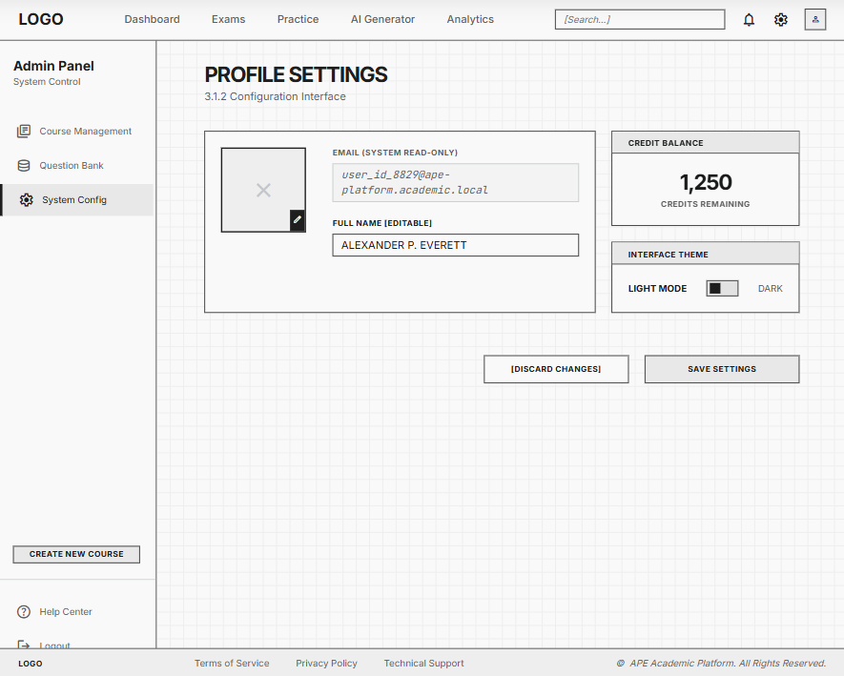

Related Use Cases: UC-17 (View Profile), UC-18 (Edit Profile)

This screen allows authenticated users (Student and Super Admin) to:
- View personal information: email (read-only from Google SSO), display name, avatar.
- Edit display name and avatar (max 2MB, JPG/PNG per BR-63).
- View current credit balance (real-time from UserAccounts.credit per BR-59).
- Toggle theme (Light / Dark mode).
Field Description:

Field Name | Description
Avatar | Display + editable. Image loaded from avatar_url. Click to change. Format: JPG/PNG, max 2MB (BR-63).
Email | Display only (read-only). String, sourced from Google SSO. Cannot be edited (BR-61).
Full Name | Editable text input. Data type: String, max 100 characters. Required.
Credit Balance | Display only. Integer. Current credit count from UserAccounts.credit. Updated in real-time (BR-59). Shows link to Purchase Credits (UC-20).
Theme Toggle | Switch control. Values: Light / Dark. Saves to localStorage. Default: Light.
Save Button | Saves profile changes. Validates required fields. On success → MSG "Profile updated successfully".

3.1.3 Subscription Management
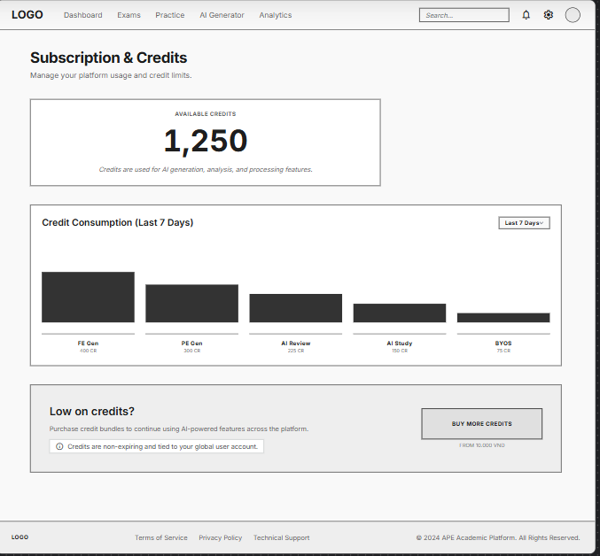

Related Use Cases: UC-20 (Purchase Credits)

This screen allows Students to:
- View current credit balance with visual indicator.
- View credit usage breakdown (last 7 days): FE Generation, PE Generation, AI Code Review, AI Study Advice, BYOS Processing.
- Navigate to Purchase Credits page (UC-20) to buy more credits.

Field Description:
Field Name | Description
Credit Balance | Display only. Integer from UserAccounts.credit. Large font, centered. Updated real-time.
Usage Chart | Display only. Bar chart showing credit consumption per feature over last 7 days. Sourced from APIUsageLogs aggregation.
Purchase Credits (Button) | Primary CTA. Navigates to Purchase Credits page (UC-20). Text: "Buy More Credits".

3.1.4 Practice History
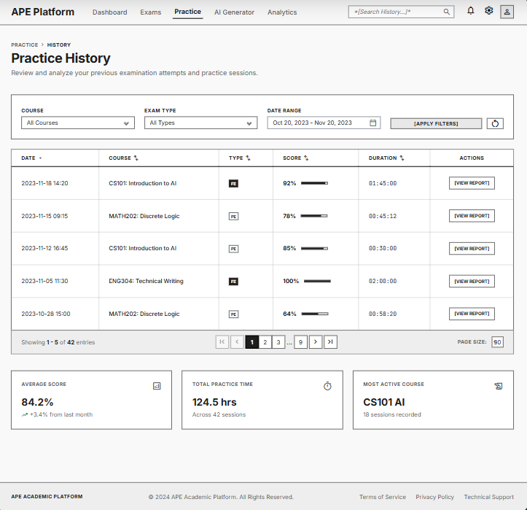

Related Use Cases: UC-19 (View Practice History)

This screen allows Students to:
- Browse past practice sessions with date, course, exam type, score, and duration.
- Filter by course, exam type (FE/PE), date range.
- Sort by date (default: newest first), score, or duration.
- Click a row to view detailed results (redirects to Result Viewer for PE, or summary for FE).
Field Description:

Field Name | Description
Filter: Course | Dropdown. Values: all active courses from Courses collection. Default: "All Courses".
Filter: Exam Type | Dropdown. Values: All, FE, PE. Default: "All".
Filter: Date Range | Date picker (from-to). Default: last 30 days.
Date | Display only. DateTime formatted as DD/MM/YYYY HH:mm. Sourced from PracticeSessions.start_time.
Course | Display only. Course name. Sourced via Exams.course_id → Courses.name.
Type | Display only. "FE" or "PE". Badge color: blue (FE), green (PE).
Score | Display only. For PE: Decimal (e.g., 80.0%). For FE: "X/Y correct" from fe_answers[].
Duration | Display only. Calculated: end_time - start_time, formatted as "Xm Ys".
Pagination | 20 rows per page (BR-65). Standard pagination controls.

3.2 FE-01: AI-Powered Data Ingestion & Vectorization

3.2.1 Data Ingestion Upload (Admin - System Level)
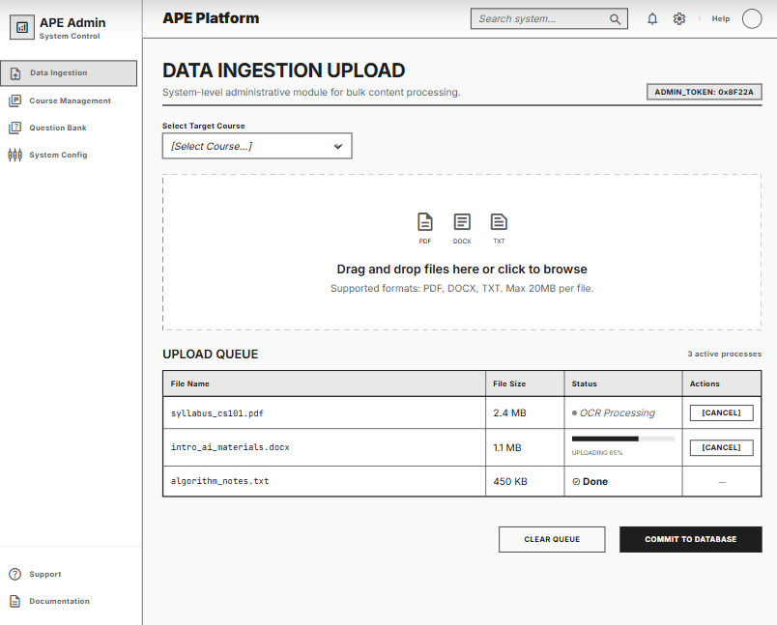

Related Use Cases: UC-22 (Upload System Syllabus)

This screen allows Super Admin to:
- Select target course from dropdown (only active courses).
- Upload official syllabus documents via drag-and-drop or file picker.
- View upload queue with real-time status per file (uploading → OCR processing → AI Gatekeeper → chunking → done).
- Cancel an in-progress upload.
After upload, files go through the Data Ingestion pipeline (OCR → Gatekeeper → Chunking → Tagging → Vectorization) and appear on the Data Approval & Preview screen.

Field Description:
Field Name | Description
Course Selector | Dropdown. Values: active courses from Courses collection (_id, name). Required.
File Upload Zone | Drag-and-drop area + "Browse" button. Accepted formats: PDF, DOCX, TXT. Max file size: 20MB (BR-01). Multiple files allowed.
Format Info | Display only. Text: "Supported formats: PDF, DOCX, TXT. Max 20MB per file."
Upload Queue Table
File Name | Display only. String, original filename.
File Size | Display only. Formatted as KB/MB.
Status | Display only. Progress indicator: Uploading → OCR Processing → Gatekeeper Check → Chunking → Done / Failed. Color-coded.
Action: Cancel | Button. Only visible when status = Uploading or Processing. Cancels the pipeline.

3.2.2 BYOS Upload (Student - Personal Materials)

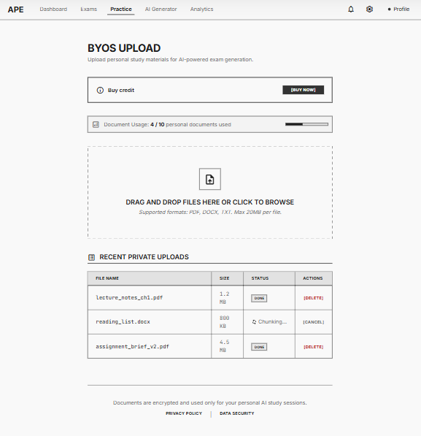
Related Use Cases: UC-01 (Upload Personal Materials), UC-02 (Preview Extracted Content)

This screen allows Students with sufficient credits to:
- Upload personal study materials for AI-powered exam generation from their own documents.
- View remaining upload quota (max 10 personal documents per BR-07).
- See upload status with same pipeline as Admin upload.
Students with insufficient credits see a message: "Insufficient credits for BYOS processing. Please purchase more credits." with link to Purchase Credits (UC-20). Students with BYOK API key bypass credit deduction (BR-08).

Field Name | Description
Credit Check Banner | Display only. If credit < BYOS cost: shows "Insufficient credits" message with link to Purchase Credits (UC-20). If BYOK configured: shows "BYOK Active" badge. Otherwise: hidden.
Document Count | Display only. Text: "X / 10 personal documents used". Sourced from Documents count where uploaded_by = current user (BR-07).
File Upload Zone | Drag-and-drop area. Same constraints as Admin upload: PDF, DOCX, TXT, max 20MB (BR-01). Disabled if quota reached (10/10) or insufficient credits.
Upload Queue | Same as Admin upload queue but visibility = Private. Documents stored with uploaded_by = current student (BR-06).

3.2.3 Data Approval & Preview
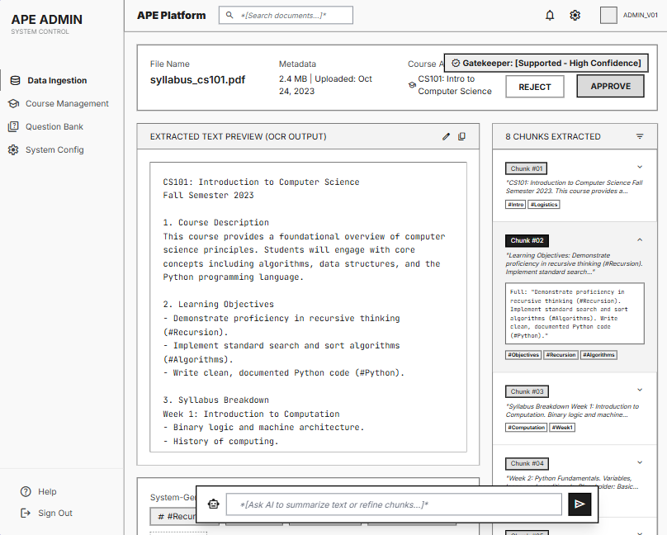
Related Use Cases: UC-03 (Preview Content), UC-04 (Approve/Reject)

This screen allows Super Admin (for system docs) or Student (for BYOS) to:
- Preview OCR-extracted text content from an uploaded document.
- View auto-generated topic tags as colored chips (e.g., #Array, #OOP, #Pointer).
- Browse individual chunks with expand/collapse.
- Edit extracted text manually (if Gatekeeper passed but content needs correction).
- Approve: finalizes the document, chunks become available for exam generation.
- Reject: marks document as rejected, chunks are NOT stored in Vector DB.
For BYOS documents, there is no Approve/Reject — auto-confirmed after vectorization.

Field Description:
Field Name | Description
Document Info | Display only. File name, size, upload date, uploaded by, course, Gatekeeper result (Supported/Rejected + reason).
Extracted Text Preview | Read-only text area (editable for Admin). Full OCR-extracted text. Scrollable.
Topic Tags | Display only. Colored chip components. Each tag = 1 auto-detected topic. Sourced from KnowledgeChunks.topic_tags[].
Chunk List | Accordion/collapsible list. Each item shows: chunk_order, first 100 chars preview, tags[]. Click to expand full content.
Chunk Count | Display only. Integer. "X chunks extracted".
Approve Button | Primary CTA (Admin only). Sets Documents.status = approved, KnowledgeChunks.status = Approved. MSG-10 on success.
Reject Button | Secondary CTA (Admin only). Sets Documents.status = rejected. Chunks not available for generation.

3.3 Data Approval & Preview

3.3.1 Course Management
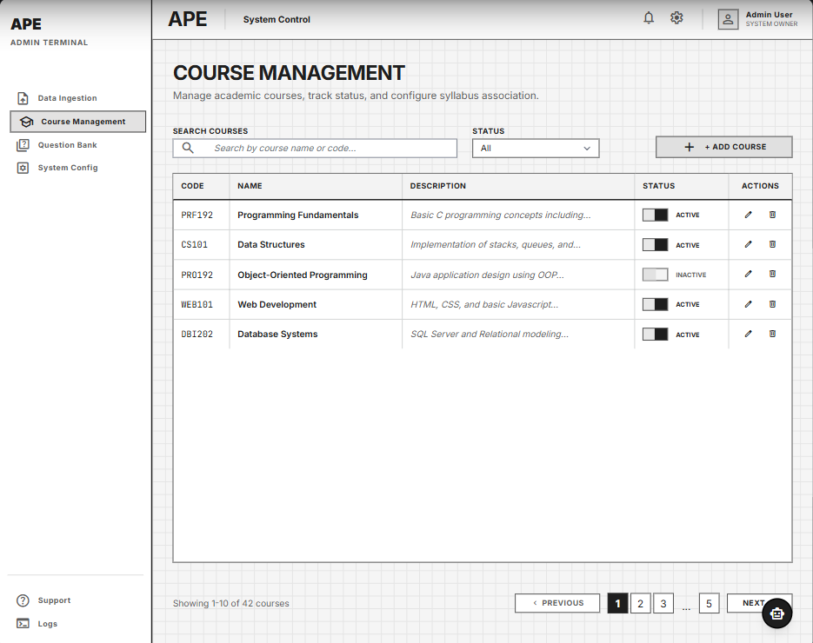
Related Use Cases: UC-26 (CRUD Course), UC-27 (Activate/Deactivate)

This screen allows Super Admin to:
- View all courses in a paginated table with search and status filter.
- Create a new course: opens inline form or modal with name, code, description fields.
- Edit existing course: click row to open edit form.
- Activate/Deactivate course: toggle status. Deactivated courses cannot be used for exam generation (MSG-41).
- Delete course: soft delete with confirmation dialog.

Field Description:
Field Name | Description
Search Bar | Text input. Searches by course name or code. Debounced 300ms.
Filter: Status | Dropdown. Values: All, Active, Inactive. Default: All.
Add Course (Button) | Opens creation form/modal.
Course Table Columns
Code (_id) | Display only. String. Primary key (e.g., "PRF192"). Unique, immutable after creation.
Name | Editable. String, max 200 chars. Required. E.g., "Programming Fundamentals".
Description | Editable. String, max 1000 chars. Nullable.
Status | Toggle switch. Boolean displayed as "Active" (green) / "Inactive" (gray). Default: Active.
Actions | Edit (pencil icon), Deactivate/Activate (toggle), Delete (trash icon with confirmation).
Pagination | 10 rows per page.

3.3.2 Question Bank Management

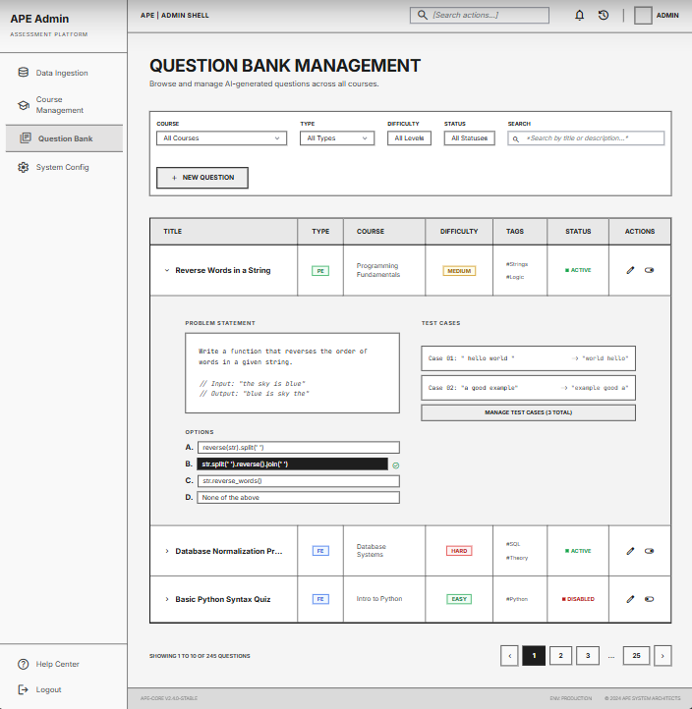
Related Use Cases: UC-28 (View/Edit/Disable Questions)

This screen allows Super Admin to:
- Browse all AI-generated questions in a centralized question bank.
- Filter by course, type (PE/FE), difficulty (Easy/Medium/Hard), status (active/disabled).
- View question details in expandable row (problem statement, options, test cases).
- Edit question content (title, description, options, correct answer).
- Disable problematic questions (censorship) — disabled questions do not appear in generated exams (MSG-40).
- Re-enable previously disabled questions.

Field Description:
Field Name | Description
Filter: Course | Dropdown. All courses. Default: All.
Filter: Type | Dropdown. Values: All, PE, FE. Default: All.
Filter: Difficulty | Dropdown. Values: All, Easy, Medium, Hard. Default: All.
Filter: Status | Dropdown. Values: All, Active, Disabled. Default: Active.
Search | Text input. Searches by title or description. Debounced 300ms.
Question Table Columns
Title | Display only. String. First 80 chars with ellipsis. Click to expand full content.
Type | Display only. Badge: "PE" (green) or "FE" (blue).
Course | Display only. Course name via course_id reference.
Difficulty | Display only. Badge: Easy (green), Medium (yellow), Hard (red).
Tags | Display only. Colored chips from topic_tags[].
Status | Display only. "Active" (green) / "Disabled" (red).
Actions | Edit (pencil icon → opens edit modal), Disable/Enable (toggle with confirmation).

3.4 FE-02: Dynamic Practice Exam Configuration & Generation

3.4.1 Exam Configuration (FE - Multiple Choice)

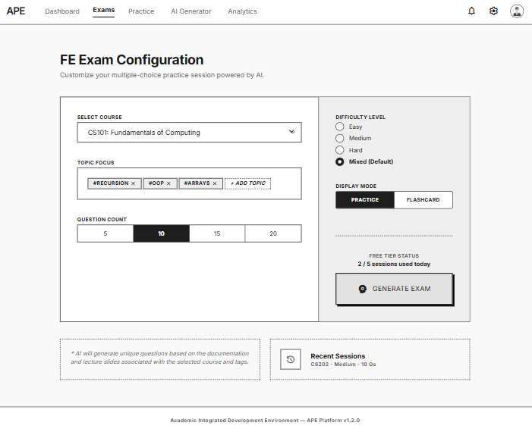
Related Use Cases: UC-03 (Generate FE Exam)
This screen allows Students to:
- Select course for FE practice.
- Choose topic tags to focus on (multi-select from available tags in the course).
- Set difficulty level (Easy / Medium / Hard / Mixed).
- Set question count (5, 10, 15, or 20).
- Select display mode: Practice (MCQ with scoring) or Flashcard (card flip for review).
- View estimated credit cost for the selected configuration (BR-09).
- Click Generate to trigger the AI Actor-Critic pipeline. Credits are deducted upon successful generation.
Students with insufficient credits are prompted to purchase more (redirects to UC-20).

Field Description:

Field Name | Description
Course Selector | Dropdown. Values: active courses with approved KnowledgeChunks. Required.
Topic Tags | Multi-select chips. Values: distinct topic_tags from KnowledgeChunks where course_id = selected course. Optional (empty = all topics).
Difficulty | Radio group or slider. Values: Easy, Medium, Hard, Mixed. Default: Mixed.
Question Count | Button group. Values: 5, 10, 15, 20. Default: 10.
Display Mode | Toggle switch. Values: Practice (default) / Flashcard.
Credit Cost Display | Display only. Estimated credit cost based on selected question count (BR-09). E.g., "Estimated cost: ~1 credit". If BYOK active: shows "BYOK Active — no credit cost".
Generate Exam (Button) | Primary CTA. Disabled if insufficient credits (and no BYOK). Triggers FE Generator pipeline (BR-10, BR-11). Shows loading spinner (~20s). On success → redirect to Practice MCQ or Flashcard based on mode.

3.4.2 Exam Configuration (PE - Coding)
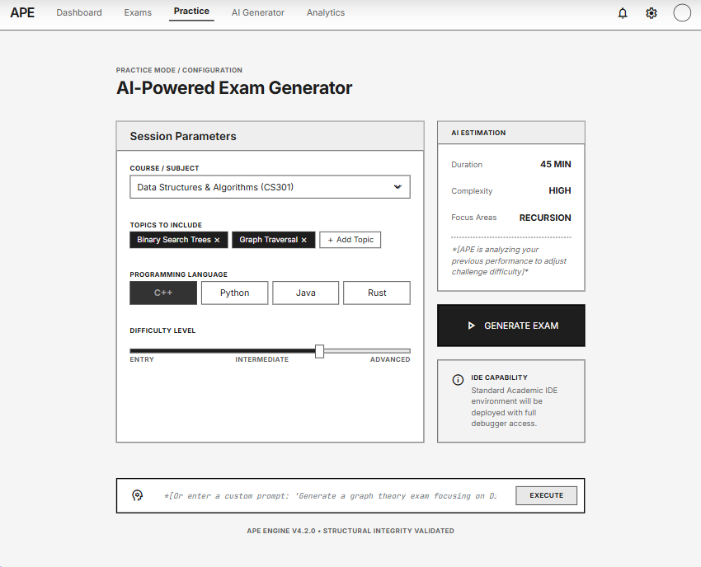
Related Use Cases: UC-06 (Configure & Generate PE Exam)

This screen allows Students to:
- Select course for PE practice.
- Choose topic tags.
- Set difficulty level.
- Select programming language (C, C++, Java, Python).
- Click Generate to trigger the PE Hybrid Validation pipeline (Generator → Critic → Judge0).
Estimated generation time: up to 60 seconds. Loading indicator shown.

Field Description:
Field Name | Description
Course Selector | Dropdown. Active courses with approved content. Required.
Topic Tags | Multi-select chips. Same as FE config. Optional.
Difficulty | Radio group. Values: Easy, Medium, Hard. Required. Default: Medium.
Language | Dropdown. Values: C, C++, Java, Python (BR-16). Required. Default: Java.
Generate Problem (Button) | Primary CTA. Triggers PE Generator pipeline. Shows loading with progress: "Generating... → Validating... → Compiling...". Timeout: 60s. On success → redirect to Practice Coding Space. On failure → MSG-16.

3.4.3 Practice MCQ Space

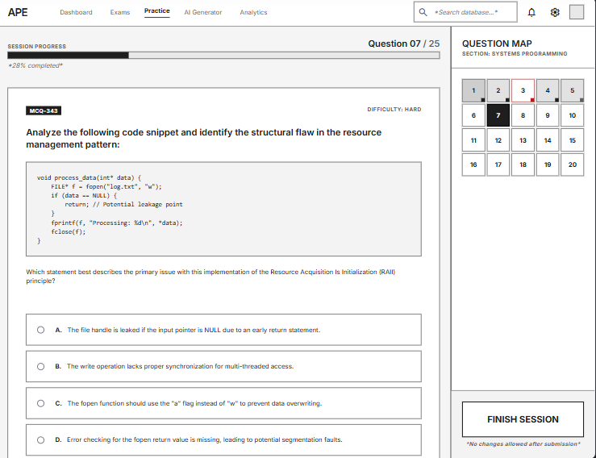
Related Use Cases: UC-07 (Practice Multiple Choice)

This screen allows Students to:
- Read the question and select one answer from 4 options (A, B, C, D).
- Click Check Answer to verify: correct answer highlighted green, wrong answer highlighted red, explanation shown.
- Navigate between questions using Previous/Next or question number sidebar.
- View progress bar showing completed/remaining questions.
- Upon completing all questions: view summary (X/Y correct) and save fe_answers[] to PracticeSessions.

Field Description:
Field Name | Description
Question Text | Display only. String from QuestionsBank.description. Supports Markdown rendering.
Options (A/B/C/D) | Radio group. 4 options from QuestionsBank.options[]. One selectable at a time.
Check Answer (Button) | Validates selected answer against QuestionsBank.correct_answer. Shows green/red highlight + explanation panel.
Explanation Panel | Hidden until Check Answer clicked. Shows QuestionsBank.explanation. Collapsible.
Progress Bar | Display only. "Question X of Y". Visual bar showing completion %.
Question Navigator | Sidebar with numbered buttons (1, 2, 3...). Color: gray (not attempted), green (correct), red (wrong).
Finish Button | Appears when all questions answered. Saves fe_answers[] to PracticeSessions. Shows summary: "Correct: X/Y (Z%)".

3.4.4 Flashcard Viewer

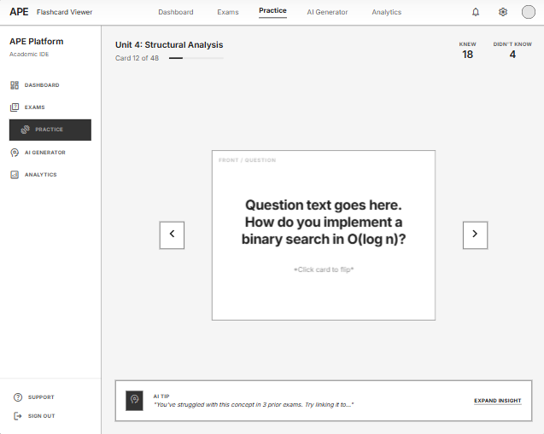
Related Use Cases: UC-08 (View Flashcard)

This screen allows Students to:
- View one flashcard at a time: front shows question text.
- Tap/click card to flip: back shows correct answer + explanation.
- Swipe or use arrows to navigate between cards.
- View progress: "Card X of Y".

Field Description:
Field Name | Description
Card Front | Display only. Question text from QuestionsBank.description. Large font, centered.
Card Back | Display only (shown after flip). Correct answer highlighted + explanation text.
Navigation | Swipe gesture or arrow buttons (← →). Sequential order.
Progress Counter | Display only. "Card X of Y". Also shows "Knew: A | Didn't Know: B" running count.

3.5 FE-03: Isolated Exam Workspace & Judge0 Auto-Grading

3.5.1 Practice Coding Space (Web IDE)
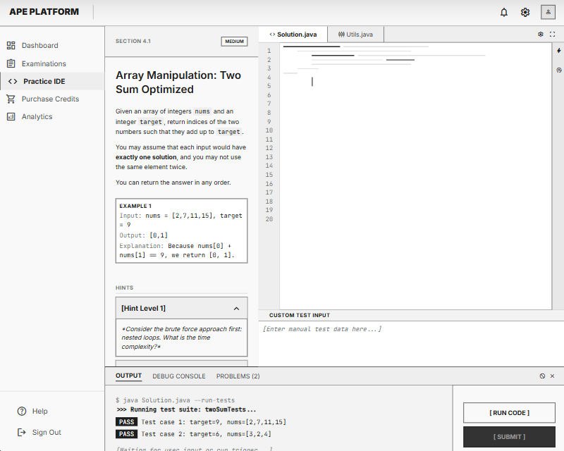
Related Use Cases: UC-07 (Practice Coding)
This screen allows Students to:
- Read problem statement, constraints, and sample I/O on the left panel.
- Write/edit code in Monaco Editor (syntax highlighting, auto-complete) on the right panel.
- Support multi-file editing for Java/C++ (tab per file from skeleton_code[]; files with is_readonly = true are locked).
- Run code with custom test input (unlimited, free — BR-21).
- Submit code for auto-grading against all official test cases (BR-22). Debounce on Submit button (BR-24).
- View execution output (stdout/stderr) in console panel below the editor.
- Resubmit creates new Submission record; final grading uses latest submission (BR-23).

Field Description:
Field Name | Description
Problem Title | Display only. String from QuestionsBank.title.
Problem Description | Display only. Markdown rendered from QuestionsBank.description.
Difficulty Badge | Display only. Easy/Medium/Hard with color.
File Tabs | Tab per file from skeleton_code[]. Tab label = filename. Read-only files show lock icon.
Code Editor | Monaco Editor component. Language auto-set from QuestionsBank.language. Initial content from skeleton_code[].content.
Custom Test Input | Text area below editor. User enters custom stdin input for "Run" mode.
Console Output | Read-only text area. Shows stdout/stderr from Judge0 execution. Scrollable, monospace font.x
Run Button | Sends code + custom input to Judge0 (single test). Result shown in console. Unlimited uses, no credit cost (BR-21).
Submit Button | Sends code against ALL official test cases. Debounced (BR-24). On success → redirect to Result Viewer («include» UC-09). Shows loading: "Grading...".

3.5.2 Result Viewer

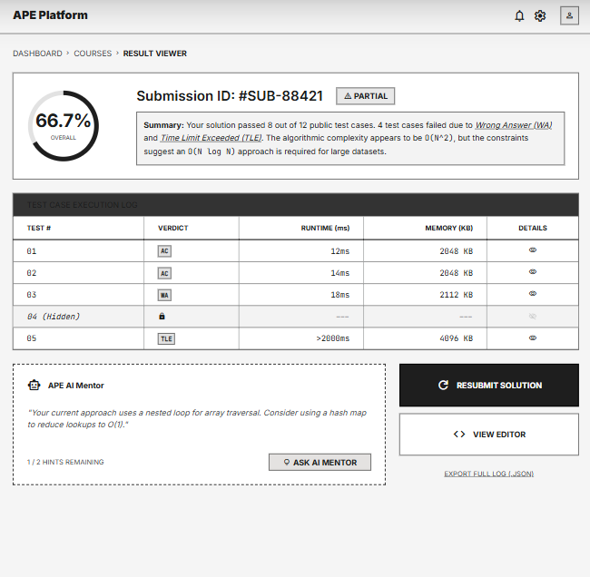
Related Use Cases: UC-11 (View Submission Result)

This screen allows Students to:
- View overall score and pass/fail status after submission.
- View per-test-case results: verdict (AC/WA/TLE/RTE), runtime (ms), memory (KB).
- Hidden test cases show verdict but NOT expected output (to prevent reverse engineering).
- Click "Ask AI Mentor" for debugging hints (max 2/session — BR-24).
- Click "Resubmit" to return to Practice Coding Space and try again.

Field Description:
Field Name | Description
Overall Score | Display only. Decimal %. Visual progress bar: green (100%), yellow (50-99%), red (<50%). E.g., "Score: 66.7% (2/3 test cases passed)".
Status Badge | Display only. Values: AC (all passed, green), Partial (yellow), Failed (red).
Test Cases Table
Test # | Display only. Integer index (1, 2, 3...).
Verdict | Display only. Values: AC (green), WA (red), TLE (orange), RTE (purple). Badge style.
Runtime | Display only. Integer in ms. From Submissions.runtime_ms.
Memory | Display only. Integer in KB. From Submissions.memory_kb.
Hidden Flag | Display only. Lock icon if QuestionsBank.test_cases[].is_hidden = true. Expected output not shown.
Actions
Ask AI Mentor (Button) | Enabled if mentor_hints_used < 2. Shows remaining count: "X hints remaining". On click → opens AI Code Mentor Dialog. Disabled with tooltip if limit reached (MSG-28).
Resubmit (Button) | Returns to Practice Coding Space with previous code pre-loaded.

3.5.3 AI Code Review Dialog
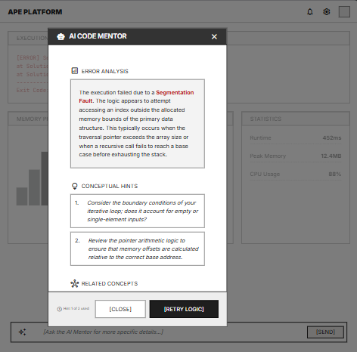
Related Use Cases: UC-10 (Request AI Code Mentor)

Related Use Cases: UC-08 (Request AI Code Review)
This screen (modal overlay) allows Students to:
- View AI-generated code quality review based on their submitted code and Judge0 results.
- Read structured feedback: Error Analysis (what went wrong), Code Quality Score (x/10 with specific issues), Improvement Suggestions (actionable recommendations), Related Concepts (topics to review).
- AI Code Review NEVER reveals solution code (BR-26). Backend filters/redacts any complete code from AI response.
- Review costs credits (~1–2 per request, BR-28). If LLM fails, credits NOT deducted (BR-29).
- Close dialog and return to Result Viewer or Practice Coding Space to modify and resubmit.

Field Description:
Field Name | Description
Error Analysis | Display only. Text section describing detected logic/syntax errors. E.g., "Off-by-one error detected at array traversal logic". Sourced from LLM Tier 2 response (BR-27).
Code Quality Score | Display only. Score x/10 with list of specific issues. E.g., "7/10 — Issues: Nested loops can be optimized, Missing edge case handling".
Improvement Suggestions | Display only. Numbered list of actionable suggestions. E.g., "1. Consider using HashMap for O(1) lookup. 2. Add null check for input." NO solution code (BR-26).
Related Concepts | Display only. Tag chips linking to topics. E.g., #TimeComplexity, #HashMap. Clickable → redirects to Exam Config with tag pre-selected.
Review Counter | Display only. "Review X of 2 used this session" (BR-25).
Close Button | Closes modal. Returns to previous screen.

3.6 FE-04: Knowledge Analytics & AI Study Advice

3.6.1 Knowledge Analytics Dashboard
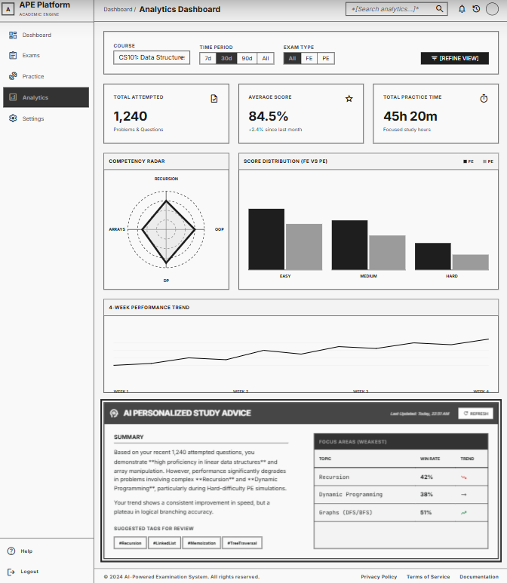
Related Use Cases: UC-13 (View Competency Assessment), UC-15 (View Summary Statistics)

This screen allows Students to:
- View Competency Radar Chart: spider/radar chart showing competency % per topic tag. Data from UserAnalytics.topic_stats[].
- View Score Distribution: bar chart grouping scores by difficulty (Easy/Medium/Hard).
- View Progress Timeline: line chart showing score trend over the past 4 weeks.
- Filter by course, time period (7d / 30d / 90d / All), exam type (FE/PE).
- View summary stats: total problems attempted, average score, total practice time.

Requires minimum 3 completed sessions (BR-28). If insufficient → shows MSG-30 with placeholder chart.

Field Description:
Field Name | Description
Filter: Course | Dropdown. All courses. Default: All.
Filter: Time Period | Button group. Values: 7 days, 30 days, 90 days, All time. Default: 30 days.
Filter: Exam Type | Toggle. Values: All, FE only, PE only. Default: All.
Summary Stats Cards
Total Attempted | Display only. Integer. Total submissions (PE) + total FE questions answered.
Average Score | Display only. Decimal %. Weighted by difficulty (BR-29).
Total Practice Time | Display only. Formatted as "Xh Ym". Sum of all session durations.
Charts
Competency Radar | Radar/Spider chart. Axes = topic tags. Values = win_rate from UserAnalytics.topic_stats[]. Range 0-100%.
Score Distribution | Grouped bar chart. X-axis: Easy/Medium/Hard. Y-axis: average score %. Separate bars for FE vs PE.
Progress Timeline | Line chart. X-axis: dates. Y-axis: average score per day. Separate lines for FE/PE.

3.6.2 AI Study Advice Panel
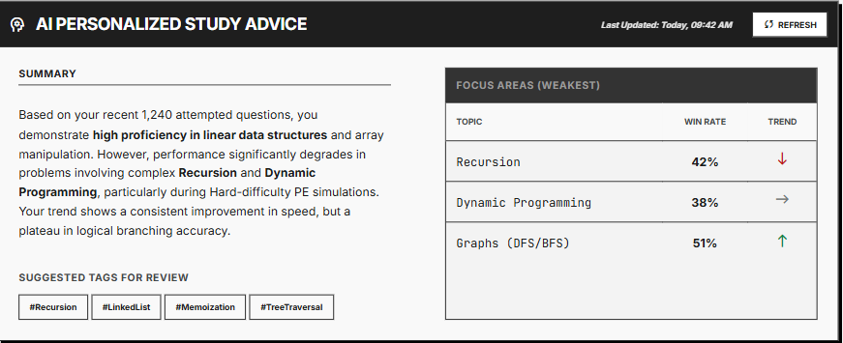
Related Use Cases: UC-14 (Request AI Study Advice)

This screen (embedded panel in Analytics Dashboard) allows Students to:
- View personalized AI-generated study advice based on their analytics data.
- See weak areas identified by AI and recommended focus topics.
- Click suggested topic tags to start a new practice session targeting that topic (redirects to Exam Config with tag pre-selected).
- Refresh advice manually (triggers hybrid recalculation).
Advice is stored in UserAnalytics.ai_study_advice and cached for fallback (BR-32).

Field Description:
Field Name | Description
Advice Text | Display only. String from UserAnalytics.ai_study_advice. Markdown rendered. E.g., "Your Array skills are strong (85%), but Recursion needs work (42%). Focus on..."
Weak Areas | Display only. List of topics with low win_rate. Each shows: topic name, current %, trend arrow (↑ improving / ↓ declining).
Suggested Tags | Clickable chips. E.g., #Recursion, #LinkedList. On click → redirect to Exam Config (FE or PE) with tag pre-selected.
Refresh Advice (Button) | Triggers on-demand recalculation + new AI advice generation. Shows loading spinner. On success → updates advice text.
Last Updated | Display only. DateTime. Shows when advice was last generated. E.g., "Updated: 12/06/2026 08:30".

3.7 FE-05: Gamification & Engagement System

3.7.1 Streak & Badges
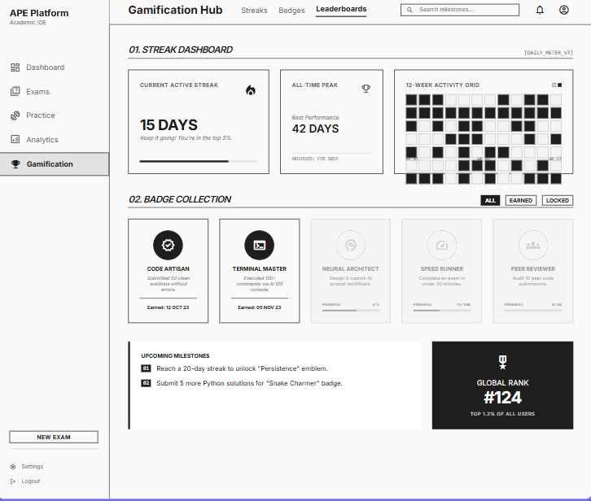
Related Use Cases: UC-16 (Track Daily Streak), UC-17 (View Badge Collection)

This screen allows Students to:
- View current streak and highest streak with fire animation.
- See calendar heatmap showing practice days (green = practiced, gray = missed).
- Browse badge collection: earned badges shown in full color, unearned in grayscale with progress bar.
- Click a badge to view criteria details.

Field Description:
Field Name | Description
Current Streak | Display only. Integer from Users.current_streak. Fire icon animation if > 0. Text: "X days".
Highest Streak | Display only. Integer from Users.highest_streak. Trophy icon. Text: "Best: X days".
Calendar Heatmap | Display only. 12-week grid. Green cells = days with at least 1 PracticeSession. Gray = no activity. Sourced from PracticeSessions.start_time dates.
Badge Collection Grid
Badge Card | Display per badge. Shows: icon, name, description. Earned = full color + earned_at date. Unearned = grayscale + progress bar (e.g., "45/100 problems solved").
Badge Criteria | Tooltip/modal on click. Shows detailed criteria. E.g., "Solve 100 PE problems" or "Maintain a 7-day streak".

3.7.2 Leaderboard
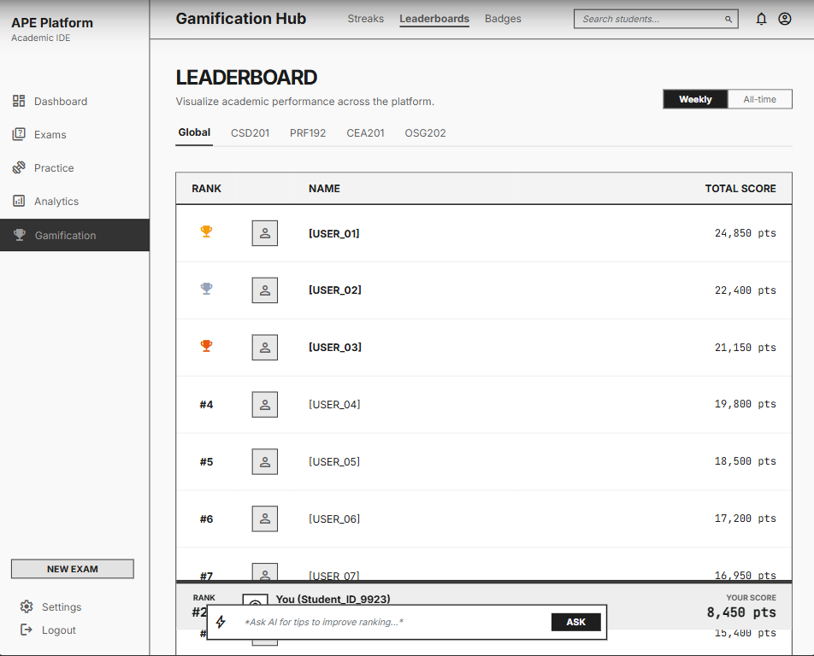
Related Use Cases: UC-18 (View Leaderboard)

This screen allows Students and Super Admin to:
- View course-specific or global leaderboard.
- Switch between weekly and all-time rankings.
- See own position highlighted in the table.
- Click peer name to view their public profile (limited info).

Field Description:
Field Name | Description
Scope Tab | Tab control. Values: per-course tabs (PRF192, CSD201, etc.) + "Global". Default: Global.
Period Toggle | Button group. Values: Weekly, All-time. Default: Weekly.
Ranking Table
Rank (#) | Display only. Integer position. Top 3 shown with gold/silver/bronze icon.
Avatar | Display only. Small circular image from Users.avatar_url.
Name | Display only. Users.full_name.
Total Score | Display only. Decimal from Leaderboard.total_score.
Current User Row | Highlighted with accent color background. Always visible (sticky if outside top N). Shows: "You are ranked #X".
Pagination | 20 rows per page. Show top 100.

3.8 FE-06: Advanced AI Configurator

3.8.1 System Prompts Management
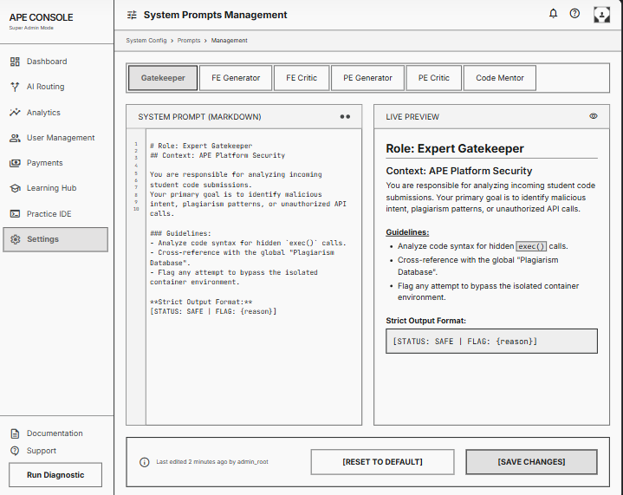
Related Use Cases: UC-19 (Manage System Prompts)

This screen allows Super Admin to:
- View all system prompts grouped by task type (Gatekeeper, FE Generator, FE Critic, PE Generator, PE Critic, Code Mentor).
- Edit prompt text in a large text area with Markdown preview.
- Save changes (updates AIConfigs.system_prompt).
- Reset to default prompt template.
Field Description:
Field Name | Description
Task Type Selector | Tab or sidebar list. Values: Gatekeeper, FE Generator, FE Critic, PE Generator, PE Critic, Code Mentor. Sourced from AIConfigs.task_type.
Prompt Editor | Large text area (min 10 rows). Content from AIConfigs.system_prompt. Supports Markdown.
Preview Panel | Live Markdown preview of the prompt. Side-by-side with editor.
Save Button | Saves to AIConfigs collection. Audit logged.
Reset to Default | Reverts prompt to hardcoded default. Confirmation dialog required.

3.8.2 AI Model & Routing Configuration

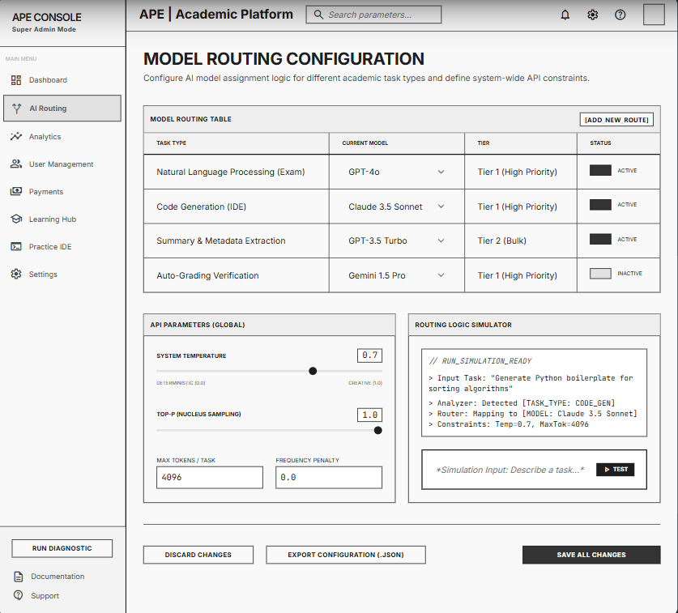
Related Use Cases: UC-20 (Configure AI Model Routing)

This screen allows Super Admin to:
- View current model assignments: which LLM model handles each task type.
- Change model assignment per task (e.g., switch FE Generator from GPT-4o-mini to Gemini 1.5 Flash).
- Set tier routing rules: Tier 1 tasks vs Tier 2 tasks.
- Toggle default BYOK behavior.

Field Description:
Field Name | Description
Model Routing Table
Task Type | Display only. Values: Gatekeeper, Auto-Tagging, FE Generator, FE Critic, PE Generator, PE Critic, Code Mentor, Study Advice.
Current Model | Dropdown. Values: GPT-4o-mini, GPT-4o, Gemini 1.5 Flash, Gemini 1.5 Pro. Sourced from AIConfigs.model_name.
Tier | Display only (derived). Tier 1 (fast/cheap) or Tier 2 (deep/expensive). Auto-set based on model selection.
Is Active | Toggle. Boolean from AIConfigs.is_active. Inactive configs are skipped.
Save All (Button) | Saves all changes to AIConfigs. Audit logged.

3.8.3 API Parameters Configuration
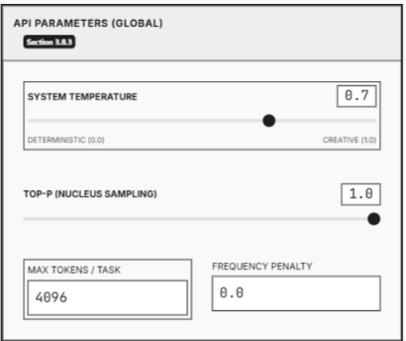
Related Use Cases: UC-21 (Customize API Parameters)

This screen allows Super Admin to:
- Adjust temperature and max_tokens per task type.
- View current parameter values in a table.
- Save changes.

Field Description:
Field Name | Description
Parameters Table
Task Type | Display only. Same list as Model Routing.
Temperature | Slider or number input. Range: 0.0 - 2.0. Step: 0.1. Default varies by task. From AIConfigs.temperature.
Max Tokens | Number input. Range: 100 - 16000. Default varies by task. From AIConfigs.max_tokens.
Save Button | Saves updated parameters. Audit logged.

3.9 FE-07: System Dashboard & User Management

3.9.1 Traffic Analytics Dashboard

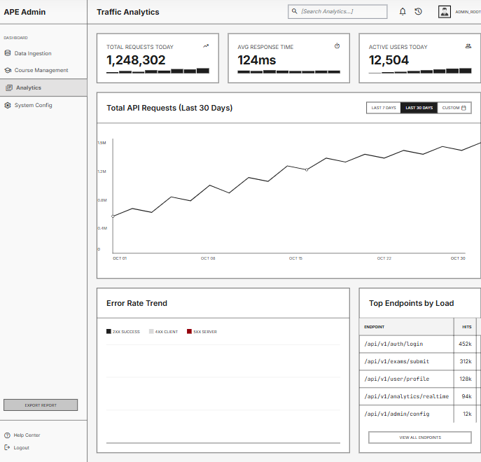
Related Use Cases: UC-22 (View Traffic Analytics)

This screen allows Super Admin to:
- View total API requests per day (line chart, last 30 days).
- View error rate trend (bar chart, grouped by HTTP status code).
- View summary cards: total requests today, average response time (ms), active users today.
- Filter by date range.

Field Description:
Field Name | Description
Date Range Filter | Date picker (from-to). Default: last 7 days.
Total Requests Card | Display only. Integer. Today's total API requests.
Avg Response Time Card | Display only. Integer (ms). Average across all endpoints.
Active Users Card | Display only. Integer. Distinct users with activity today.
Requests Chart | Line chart. X-axis: dates. Y-axis: request count.
Error Rate Chart | Stacked bar chart. X-axis: dates. Y-axis: count. Segments: 2xx, 4xx, 5xx.

3.9.2 User Analytics Dashboard

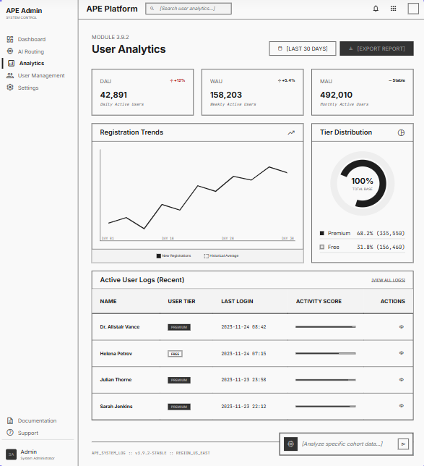
Related Use Cases: UC-41 (View User Analytics)
This screen allows Super Admin to:
- View new user registrations per day (line chart).
- View feature adoption rates: % users who used FE, PE, BYOS, AI Code Review.
- View active user metrics: DAU (BR-115), WAU, MAU (BR-116).
Field Description:

Field Name | Description
Registrations Chart | Line chart. X-axis: dates. Y-axis: new users count.
Feature Adoption | Bar chart or table. Shows % of users who used each feature (FE, PE, BYOS, AI Code Review, Study Advice).
DAU/WAU/MAU Cards | 3 cards showing Daily Active Users (BR-115), Weekly Active Users, Monthly Active Users (BR-116).

3.9.3 API Cost Tracker
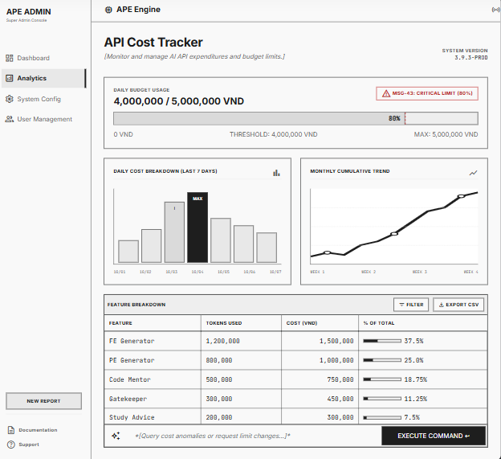
Related Use Cases: UC-24 (View API Cost Tracker)

This screen allows Super Admin to:
- View daily AI API cost in VND (bar chart).
- View cumulative cost trend (line chart).
- See budget limit indicator (progress bar: current spend vs daily limit from BR-35).
- View per-feature cost breakdown (table: feature, tokens used, cost VND).
- Receive visual warning when nearing budget limit (MSG-43 at 80%, MSG-44 at 100%).

Field Description:
Field Name | Description
Daily Cost Chart | Bar chart. X-axis: dates. Y-axis: cost in VND. Color: green (under budget), yellow (>80%), red (exceeded).
Budget Progress Bar | Visual bar. Shows: current daily spend / daily limit. Color changes at 80% and 100% thresholds.
Feature Breakdown Table
Feature | Display only. Values: FE Generator, PE Generator, Code Mentor, Gatekeeper, Study Advice, etc.
Tokens Used | Display only. Integer. Sum of APIUsageLogs.tokens_in + tokens_out per feature.
Cost (VND) | Display only. Decimal. Sum of APIUsageLogs.cost_vnd per feature.
% of Total | Display only. Percentage of total daily cost.

3.9.4 User Management
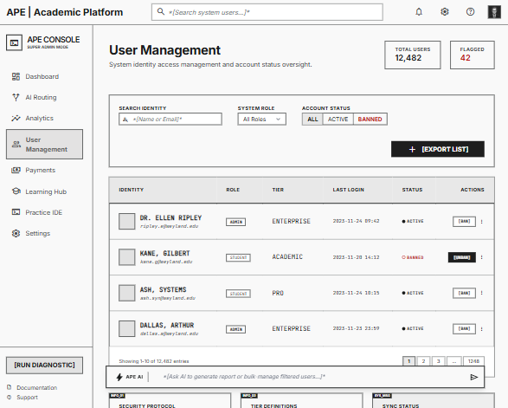
Related Use Cases: UC-25 (Manage User Accounts)
This screen allows Super Admin to:
- Browse all users with search and filters (UC-43). Pagination: 20/page (BR-120).
- View user details: email, role, credit balance, registration date, last login.
- Ban a user: user cannot log in (UC-44). Ban reason mandatory (BR-122). Super Admin cannot be banned (BR-123). Sessions invalidated immediately (BR-124).
- Unban a previously banned user (UC-45).
- Assign custom AI model to a user (UC-46), overriding system routing (BR-127).
Field Description:

Field Name | Description
Search | Text input. Searches by name or email. Debounced 300ms.
Filter: Role | Dropdown. Values: All, Student, SuperAdmin. Default: All.
Filter: Status | Dropdown. Values: All, Active, Banned. Default: All.
Full Name | Display only. String from Users.full_name.
Email | Display only. String from Users.email.
Role | Display only. Badge: Student (blue), SuperAdmin (purple).
Credit Balance | Display only. Integer from UserAccounts.credit.
Status | Display only. "Active" (green) / "Banned" (red).
Last Login | Display only. DateTime.
Actions | Ban/Unban toggle (UC-44/UC-45, with confirmation + reason), Assign AI Model (UC-46, dropdown modal).

3.10 Payment Management

3.10.1 Purchase Credits

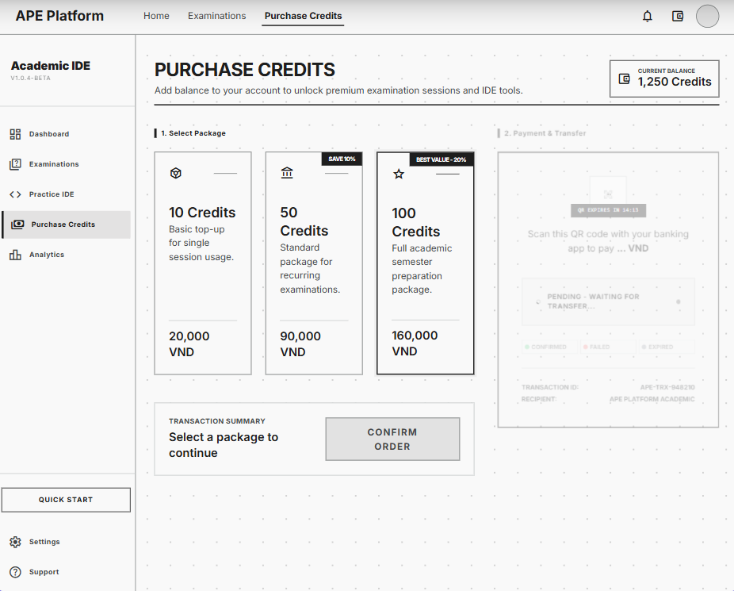
Related Use Cases: UC-20 (Purchase Credits)
This screen allows Students to:
- View current credit balance.
- Select credit package: preset packages (e.g., 10 credits = 20,000 VND, 50 credits = 90,000 VND, 100 credits = 160,000 VND). Packages predefined by Admin (BR-66).
- Initiate payment via Payment API: QR code generated for bank transfer (BR-67).
- View real-time transaction status (pending → confirmed / failed / expired). Transaction timeout = 15 minutes (BR-69).
- On success: credits added to balance, confirmation displayed. Webhook verified with HMAC-SHA256 (BR-68).
Field Description:

Field Name | Description
Credit Balance | Display only. Integer from UserAccounts.credit.
Package Selector | Button group. Credit packages predefined by Admin (BR-66). E.g., 10/50/100 credits with VND prices.
Confirm Purchase (Button) | Initiates payment. Creates Transaction record (status=pending). Calls Payment API → generates QR code.
QR Code Display | Image generated by Payment API. Shown after confirm. User scans with banking app.
Transaction Status | Real-time status: Pending (yellow spinner) → Confirmed (green checkmark) / Failed (red) / Expired (gray, after 15min per BR-69). Updated via webhook.

3.10.2 Purchase History

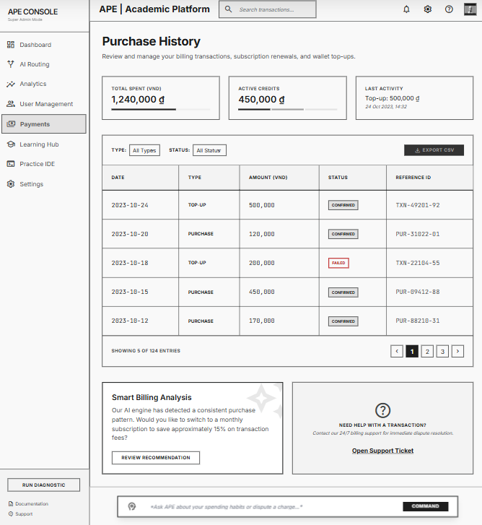
Related Use Cases: UC-35 (View Purchase History)

This screen allows Students and Super Admin to:
- Browse past transactions: top-ups and purchases.
- Filter by type (top-up / purchase) and status (confirmed / pending / failed).
- Sort by date (newest first) or amount.
- View transaction details: payment API reference ID for troubleshooting.

Field Description:
Field Name | Description
Filter: Type | Dropdown. Values: All, Top-up, Purchase. Default: All.
Filter: Status | Dropdown. Values: All, Confirmed, Pending, Failed. Default: All.
Transaction Table
Date | Display only. DateTime from Payments.created_at. Formatted DD/MM/YYYY HH:mm.
Type | Display only. Badge: "Top-up" (blue), "Purchase" (green).
Amount | Display only. Decimal formatted as VND. Positive for top-up, negative for purchase.
Status | Display only. Badge: Confirmed (green), Pending (yellow), Failed (red).
Reference | Display only. String from Payments.payment_api_ref. Copyable.
Pagination | 10 rows per page.

3.10.3 Payment Troubleshooting (Admin)

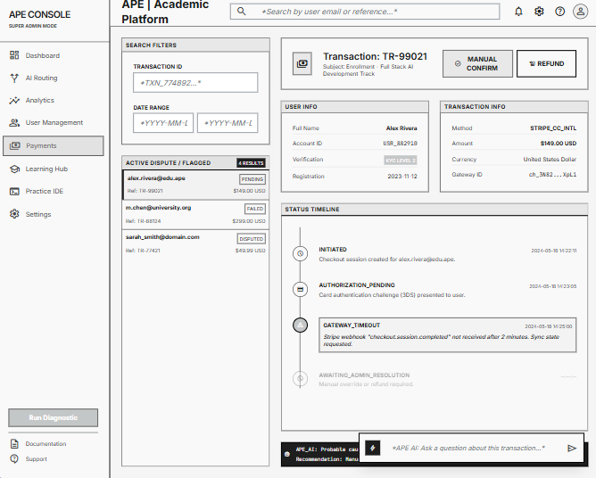
Related Use Cases: UC-36 (Troubleshoot Payment)

This screen allows Super Admin to:
- Search transactions by user email or payment API reference ID.
- View full transaction details including timestamps, status changes, and Payment API response.
- Manually confirm a stuck pending transaction.
- Initiate refund for a failed/disputed transaction.
All actions are audit logged.

Field Description:
Field Name | Description
Search | Text input. Searches by user email or payment_api_ref. Debounced 300ms.
Transaction Detail Panel
User Info | Display only. User's full_name, email, current tier, wallet balance.
Transaction Info | Display only. All Payments fields: type, amount, status, payment_api_ref, created_at.
Status Timeline | Display only. Visual timeline showing status changes with timestamps.
Manual Confirm (Button) | Forces status = confirmed and credits wallet. Confirmation dialog required. Audit logged.
Refund (Button) | Forces status = refunded and debits wallet (if already credited). Calls Payment API refund endpoint. Audit logged.

4. Non-Functional Requirements

4.1 External Interfaces

System | Provider | Purpose | Protocol | Auth / Notes
Judge0 API | Judge0 (Docker) | Code execution sandbox for PE grading. APE sends source code + inputs, receives stdout/stderr per test case. | HTTPS / REST | API Key in header. Hard timeout 30s/call. Supports: C, C++, Java, Python.
LLM Cloud Service (Tier 1) | Google Gemini 1.5 Flash / GPT-4o-mini | AI Gatekeeper classification, Auto-Tagging, FE MCQ generation (Actor-Critic). Fast & cost-efficient. | HTTPS / REST | Bearer token (API Key). Managed via AI Configurator. BYOK supported.
LLM Cloud Service (Tier 2) | Google Gemini 1.5 Pro / GPT-4o | PE Generator (Generator+Critic Agents), AI Code Mentor (AST/Semantic analysis). Deep reasoning tasks. | HTTPS / REST | Bearer token (API Key). Token budget enforced. BYOK supported.
OCR Cloud Service | Google Cloud Vision / Azure OCR | Extracts plain text from uploaded raw documents (PDF/DOCX/scanned images) before AI processing. | HTTPS / REST | Service Account / API Key. Returns structured text strings.
Payment API | VNPay / MoMo | Handles Premium Tier purchase and Top-up wallet transactions. APE sends QR generation requests; receives payment status webhook. | HTTPS / REST + Webhook | HMAC-SHA512 signature verification on webhook. Idempotency key on each transaction.
Google SSO | Google OAuth 2.0 | User authentication. APE redirects to Google Login, receives ID Token, verifies via Google public keys, creates/updates User record. | OAuth 2.0 / OIDC | ID Token verified with Google public keys. JWT issued by APE after verification.
Vector Database | Pinecone / Qdrant | Stores and queries vector embeddings of text chunks for RAG-based exam generation. | HTTPS / gRPC | API Key. Namespace isolation: system vs. per-user (BYOS).

4.2 Quality Attributes

4.2.1 Usability

Attribute | Requirement
Learnability | A new student user with no prior APE experience must be able to complete their first practice exam (FE type) within 5 minutes of first login, without requiring any documentation.
Responsive Design | All screens must be fully functional on desktop (1920×1080), laptop (1366×768), and tablet (768×1024) viewports. Mobile (< 480px) is supported in read-only mode.
Language | The system interface is in English. AI-generated content (questions, hints, advice) is generated based on the language of the source syllabus document.
Accessibility | Color contrast ratio ≥ 4.5:1 (WCAG AA). All interactive elements have ARIA labels. Keyboard navigation supported on all core screens.
Error Feedback | All form validation errors are displayed inline next to the relevant field within 200ms. System errors (AI timeout, Judge0 failure) display user-friendly messages with retry guidance, never raw stack traces.
Loading States | All AI generation operations (FE/PE exam, AI Mentor, Study Advice) display a loading indicator with estimated wait time. Operations exceeding 15s display a progress message.
Onboarding | First-time users are guided through a 3-step onboarding flow: (1) Select subscription tier, (2) Choose a course, (3) Generate first practice exam.

4.2.2 Performance

Metric | Target / Constraint
Page Load Time | Initial page load ≤ 2 seconds (FCP) on a 10 Mbps connection. Subsequent navigation ≤ 500ms (SPA routing).
FE Exam Generation | AI-generated MCQ exam (10 questions) must be returned to the user within 20 seconds under normal load.
PE Problem Generation | Full PE generation pipeline (Generator + Critic + Judge0 validation) must complete within 60 seconds. Each individual AI call hard timeout: 30 seconds.
Code Execution (Run) | Judge0 single-run response (custom test input) ≤ 10 seconds. Compilation timeout: 5 seconds. Execution timeout: 10 seconds per test case.
Code Execution (Submit) | Judge0 batch submission (all test cases) ≤ 30 seconds total. Results streamed per test case as they complete.
AI Code Mentor | AST/Semantic analysis response from LLM Tier 2 ≤ 30 seconds.
Knowledge Analytics | Competency chart computation and page render ≤ 3 seconds for up to 500 historical submissions.
Concurrent Users | System must support ≥ 100 concurrent active users without degradation. Judge0 and LLM calls are queued with backpressure if capacity is exceeded.
Database Query | MongoDB Atlas read operations ≤ 100ms (p95). Write operations ≤ 200ms (p95). Index coverage required on all queried fields.
API Rate Limit | APE Backend enforces 60 requests/minute per user token. Burst allowance: 10 requests/5 seconds.

4.2.3 Security

Security Domain | Requirement
Authentication | All users authenticate via Google OAuth 2.0 / OIDC. APE issues a signed JWT (RS256) with 1-hour expiry after verifying the Google ID Token. Refresh token stored in HttpOnly cookie.
Authorization | Role-Based Access Control (RBAC): Student vs. Super Admin. All API endpoints verify JWT and role claim before processing. Unauthorized requests return HTTP 403 immediately.
Transport Security | All traffic over HTTPS (TLS 1.2+). HSTS enforced. No sensitive data in URL query parameters.
BYOK API Key Storage | User-provided API keys (BYOK) are encrypted at rest using AES-256 before storage in MongoDB. Keys are never logged or returned in API responses after initial save.
Code Execution Sandbox | All student-submitted code runs in Judge0’s isolated Docker container with no network access, restricted filesystem, and hard CPU/memory limits. APE never executes code directly on its own servers.
Input Validation | All user inputs (file uploads, form fields, code) are validated and sanitized server-side. File uploads are virus-scanned via OCR Cloud Service pipeline before processing. Max file size: 20MB.
AI Prompt Injection | System prompts are separated from user-provided content. User inputs in AI prompts are wrapped in explicit delimiters to prevent prompt injection attacks.
Payment Security | Payment webhook callbacks verified via HMAC-SHA512 signature. Wallet balance updates use MongoDB transactions to prevent race conditions. No card data stored by APE.
Data Privacy | Personal documents (BYOS) are stored in user-namespaced Vector DB partitions. One user cannot query another user’s private content. Admin cannot access student personal documents.
Audit Logging | All Admin actions (ban user, delete question, change AI config) are logged with actor, timestamp, and change description. Logs are append-only.

4.2.4 Scalability

Component | Scalability Strategy
Backend (.NET 8) | Deployed on Azure App Service with auto-scaling rules: scale out when CPU > 70% for 5 minutes. Horizontal scaling to max 5 instances. Stateless design – session state in Redis, not in-process.
Frontend (ReactJS) | Deployed on Vercel Edge Network (CDN). Static assets cached globally. No server-side rendering required. Zero cold start.
Database (MongoDB Atlas) | MongoDB Atlas M10+ cluster with auto-scaling storage. Connection pooling via .NET MongoDB driver. Read preference: primaryPreferred for analytics queries to reduce primary load.
Cache (Redis) | Redis used for: JWT blacklist, session data, recent AI generation results (TTL 1 hour), rate limiting counters. Azure Cache for Redis with 1GB tier.
Vector DB (Pinecone/Qdrant) | Pinecone Serverless or Qdrant Cloud – auto-scales index replicas based on query load. Namespace isolation ensures per-user BYOS queries do not impact system-level performance.
AI Call Throughput | LLM API calls managed via LangChain .NET with async/await and configurable concurrency limits. Model Routing reduces Tier 2 (expensive) calls to only PE Generator and Code Mentor tasks.
Judge0 Throughput | Judge0 API calls are async. Multiple test case submissions are batched per job. Retry with exponential backoff on 429/503 responses.
CI/CD | GitHub Actions pipeline: build → unit test → integration test → deploy to staging → smoke test → promote to production. Zero-downtime deployment via Azure deployment slots.

4.2.5 Reliability

Reliability Aspect | Requirement / Mechanism
Availability Target | System uptime ≥ 99.5% per month (excluding planned maintenance windows announced 24 hours in advance). Core exam functionality must degrade gracefully if AI services are unavailable.
Circuit Breaker | Circuit breaker pattern implemented for LLM Cloud Services and Judge0 API. After 3 consecutive failures within 30 seconds: circuit opens, requests fail fast with user-friendly error. Circuit retries after 60 seconds.
LLM Failover (Model Routing) | If primary LLM provider (e.g., OpenAI) returns 5xx or timeout: automatically retry with backup provider (Google Gemini) within same Tier. Failover is transparent to the user.
Judge0 Resilience | If Judge0 API is unavailable: queue submission request, notify user "Grading in progress, results will appear shortly." Retry queue with max 3 attempts over 5 minutes before returning error.
Graceful Degradation | If AI services are fully unavailable: Students can still browse existing question banks, view past results, and access analytics. AI generation features display "AI temporarily unavailable" with ETA.
Data Integrity | MongoDB write operations for Submissions use Optimistic Locking to prevent overwrite race conditions. Financial transactions (Payments, wallet top-up) use MongoDB multi-document transactions.
Backup & Recovery | MongoDB Atlas automated daily backups with 7-day retention. Point-in-time recovery to any minute within the retention window. RTO ≤ 4 hours, RPO ≤ 24 hours.
Error Monitoring | All unhandled exceptions logged to Azure Application Insights with stack trace, request context, and user ID (anonymized). Alerts triggered on error rate > 1% over 5-minute window.

5. Requirement Appendix

5.1 Business Rules

BR ID | Business Rule Description | Related UC(s)
FE-01: AI-Powered Data Ingestion & Vectorization
BR-01 | Maximum upload file size = 20MB. | UC-22, UC-01
BR-02 | Supported document formats: PDF, DOCX, TXT. | UC-22, UC-01
BR-03 | AI Gatekeeper samples 1,000–2,000 tokens (cover + TOC + random pages) for classification. | UC-22, UC-01
BR-04 | Document must be approved by Admin before chunks are available for exam generation. | UC-22, UC-24
BR-05 | BYOS processing costs credits. Cost scales with document size. | UC-01
BR-06 | Personal documents are private; only the uploading student can access/generate from them. | UC-01
BR-07 | Maximum 10 personal documents per student. | UC-01
BR-08 | Students with valid BYOK API key bypass credit deduction for LLM calls. | UC-01, UC-03, UC-04, UC-08, UC-11
BR-40 | Preview is mandatory before upload confirmation («include» enforced). | UC-02
BR-41 | Student CANNOT edit extracted content (read-only preview). Only Admin can edit. | UC-02, UC-23
BR-73 | Only Super Admin can edit extracted content. | UC-23
BR-74 | Edit history is logged (who, when, what changed) for audit trail. | UC-23
BR-75 | Rejection reason is mandatory when rejecting a document. | UC-24
BR-76 | Approved documents cannot be un-approved (must re-upload). | UC-24
BR-77 | Only documents with status="processed" appear in the review queue. | UC-24
FE-02: Dynamic Practice Exam Generation
BR-09 | Each FE generation costs credits based on question count. | UC-03
BR-10 | FE Generation uses LLM Tier 1 (Gemini 2.5 Flash / GPT-4o-mini). | UC-03
BR-11 | Actor-Critic retry maximum = 2 attempts. | UC-03, UC-04
BR-12 | All generated questions default to status = "active". | UC-03, UC-04
BR-13 | Students with BYOK API key bypass credit deduction for LLM calls. | UC-03, UC-04
BR-14 | AI is STRICTLY FORBIDDEN from generating Expected Outputs. Only Judge0 produces outputs. | UC-04
BR-15 | PE Generation uses LLM Tier 2 (Gemini 2.5 Pro / GPT-4o). | UC-04
BR-16 | Critic retry limit = 2. Judge0 validation retry limit = 2. | UC-04
BR-17 | Supported languages for Judge0: C, C++, Java, Python. | UC-04, UC-07
BR-18 | Each AI call has a 30-second hard timeout. | UC-04, UC-03, UC-08, UC-11
BR-19 | PE generation costs more credits than FE due to Tier 2 usage (~3–5 credits/exercise). | UC-04
BR-20 | If generation fails after all retries, credits are NOT deducted (rollback). | UC-04
BR-42 | FE Practice scoring: Score = (correct / total) × 100%. | UC-05
BR-43 | All answers are auto-saved per question (resilient to disconnection). | UC-05
BR-44 | Once answered, an FE answer cannot be changed (immediate feedback model). | UC-05
BR-45 | Flashcard mode is self-assessment; no automated grading against correct answer. | UC-06
BR-46 | "Knew It" = is_correct: true; "Didn’t Know" = is_correct: false. | UC-06
FE-03: Exam Workspace & Auto-Grading
BR-21 | "Run" mode uses student-provided custom input (free, unlimited, no credit cost). | UC-07
BR-22 | "Submit" mode runs against all official test inputs (counts as submission). | UC-07
BR-23 | Resubmit creates a new Submission record; final grading uses the latest submission per question. | UC-07
BR-24 | Debounce Submit button on FE to prevent double-submission. | UC-07
BR-25 | Maximum 2 AI Code Review requests per practice session. | UC-08
BR-26 | AI Code Review MUST NOT reveal solution code. Backend MUST filter/redact. | UC-08
BR-27 | AI Code Review uses LLM Tier 2 (deep reasoning model). | UC-08
BR-28 | Each AI Code Review request costs ~1–2 credits. | UC-08
BR-29 | If LLM call fails/times out, credits are NOT deducted. | UC-08, UC-11
BR-30 | Hidden test cases NEVER reveal input/output to student. | UC-09
BR-31 | PE scoring: Score = (passed_tests / total_tests) × 100. | UC-09
BR-32 | Result Viewer is triggered automatically after submission («include»). | UC-09
FE-04: Knowledge Analytics & AI Study Advice
BR-33 | Minimum 3 completed sessions required to unlock analytics. | UC-10
BR-34 | Competency % = (correct / total attempts) × 100, weighted by difficulty. | UC-10
BR-35 | Analytics refreshed on page visit (hybrid trigger) + nightly Cron Job. | UC-10
BR-36 | AI Study Advice uses LLM Tier 1 (cost-efficient). | UC-11
BR-37 | Last AI Study Advice is cached for fallback on failure. | UC-11
BR-38 | Each AI Study Advice request costs ~0.5 credit. | UC-11
BR-39 | If LLM call fails/times out, credits are NOT deducted. | UC-11
BR-47 | Trend data shows past 4 weeks by default. | UC-12
BR-48 | Statistics computed from PracticeSessions and Submissions collections. | UC-12
FE-05: Gamification & Engagement System
BR-49 | A "practice day" = at least 1 completed session (FE or PE). | UC-13
BR-50 | Streak resets at midnight (UTC+7) if no session is completed that day. | UC-13
BR-51 | Badge criteria are predefined (e.g., "Solve 10 Array problems", "7-day streak"). | UC-14
BR-52 | Badges are awarded automatically when criteria are met (checked after each session). | UC-14
BR-53 | Leaderboard score = weighted sum of FE scores + PE scores. | UC-15
BR-54 | Leaderboard is cached and refreshed every 15 minutes. | UC-15
FE-06: AI Configurator
BR-98 | Only one prompt can be active per Agent Type at a time. | UC-34
BR-99 | Prompt version is auto-incremented per Agent Type. | UC-34, UC-36
BR-100 | Active prompt per agent type is always visible at the top of the list. | UC-35
BR-101 | Agent Type is immutable after prompt creation. | UC-36
BR-102 | Version auto-increments on content change. | UC-36
BR-103 | Editing an active prompt takes effect immediately for all new AI calls. | UC-36
BR-104 | Active prompts CANNOT be deleted. Must be deactivated or replaced first. | UC-37
BR-105 | Prompt deletion is permanent (hard delete, not soft delete). | UC-37
BR-106 | Model routing changes take effect immediately for all new AI calls. | UC-38
BR-107 | In-progress AI calls are not affected by routing changes. | UC-38
BR-108 | Available models are predefined in system configuration. | UC-38
BR-109 | API parameter changes take effect immediately. | UC-39
BR-110 | Each task type has independent parameter configuration. | UC-39
BR-111 | Default API params: temperature=0.7, max_tokens=4096, top_p=0.95, frequency_penalty=0. | UC-39
FE-07: System Dashboard & User Management
BR-112 | Traffic data is aggregated from application logs. | UC-40
BR-113 | Dashboard auto-refreshes every 60 seconds. | UC-40
BR-114 | Historical traffic data retained for 90 days. | UC-40
BR-115 | DAU = unique users with ≥1 session that day. | UC-41
BR-116 | MAU = unique users with ≥1 session in the past 30 days. | UC-41
BR-117 | Token costs are calculated based on provider pricing at time of call. | UC-42
BR-118 | Costs are displayed in VND (converted from USD at configured exchange rate). | UC-42
BR-119 | API usage logs are retained for 180 days. | UC-42
BR-120 | User list pagination: 20 users per page, sorted by registration date. | UC-43
BR-121 | Admin cannot modify their own account status from User Management. | UC-43
BR-122 | Ban reason is mandatory (for audit trail). | UC-44
BR-123 | Super Admin accounts CANNOT be banned (protected role). | UC-44
BR-124 | All active sessions are invalidated immediately upon ban. | UC-44
BR-125 | Unban does NOT restore expired JWT tokens; user must login again. | UC-45
BR-126 | Ban/unban history is retained in audit log. | UC-45
BR-127 | Custom AI model assignment overrides system-level routing for that user. | UC-46
BR-128 | Setting to "Default" removes the custom override. | UC-46
BR-129 | Custom assignment does NOT affect credit costs. | UC-46
FE-08: Course & Question Bank Management
BR-78 | New courses default to status = "inactive". | UC-25
BR-79 | Course Code must be unique across the system. | UC-25
BR-80 | Course list pagination: 20 courses per page. | UC-26
BR-81 | Soft-deleted courses are excluded from the list by default. | UC-26
BR-82 | Course Code is immutable after creation. | UC-27
BR-83 | Update is allowed regardless of course status (active or inactive). | UC-27
BR-84 | Course deletion is soft-delete only (is_deleted = true). | UC-28
BR-85 | Cascade: documents and questions linked to the course are also soft-deleted. | UC-28
BR-86 | Active courses must be deactivated before deletion. | UC-28
BR-87 | Course requires ≥1 approved document to be activated. | UC-29
BR-88 | Activation is immediate (no approval workflow needed). | UC-29
BR-89 | Deactivation does NOT delete documents or questions. | UC-30
BR-90 | Students with in-progress sessions can finish, but cannot start new exams on deactivated course. | UC-30
BR-91 | Question bank pagination: 20 questions per page. | UC-31
BR-92 | Both active and disabled questions are visible (filterable by status). | UC-31
BR-93 | All question edits are logged with admin ID and timestamp. | UC-32
BR-94 | Editing a PE question does NOT re-run Judge0 validation. | UC-32
BR-95 | Disable reason is mandatory (for audit/quality tracking). | UC-33
BR-96 | Disabled questions remain in database but are filtered out of generation queries. | UC-33
BR-97 | Admin can re-enable a previously disabled question. | UC-33
FE-09: Authentication & Profile Management
BR-55 | Only Google SSO is supported (no username/password registration). | UC-16
BR-56 | JWT access token TTL = 15 minutes; refresh token TTL = 7 days. | UC-16
BR-57 | New users default to role="Student", credit=0. | UC-16
BR-58 | Super Admin role can only be assigned by another Super Admin. | UC-16
BR-59 | Credit balance is queried in real-time on profile page load. | UC-17
BR-60 | BYOK status = "Configured" if api_key field is not null. | UC-17
BR-61 | Email CANNOT be changed (linked to Google SSO identity). | UC-18
BR-62 | BYOK API key is encrypted at rest (AES-256). | UC-18
BR-63 | Avatar max size = 2MB, formats: JPG, PNG. | UC-18
BR-64 | Practice history shows all sessions regardless of status. | UC-19
BR-65 | History pagination: 20 sessions per page, sorted by most recent. | UC-19
Payment Management
BR-66 | Credit packages are predefined by Admin. | UC-20
BR-67 | Payment method = bank transfer via QR code (no credit card in v1.0). | UC-20
BR-68 | Webhook signature must be verified (HMAC-SHA256) before crediting. | UC-20
BR-69 | Transaction timeout = 15 minutes. | UC-20
BR-70 | All transactions are logged for audit trail. | UC-20
BR-71 | Transaction statuses are immutable after final state (completed/expired). | UC-21
BR-72 | Transaction history pagination: 20 per page. | UC-21
BR-130 | All manual credit adjustments require admin reason (audit trail). | UC-47
BR-131 | Manual credit and refund actions are logged: admin_id, timestamp, amount, reason. | UC-47
BR-132 | Refund can only be initiated if student has sufficient credit balance. | UC-47
BR-133 | Only Super Admin can perform manual credit adjustments. | UC-47
BR-57 | New users default to role="Student", credit=0. | UC-16
BR-58 | Super Admin role can only be assigned by another Super Admin. | UC-16
BR-59 | Credit balance is queried in real-time on profile page load. | UC-17
BR-60 | BYOK status = "Configured" if api_key field is not null. | UC-17
BR-61 | Email CANNOT be changed (linked to Google SSO identity). | UC-18
BR-62 | BYOK API key is encrypted at rest (AES-256). | UC-18
BR-63 | Avatar max size = 2MB, formats: JPG, PNG. | UC-18
BR-64 | Practice history shows all sessions regardless of status. | UC-19
BR-65 | History pagination: 20 sessions per page, sorted by most recent. | UC-19
Payment Management
BR-66 | Credit packages are predefined by Admin. | UC-20
BR-67 | Payment method = bank transfer via QR code (no credit card in v1.0). | UC-20
BR-68 | Webhook signature must be verified (HMAC-SHA256) before crediting. | UC-20
BR-69 | Transaction timeout = 15 minutes. | UC-20
BR-70 | All transactions are logged for audit trail. | UC-20
BR-71 | Transaction statuses are immutable after final state (completed/expired). | UC-21
BR-72 | Transaction history pagination: 20 per page. | UC-21
BR-130 | All manual credit adjustments require admin reason (audit trail). | UC-47
BR-131 | Manual credit and refund actions are logged: admin_id, timestamp, amount, reason. | UC-47
BR-132 | Refund can only be initiated if student has sufficient credit balance. | UC-47
BR-133 | Only Super Admin can perform manual credit adjustments. | UC-47

5.2 System Messages

MSG-ID | Trigger | Message Text | Type | Feature
FE-09 — Authentication & Profile Management
MSG-01 | Login success | Welcome back, {full_name}! You are now logged in. | Success | FE-09
MSG-02 | Session expired | Your session has expired. Please log in again. | Warning | FE-09
MSG-03 | Unauthorized access | You do not have permission to access this resource. | Error | FE-09
MSG-45 | BYOK: key configured | BYOK API key configured successfully. AI features will use your personal API key. No system credits will be deducted. | Success | FE-09
MSG-46 | BYOK: key removed | BYOK API key has been removed. System credits will now be used for AI features. | Info | FE-09
MSG-47 | BYOK: invalid key | The API key provided is invalid or has expired. Please verify your key and try again. | Error | FE-09
MSG-57 | Login: banned account | Your account has been suspended. Please contact support for assistance. | Error | FE-09
FE-01 — Data Ingestion
MSG-04 | File upload success | Document uploaded successfully. Processing has started. | Success | FE-01
MSG-05 | File size exceeded | File size exceeds the 20 MB limit. Please upload a smaller file. | Error | FE-01
MSG-06 | Unsupported file format | Unsupported file format. Please upload PDF, DOCX, or TXT files only. | Error | FE-01
MSG-07 | AI Gatekeeper: rejected | Your document does not appear to be an IT study material. Reason: {reason}. You may edit the content manually and resubmit. | Warning | FE-01
MSG-08 | AI Gatekeeper: passed | Document validated successfully. Content extraction and tagging is in progress. | Success | FE-01
MSG-09 | OCR service timeout | OCR service is temporarily unavailable. Please retry in a few moments. | Error | FE-01
MSG-10 | Vectorization complete | Document processed: {chunk_count} chunks indexed with {tag_count} auto-tags. Ready for exam generation. | Success | FE-01
MSG-11 | BYOS: insufficient credits | Uploading a personal document costs {cost} credit(s). Current balance: {balance} credit(s). Please purchase more credits to continue. | Warning | FE-01
MSG-12 | Max documents reached | You have reached the maximum of 10 personal documents. Please delete an existing document before uploading a new one. | Warning | FE-01
MSG-58 | Document approved (Admin) | Document "{document_name}" has been approved and is now available for exam generation. | Success | FE-01
MSG-59 | Document rejected (Admin) | Document "{document_name}" has been rejected. Reason: {reason}. | Warning | FE-01
FE-02 — Exam Generation
MSG-13 | FE exam generated | Practice exam ready! {count} questions generated from {topic}. {cost} credit(s) deducted. Remaining balance: {balance}. | Success | FE-02
MSG-14 | No content for topic | Not enough content found for the selected topic. Please choose a different topic or upload more study materials. | Warning | FE-02
MSG-15 | AI generation timeout | AI service is busy. Please retry in a moment. No credits were deducted. | Error | FE-02
MSG-16 | PE generation failed | AI could not generate a valid problem after multiple attempts. Please try again or select a different topic. No credits were deducted. | Error | FE-02
MSG-17 | Insufficient credits: exam | Insufficient credits to generate this exam. Required: {cost} credit(s). Current balance: {balance} credit(s). Please purchase more credits. | Warning | FE-02
MSG-18 | Actor-Critic partial pass | Some questions were excluded due to quality checks. Exam generated with {count} out of {requested} requested questions. | Info | FE-02
FE-03 — Exam Workspace (Practice Coding)
MSG-19 | Code run: success | Execution complete. Output: {stdout} | Success | FE-03
MSG-20 | Code run: compile error | Compilation failed. {error_message}. Check your syntax and try again. | Error | FE-03
MSG-21 | Code run: runtime error | Runtime Error (RTE). Your program crashed during execution. {error_message} | Error | FE-03
MSG-22 | Code run: TLE | Time Limit Exceeded (TLE). Your program took too long. Consider optimizing your algorithm. | Warning | FE-03
MSG-23 | Submit: all accepted | Congratulations! All {total} test cases passed. Score: 100%. | Success | FE-03
MSG-24 | Submit: partial accepted | Submission recorded. {passed}/{total} test cases passed. Click "Request AI Code Review" to get a detailed analysis of failed cases. | Info | FE-03
MSG-25 | Submit: all failed | Submission recorded. 0/{total} test cases passed. Review your logic and try again. | Warning | FE-03
MSG-26 | Judge0 API unavailable | Code execution service is temporarily unavailable. Your submission has been queued and will be graded shortly. | Warning | FE-03
MSG-27 | AI Code Review: delivered | AI Code Review complete. Quality Score: {score}/10. {remaining} review(s) remaining for this session. {cost} credit(s) deducted. | Info | FE-03
MSG-28 | AI Code Review: limit hit | You have used all 2 AI Code Review requests for this session. Start a new session to request more. | Warning | FE-03
MSG-29 | AI Code Review: timeout | AI Code Review is temporarily busy. Please retry in a moment. No credits were deducted. | Error | FE-03
FE-04 — Knowledge Analytics & AI Study Advice
MSG-30 | Analytics: insufficient data | Complete at least 3 practice sessions to unlock your Knowledge Analytics dashboard. | Info | FE-04
MSG-31 | AI Study Advice: generated | Your personalized study advice has been updated. {cost} credit(s) deducted. Remaining balance: {balance}. | Success | FE-04
MSG-32 | AI Study Advice: cached | AI advisor is temporarily busy. Showing your last generated advice from {date}. No credits were deducted. | Info | FE-04
FE-05 — Gamification & Engagement
MSG-33 | Badge earned | Achievement Unlocked: "{badge_name}"! {badge_description} | Success | FE-05
MSG-34 | Streak maintained | Great job! Your {n}-day streak is still alive. Keep it up! | Success | FE-05
MSG-35 | Streak broken | Your streak has been reset. Start a new streak today by completing a practice session! | Info | FE-05
Payment — Credit System
MSG-36 | Credits purchased: success | Purchase successful! {credits} credits have been added to your account. New balance: {balance} credits. | Success | Payment
MSG-37 | Credits purchased: failed | Payment could not be processed. Please verify your bank transfer and try again. If the issue persists, contact support. | Error | Payment
MSG-38 | Credits purchase: pending | Payment received. Your credits are being processed and will be available within 5 minutes. | Info | Payment
MSG-39 | Insufficient credits | Insufficient credits to perform this action. Required: {cost} credit(s). Current balance: {balance} credit(s). Please purchase more credits. | Warning | Payment
MSG-48 | BYOK: credit bypass active | BYOK is active. This AI action uses your personal API key. No system credits will be deducted. | Info | Payment
MSG-53 | QR code generated | Payment QR code generated. Please complete the bank transfer of {amount} VND within 15 minutes. | Info | Payment
MSG-54 | QR code expired | Payment QR code has expired. Please generate a new one to complete your purchase. | Warning | Payment
MSG-51 | Admin: credit adjusted | {credits} credits have been manually adjusted for user {username}. Reason: {reason}. | Success | Payment
MSG-52 | Admin: credit refund | Credit refund of {credits} credits has been issued to user {username}. | Success | Payment
FE-08 — Course & Question Bank Management
MSG-40 | Question disabled | Question {id} has been disabled and will no longer appear in generated exams. | Success | FE-08
MSG-41 | Course deactivated | Course "{course_name}" has been deactivated. No new exams can be generated from this course. | Warning | FE-08
MSG-60 | Course created | Course "{course_name}" has been created successfully. | Success | FE-08
MSG-61 | Course updated | Course "{course_name}" has been updated successfully. | Success | FE-08
MSG-62 | Course deleted | Course "{course_name}" has been permanently deleted. | Warning | FE-08
MSG-63 | Course activated | Course "{course_name}" has been activated. Exam generation is now available for this course. | Success | FE-08
MSG-64 | Question updated | Question {id} has been updated successfully. | Success | FE-08
FE-07 — System Dashboard & User Management
MSG-42 | Account banned | User {username} has been banned. They will no longer be able to log in. | Success | FE-07
MSG-49 | Account unbanned | User {username} has been unbanned. Their account is now active. | Success | FE-07
MSG-50 | Custom AI model assigned | Custom AI model "{model_name}" has been assigned to user {username}. This overrides the default model routing configuration. | Success | FE-07
MSG-43 | API cost: limit approaching | Warning: Daily API token usage has reached 80% of the configured budget limit. Consider adjusting limits in AI Configurator. | Warning | FE-07
MSG-44 | API cost: limit exceeded | Daily API token budget has been exceeded. AI generation features are temporarily disabled until midnight reset. | Error | FE-07
FE-06 — AI Configurator
MSG-55 | Model routing updated | Model routing updated. Tier 1: {model_tier1}. Tier 2: {model_tier2}. Changes take effect immediately for all new AI calls. | Success | FE-06
MSG-56 | System prompt updated | System prompt for "{agent_type}" updated to version {version}. Changes take effect immediately for all new AI calls. | Success | FE-06

5.3 Other Requirements

Requirement | Detail
Data Retention Policy | User submission history retained for 2 years. Personal documents (BYOS) retained for 1 year after last access. Users can request data deletion at any time (right to erasure).
Localization | System UI is English-only in v1.0. AI-generated content follows the language of the source document. Vietnamese language support planned for v2.0.
Legal & Compliance | Platform is designed for educational self-practice only (LI-1: no real-time proctoring). Not intended as an official examination system. FPT University retains ownership of system-ingested syllabus content.
BYOK Terms | Students using BYOK (Bring Your Own Key) agree that API costs are billed directly to their personal API accounts. APE is not responsible for third-party API charges incurred via BYOK.
Open Source Dependencies | All third-party libraries used under MIT, Apache 2.0, or equivalent open-source licenses. License inventory maintained in project repository.
Browser Support | Supported browsers: Chrome 100+, Firefox 100+, Edge 100+, Safari 15+. Internet Explorer not supported.

